**MINISTRY OF EDUCATION AND TRAINING **

**FPT UNIVERSITY**

Capstone Project Document

_______________________________________________________________

**Automatic Alternative Image Recognition to Voice**

|  |  |
| --- | --- |
| **Group 04** | |
| **Group members** | Phan Trung Thành – Team Leader – SE61288  Nguyễn Vũ Hoàng Sơn – Team Member – SE61490  Võ Hà Quân – Team Member - SE61254  Nguyễn Cao Duy – Team Member - SE61032(Dropped out) |
| **Supervisor** | Mr. Kiều Trọng Khánh |
| **Ext. Supervisor** | N/A |
| **Capstone Project code** | AAIV |

-Ho Chi Minh City, ***January 05 2016***-

*This page is intentionally left blank*

**ACKNOWLEDGEMENTS**

We wish to thank various people for their contribution to this project: Our teachers for their advice and participation in the final review, our friends for their valuable technical support.

Special thanks should be given to Mr. Kiều Trọng Khánh, our research supervisor for his professional guidance and the useful, constructive recommendations throughout the course of this project.

**Table of Contents**

1 Introduction 8

1.1 Project Information 8

1.2 Introduction 8

1.3 Current Situation 8

1.4 Problem Definition 8

1.5 Proposed Solution 9

1.5.1 Feature functions 9

1.5.2 Advantages and disadvantages 9

1.6 Functional Requirements 9

1.7 Role and Responsibility 10

2 Software Project Management Plan 11

2.1 Problem Definition 11

2.1.1 Name of this Capstone Project 11

2.1.2 Problem Abstract 11

2.1.3 Project Overview 11

2.2 Project organization 15

2.2.1 Software Process Model 15

2.2.2 Roles and responsibilities 15

2.2.3 Tools and Techniques 17

2.3 Project Management Plan 17

2.3.1 Product Backlog 17

2.3.2 Sprint Backlog 19

2.3.3 Deliverables 24

2.3.4 All Meeting Minutes 25

2.4 Coding Convention 25

3 Software Requirement Specification 26

3.1 User Requirement Specification 26

3.1.1 Guest Requirement 26

3.1.2 User Requirement 26

3.1.3 Admin Requirement 26

3.2 System Requirement Specification 26

3.2.1 External Interface Requirement 26

3.2.2 System Overview Use Case 27

3.2.3 List of Use Case 29

3.3 Software System Attribute 58

3.3.1 Usability 58

3.3.2 Reliability 58

3.3.3 Availability 58

3.3.4 Security 58

3.3.5 Maintainability 58

3.3.6 Portability 58

3.3.7 Performance 58

3.4 Conceptual Diagram 59

4 Software Design Description 60

4.1 Design Overview 60

4.2 System Architectural Design 60

4.2.1 Mobile Application Architecture Description 60

4.2.2 Web Service Architecture Description 61

4.2.3 Web Application Architecture Description 62

4.3 Component Diagram 63

4.4 Detailed Description 64

4.4.1 Class Diagram 64

4.4.2 Class Diagram Explanation 65

4.4.3 Interaction Diagram 68

4.5 Interface 76

4.5.1 Component interface 76

4.5.2 User Interface Design 80

4.6 Database Design 116

4.6.1 Entity relationship diagram (ERD) 116

4.6.2 Data Dictionary 116

4.7 Algorithms 117

4.7.1 Person Group For Each User 117

4.7.2 Detect Person Algorithms 118

4.7.3 Training Person Algorithms 121

4.7.4 Find Duplicated Person By Faces 124

4.7.5 Find Duplicated Person By Name 127

4.7.6 Detect Object Algorithms 129

4.7.7 Training Object Algorithms 131

5 System Implementation & Test 133

5.1 Introduction 133

5.1.1 Overview 133

5.1.2 Test Approach 133

5.2 Database Relationship Diagram 133

5.2.1 Physical Diagram 133

5.2.2 Data Dictionary 135

5.3 Performance Measures 138

5.4 Test Plan 138

5.5 System Testing Test Case 138

5.5.1 Communication Diagram 138

5.5.2 Test Cases 139

6 Software User’s Manual 146

6.1 Installation Guide 146

6.1.1 Setting up environment at server side 146

6.1.2 Web Services Application Deployment Process 147

6.1.3 Mobile Application Deployment Process 157

6.2 User Guide 160

6.2.1 Mobile Application Guide 160

6.2.2 Web Application Guide 178

**Definitions, Acronyms, and Abbreviations**

|  |  |
| --- | --- |
| **Name** | **Definition** |
| AAIV | Automatic Alternative Image Recognition to Voice |
| DEV | Developer |
| MCS | Microsoft Cognitive Service |
| Friend | Same meaning with Person |
| Friend Group | Same meaning with Person Group |
| Confident Rate | The percentage of accuracy of detecting result |

**Table 1: Definitions, Acronyms, and Abbreviations**

# Introduction

## Project Information

* **Project Name:** Automatic Alternative Image Recognition to Voice.
* **Project Code:** AAIV
* **Production Type:** Mobile Application
* **Start Date:** 05/01/2017
* **End Date:** 06/04/2017

## Introduction

* In this document, we introduce a solution for blind people to recognize faces and things that happening around them. Nowadays smartphone is very popular, almost everybody can afford one with a reasonable price. They support voice control and shortcut keys for customers. Because of those advances and conveniences, we decide to create a mobile application that can help the blind people or people with a visual impairment to recognize the person or things that stand in front of them and notify them through voices.
* By using Microsoft’s powerful **Cognitive Services**, our customer can take pictures of a person in front of them, and the application will recognize the face(s) base on trained data, which can be imported by the blind user’s family, friends, or caretaker. Furthermore, the application can also detect objects in the picture taken by the user, and then describes it back to them through voice notification.
* Because of the specific purpose and type of customer (blind person), our application supports voice control- which is supported by most of nowadays smartphones – as well as voice notifications.

## Current Situation

Through research and investigation, we found some currently available applications that serve similar functions. After using and testing, we divided them into 2 main categories:

* **Applications that help identifying objects (LookTel, KNFB Reader App, TapTapSee…):** these apps help the user to navigate and identify specific objects or describe scenes through taken picture. Things like money, text, color….
* **Applications that help blind people through sighted volunteers (Be My Eye):** these apps help the blind people by using the help of sighted volunteers. The blind person will request assistance in the app (the challenge can be anything from knowing the expiry date on the milk to navigating new surroundings…). Then the volunteer helper receives a notification for help and a live video connection is established. From the live video, the volunteer can help the blind person by answering the question they need to be answered

## Problem Definition

From that information, we immediately notice some problems:

* **For the identifying objects apps:**
  + Although these apps serve the needed function, that is to help the blind person identify things around them, but they haven’t been able to recognize people face.
  + Some apps do not support voice control.
  + Low performance, take too long (over 20 seconds, with an average bandwidth of 17.3 Mbps) to return the result.
  + Most of these apps are hard to use and not user-friendly.
* **For the volunteer-based apps**:
  + This concept is fairly new and interesting but it doesn’t solve the problem automatically; it always needs the real volunteer to solve the problem and return the result to user.
  + A stable Internet connection is always needed.
  + Security problems.

## Proposed Solution

### Feature functions

* Remote simulator camera:
* Sending images to the system to add new persons to acquaintance list.
* Sending images to the system to detect acquaintances, their features and emotions.
* Sending images to the system to analyze landscape, objects.
* For the blind people:
* Taking photos via voice/shortcut key.
* Getting information about the person in the taken photo.
* Getting information about the landscape or the objects in the taken photo.
* For the trainers:
* Allow training the system through taken images by adding information about new persons such as name, relationship.
* Getting information about photos which the blinds took, where they went, who they met, what they saw.

### Advantages and disadvantages

* Advantages:
* Detect the acquaintances, landscape, objects without helping of other people.
* Storing data as a diary, easy to track what the blinds met anytime.
* The blinds know the people talking to and their attitude that help them communicate effectively.
* Disadvantages:
* Sometimes the detection does not work accurately.

## Functional Requirements

Functional requirements of the system are listed as below:

* Train component:
  + System training: trainer will create blind’s friend information from taken photos.
* Blind person component:
  + Capture a picture: the blind will use the application to capture a picture of people who are talking face to face to them or the landscape/objects in front of them.
  + Save picture: the system can save the picture automatic which system have not been able to recognize as data for later training.
  + Voice control: the blind will use their voice to control the application.
* Camera component:
  + Take picture: the camera will take pictures of people who face to face to the blind or the landscape/objects in front of the blinds.
* System component:
  + Recognize image: The system will recognize the image of blind when they capture a picture and say the name of known people. If the system cannot recognize the person, the taken picture would be saved into database.
  + Store data: The system will store blind’s friend information to the database. Add it to Microsoft Cognitive Service to identify.
  + Voice notification: the system will return blind’s friend information as voice notification when it recognized the person.

## Role and Responsibility

|  |  |  |  |  |
| --- | --- | --- | --- | --- |
| **No** | **Full Name** | **Role** | **Position** | **Contact** |
| 1 | Kiều Trọng Khánh | Project Manager | Supervisor | khanhkt@fpt.edu.vn |
| 2 | Phan Trung Thành | Developer | Leader | thanhptse61288@fpt.edu.vn |
| 3 | Nguyễn Vũ Hoàng Sơn | Developer | Member | sonnvhse61490@fpt.edu.vn |
| 4 | Võ Hà Quân | Developer | Member | quanvhse61254@fpt.edu.vn |
| 5 | Nguyễn Cao Duy | Developer | Member | duyncse61032@fpt.edu.vn |

***Table 1: Role and Responsibility***

# Software Project Management Plan

## Problem Definition

### Name of this Capstone Project

* **Official name:** Automatic Alternative Image Recognition to Voice.
* **Vietnamese name:** Nhận dạng hình ảnh hỗ trợ người mù giao tiếp.
* **Abbreviation:** AAIV.

### Problem Abstract

* With the current situation, if the blinds want to get information about the people, the landscape of the objects in front of them, they have to get help from the other people. It’s hard for them to travel alone or communicate effectively. There are some applications that support them to detect things but the effectiveness is not high. So we build an application based on the Image Recognition Technology that helps the blinds detect the acquaintances, the landscape or things in front of them by the photos they took. We have to study new technologies then apply to get the high-accuracy result such as detecting the acquaintances, classifying images into some categories: human features and emotions, landscape, objects…Then we use to speech technology to send the picture information to the blinds via voice. All the captured images are stored in the log file so that the blind’s relatives can use for tracking or training.
* We also provide the function that the blind’s relatives can train images. It means they will provide information for the images in acquaintance list so that it’s easier to detect the people the blind meet. This function can be used via phone application or web application.

### Project Overview

#### Current Situation

Below are the problems encountered in this project:

* **First time using Microsoft Cognitive Services:** this is the first time our team uses the Cognitive Services. Therefore times and efforts are required to investigating and developing.
* **Lack of Mobile development skills:** our team members are quite new to Android development procedure (UI, UX, coding..).
* **Time-consuming to implement Camera and Voice control function:** the application requires a picture taken by user in order to identify faces/objects. Also, the application must support voice control system to fit the user needs.
* **User Interface and User Experience design:** because of the special function and type of customer (blind people), our team has to design our application in a way that blind users can use it conveniently and effectively.
* **Still required an Internet connection:** the Cognitive Service requires an Internet connection in order to request APIs and return results. Our team must find a walk around for this issue.

#### The proposed system

* After research, we concluded that Microsoft’s Cognitive Services matched the requirements for this applications. It provides lots of services for identifying human faces and object.
* Using Cognitive Service, we can identify a person by the taken picture of them. Moreover, the system can also learn new faces input by the user/ user’s partner to enhance performance in the future.
* The results returned by the Cognitive Service will be handled and filter by the system. Then it will be shown to the user through voice notifications.
* User can use voice to control the application.

We divided our system into:

**The back-end system:**

* The back-end system will be implemented in C# .Net framework.
* Receive picture taken by the mobile application, using the Face Recognition / Computer Vision API, to identify person/object that the user needs.
* Storing pictures and training new faces as requested by user in a database.

**The mobile application:**

* Used by user/user’s partner to take pictures for the identification process.
* Receives result returned from server and notice user through voice.
* Create and learn new faces through the training process.

**The website:**

* Created for the user’s partners, family…to manage the application resources (people faces, pictures).

#### Boundaries of the system

The system can:

* Allow user to train the system to learn new faces.
* Allow the blind to capture a picture by the camera.
* Allow saving log files if it could not recognize, for later training.
* Allow voice control.
* The system can be used online.
* Get blind’s friend’s attendance.

#### Future plans

* Improve voice control: support new features: search information by voice.
* Describe object should be recognized.
* Repeat last picture identification.
* Support multipla platforms: iOS, Window phone or smart glasses.

#### Development Environment

**Hardware requirement**

+ For server

|  |  |  |
| --- | --- | --- |
| Windows | Minimum Requirements | Recommended |
| Internet Connection | Cable(4 Mbps) | Cable(8 Mbps) |
| Operating System | Window Server 2008 | Window Server 2012 |
| Computer Processor | Intel® Core i3 1.4GHz | Intel® Core i5 2.50 GHz |

**Table 2: Hardware requirement for Server**

+ For mobile

|  |  |  |
| --- | --- | --- |
| Windows | Minimum | Recommended |
| Internet Connection | Wi-Fi or 3G (4 Mbps) | Wi-Fi or 3G (14 Mbps) |
| Operating System | Android 6.0.1 | Android 6+ |
| Device | Support camera 5 megapixel  Internet connection (4 Mbps) | Support camera 5+ megapixel  Internet connection (14 Mbps) |

**Table 3: Hardware requirement for mobile**

+ For web

|  |  |  |
| --- | --- | --- |
| Windows | Minimum | Recommended |
| Internet Connection | Cable or Wi-Fi or 3G (4 Mbps) | Cable or Wi-Fi or 3G (14 Mbps) |
| Operating System | Window 7 | Window 10 |
| Computer Processor | Intel® Core i3 1.4GHz | Intel® Core i5 2.50 GHz |

**Table 4: Hardware requirement for web**

**Software requirement**

|  |  |  |
| --- | --- | --- |
| Software | Name / Version | Description |
| Operating system | Window 7, Window 10 | Operating system and platform for development |
| Environment | .NET | Specification for developing web application |
| IDE | Android Studio 2.3, Visual Studio 2015 | Used for implement website and Android Mobile App. |
| Design Model tool | StarUML v5.0 | Used for creating modal and diagrams. |
| DBMS | SQL Server 2008 | Used to create & manage the database for system |
| Document storage | Slack | Used for storing document |
| Store and manage source code | GitHub, SourceTree | Used to store all source code |

## Project organization

### Software Process Model

Our project using Scum model to develops, which is an iterative and incremental agile software development framework. Because four reason:

* We use Microsoft Cognitive Service and Clarify which is new for us, need time to research and practice.
* Project can respond easily to change.
* Reduced risk (spending large amounts of time with no return on investment).
* Shorten the time-release software



**Figure 1: Scrum Development Model**

(Software Engineering 9 th , Sommerville - Fig. 3.7)

For more information: <https://en.wikipedia.org/wiki/Scrum_(software_development)>

### Roles and responsibilities

| No | Full name | Role in Group | Responsibilities |
| --- | --- | --- | --- |
| 1 | Kiều Trọng Khánh | Supervisor | * Specify user requirement * Control the development process * Give out technique and business analysis support |
| 2 | Phan Trung Thành | Team leader, DEV, Tester | * Managing process * Designing database * Clarifying requirements * Prepare documents * Create test plan * Coding * Testing |
| 3 | Nguyễn Vũ Hoàng Sơn | Team member, DEV,  Tester | * Designing database * Clarifying requirements * Prepare documents * GUI design * Create test plan * Coding * Test |
| 4 | Võ Hà Quân | Team member, DEV,  Tester | * Designing database * Clarifying requirements * Prepare documents * Create test plan * Coding * Test |
| 5 | Nguyễn Cao Duy | Team member, DEV, Tester | * Designing database * Clarifying requirements * Prepare documents * Create test plan * Coding * Test |

**Table 5: Roles and Responsibilities Details**

### Tools and Techniques

|  | Tools | Techniques |
| --- | --- | --- |
| **Front-end** | Visual Studio | * HTML5 * CSS3 * JavaScript * jQuery * Ajax |
| **Back-end** | Visual Studio, Android Studio,  Sublime Text 2 | * .Net framework   + ASP.NET MVC4  + Entity Framework 5   * Flask framework(Python) |
| **Web server** | IIS version 1607 | * C# .NET |
| **Mobile application** | Android Studio | * Version 2.2.3 * Java 7 * SDK 23 |
| **Database management system** | MS SQL Server 2008 | N/A |

***Table 6: Tools and Techniques***

## Project Management Plan

### Product Backlog

|  |  |  |  |  |
| --- | --- | --- | --- | --- |
| **Story ID** | **Features** | **Task ID** | **Task description** | **Sprint** |
| 1 | Create Project Back Log | 1.1 | Create project back log | 1 |
| 2 | Create Introduction Documents | 2.1 | Create Introduction Documents | 1 |
| 3 | Write Project Management Plan | 3.1 | Problem definition | 1 |
| 3.2 | Project organization | 1 |
| 3.3 | Project management plan | 1 |
| 3.4 | Coding convention | 1 |
| 3.5 | Review document | 1 |
| 4 | Create System Structure | 4.1 | Create API for online mode | 1 |
| 4.2 | Create prototype Mobile application | 1 |
| 4.3 | Create Database Structure | 1 |
| 5 | Studying Microsoft Cognitive Services | 5.1 | How it works | 1 |
| 5.2 | Face Recognition Api | 1 |
| 5.3 | Computer Vision Api | 1 |
| 6 | Studying Clarify | 6.1 | Using common model | 1 |
| 6.2 | How to do prediction | 1 |
| 6.3 | How to train model | 1 |
| 6.4 | Dealing with images and inputs | 1 |
| 7 | Write Software Requirements | 7.1 | User Requirement Specification | 2 |
| 7.2 | External Interface Requirement | 2 |
| 7.3 | Use case diagram | 2 |
| 7.4 | Software System Attributes | 2 |
| 8 | Write Software Design Description | 8.1 | Design Overview | 3 |
| 8.2 | System Architectural Design | 3 |
| 8.3 | Component Diagram | 3 |
| 8.4 | Detailed Description of Components | 3 |
| 8.5 | Sequence Diagram | 3 |
| 8.6 | User Interface Diagram | 3 |
| 8.7 | Database Design | 3 |
| 9 | Implementation | 9.1 | Mobile_Camera Surface View | 1 |
| 9.2 | Mobile_Online Mode Vision Recognition function | 1 |
| 9.3 | Mobile_Online Mode Face Recognition function | 2 |
| 9.4 | Mobile_Voice Notification of returned result | 2 |
| 9.5 | Mobile_Voice Control | 2 |
| 9.6 | Mobile_Write Log File | 3 |
| 9.7 | Mobile_Online mode Face recognition quick check | 4 |
| 9.8 | Mobile_Online Realtime mode Face Recognition | 4 |
| 9.9 | Mobile_Record of unrecognized faces | 5 |
| 9.10 | Web_User Login | 2 |
| 9.11 | Web_User Logout | 2 |
| 9.12 | Web_User Search + View data | 3 |
| 9.13 | Web_User Trains Data by adding images | 4 |
| 9.14 | System_Create Vision Api | 1 |
| 9.15 | System_Create Face Api | 1 |
| 9.16 | System_Implement realtime mode recognition | 3 |
| 9.17 | System_Implement Vision Api with Clarify | 4 |
| 10 | Create Software Test Documentation | 10.1 | Test Plan | 5 |
| 10.2 | Test Cases | 5 |
| 10.3 | Check lists | 5 |
| 11 | Quality Assurance | 11.1 | Quality Assurance for Backend | 5 |
| 11.2 | Quality Assurance for Web | 5 |
| 11.3 | Quality Assurance for Mobile | 5 |
| 12 | Software User’s Manual | 12.1 | Installation Guide | 6 |
| 12.2 | User’s Guide | 6 |

***Table 7: Product Backlog***

### Sprint Backlog

#### Sprint 1 (5/1/2017 – 19/1/2017) Project initiation

**Goals**: Sprint 1 must complete the following tasks:

* Create Project Back Log
* Create Introduction Documents
* Write Project Management Plan

+ Problem definition

+ Project organization

+ Project management plan

+ Coding convention

+ Review document

* Create System Structure

+ Create API for online mode

+ Create prototype Mobile application

+ Create Database Structure

* Studying Microsoft Cognitive Services

+ How it works

+ Face Recognition Api

+ Computer Vision Api

* Studying Clarify

+ Using common model

+ How to do prediction

+ How to train model

+ Dealing with images and inputs

* Implementation

+ Mobile_Camera Surface View

+ Mobile_Online Mode Vision Recognition function

+ System_Create Vision Api

+ System_Create Face Api

**Development:**

|  |  |  |  |
| --- | --- | --- | --- |
| **No** | **Task** | **Implement** | **Reviewer** |
| 1 | Create project back log | SonNVH | ThanhPT |
| 2 | Create Introduction Documents | SonNVH, ThanhPT, QuanVH, DuyNC | ThanhPT |
| 3 | Problem definition | QuanVH | ThanhPT |
| 4 | Project organization | ThanhPT | SonNVH |
| 5 | Project management plan | SonNVH | ThanhPT |
| 6 | Coding convention | ThanhPT | SonNVH,  DuyCT,  QuanVH |
| 7 | Review document | ThanhPT | SonNVH |
| 8 | Create API for online mode | ThanhPT | SonNVH |
| 9 | Create prototype Mobile application | SonNVH | ThanhPT |
| 10 | Create Database Structure | QuanVH, DuyNC | ThanhPT |
| 11 | How it works | SonNVH, ThanhPT | ThanhPT |
| 12 | Studying Face Recognition Api | SonNVH, ThanhPT | ThanhPT |
| 13 | Studying Computer Vision Api | SonNVH, ThanhPT | ThanhPT |
| 14 | Using common model | DuyNC | ThanhPT |
| 15 | How to do prediction | DuyNC | ThanhPT |
| 16 | How to train model | DuyNC | ThanhPT |
| 17 | Dealing with images and inputs | DuyNC | ThanhPT |
| 18 | Mobile_Camera Surface View | SonNVH | ThanhPT |
| 19 | Mobile_Online Mode Vision Recognition function | SonNVH | ThanhPT |
| 20 | System_Create Vision Api | ThanhPT | SonNVH. QuanVH, DuyNC |
| 21 | System_Create Face Api | ThanhPT | SonNVH. QuanVH, DuyNC |

***Table 8: Sprint 1 Development***

#### Sprint 2 (20/1/2017 – 21/1/2017; 31/1/2017 – 14/2/2017) Software Requirement and Core Features

**Goals:** Sprint 2 must complete the following tasks.

* Write Software Requirements

+ User Requirement Specification

+ External Interface Requirement

+ Use case diagram

+ Software System Attributes

* Implementation

+ Mobile_Online Mode Face Recognition function

+ Mobile_Voice Notification of returned result

+ Mobile_Voice Control

+ Web_User Login

+ Web_User Logout

**Development:**

|  |  |  |  |
| --- | --- | --- | --- |
| **No** | **Task** | **Implement** | **Reviewer** |
| 1 | User Requirement Specification | QuanVH | ThanhPT |
| 2 | External Interface Requirement | DuyNC | ThanhPT |
| 3 | Use case diagram | SonNVH, QuanVH, DuyNC | ThanhPT |
| 4 | Software System Attributes | DuyNC | ThanhPT |
| 5 | Mobile_Online Mode Face Recognition function | SonNVH | ThanhPT, QuanVH, DuyNC |
| 6 | Mobile_Voice Notification of returned result | SonNVH | ThanhPT, QuanVH, DuyNC |
| 7 | Mobile_Voice Control | SonNVH | ThanhPT, QuanVH, DuyNC |
| 8 | Web_User Login | QuanVH | ThanhPT, SonNVH, DuyNC |
| 9 | Web_User Logout | QuanVH | ThanhPT, SonNVH, DuyNC |

***Table 9: Sprint 2 Development***

#### Sprint 3 (15/2/2017 – 1/3/2017) Software Design Description and Main Features

**Goals**: Sprint 3 must complete the following tasks:

* Write Software Design Description

+ Design Overview

+ System Architectural Design

+ Component Diagram

+ Detailed Description of Components

+ Sequence Diagram

+ User Interface Diagram

+ Database Design

* Implementation

+ Mobile_Write Log File

+ Web_User Search + View data

+ System_Implement realtime mode recognition

**Development:**

|  |  |  |  |
| --- | --- | --- | --- |
| **No** | **Task** | **Implement** | **Reviewer** |
| 1 | Design Overview | ThanhPT | SonNVH, QuanVH, DuyNC |
| 2 | System Architectural Design | QuanVH | ThanhPT |
| 3 | Component Diagram | SonNVH | ThanhPT |
| 4 | Detailed Description of Components | ThanhPT | SonNVH, QuanVH, DuyNC |
| 5 | Class Diagram | ThanhPT | SonNVH, QuanVH, DuyNC |
| 6 | Sequence Diagram | ThanhPT | SonNVH, QuanVH, DuyNC |
| 7 | User Interface Design | QuanVH, DuyNC | ThanhPT |
| 8 | Database Design | ThanhPT, SonNVH | QuanVH, DuyNC |
| 9 | Mobile_Write Log Person File | SonNVH | ThanhPT, QuanVH, DuyNC |
| 10 | Mobile_Write Log Object File | ThanhPT | SonNVH,  QuanVH,  DuyNC |
| 11 | Web_User Search + View data | QuanVH | ThanhPT, SonNVH, DuyNC |
| 12 | System_Implement realtime mode recognition | ThanhPT, SonNVH | QuanVH, DuyNC |

***Table 10: Sprint #3 Development***

#### Sprint 4 (2/3/2017 – 16/3/2017) Finish Coding

**Goals:** Sprint 4 must complete the following tasks:

* Implementation

+ Mobile_Online mode Face recognition quick check

+ Mobile_Online realtime mode Face Recognition

+ Web_User Trains Data by adding images

+ System_Implement Vision Api with Clarify

**Development:**

|  |  |  |  |
| --- | --- | --- | --- |
| **No** | **Task** | **Implement** | **Reviewer** |
| 1 | Mobile_Online mode Face recognition quick check | SonNVH | ThanhPT, QuanVH, DuyNC |
| 2 | Mobile_Online realtime mode Face Recognition | ThanhPT, SonNVH | SonNVH, QuanVH, DuyNC |
| 3 | Web_User Trains Data by adding images | QuanVH | SonNVH, QuanVH, DuyNC |
| 4 | System_Implement Vision Api with Clarify | ThanhPT | SonNVH, QuanVH, DuyNC |
| 5 | Algorithm | SonNVH,  QuanVH, ThanhPT | ThanhPT |

***Table 11: Sprint 4 Development***

#### Sprint 5 (17/3/2017 – 31/3/2017) Testing Document and Quality Assurance

**Goals:** Sprint 5 must complete the following tasks:

* Implementation

+ Mobile_Record of unrecognized faces

* Create Software Test Documentation

+ Test Plan

+ Test Cases

+ Check lists

* Quality Assurance

+ Quality Assurance for Backend

+ Quality Assurance for Web

+ Quality Assurance for Mobile

**Development:**

|  |  |  |  |
| --- | --- | --- | --- |
| **No** | **Task** | **Implement** | **Reviewer** |
| 1 | Mobile_Record of unrecognized faces | SonNVH | ThanhPT, QuanVH, DuyNC |
| 2 | Test Plan | ThanhPT | SonNVH, QuanVH, DuyNC |
| 3 | Test Cases | ThanhPT | DuyNC, SonNVH,  QuanVH |
| 4 | Check lists | ThanhPT,  SonNVH | ThanhPT |
| 5 | Quality Assurance for Backend | ThanhPT | SonNVH, QuanVH, DuyNC |
| 6 | Quality Assurance for Web | ThanhPT | SonNVH, QuanVH, DuyNC |
| 7 | Quality Assurance for Mobile | ThanhPT | SonNVH, QuanVH, DuyNC |

***Table 12: Sprint 5 Development***

#### Sprint 6 (31/3/2017 – 6/4/2017) Software User’s Manual

**Goals:** Sprint 6 must complete the following tasks

* Software User’s Manual

+ Installation Guide

+ User’s Guide

**Development:**

|  |  |  |  |
| --- | --- | --- | --- |
| **No** | **Task** | **Implement** | **Reviewer** |
| 1 | Installation Guide | SonNVH | ThanhPT |
| 2 | User’s Guide | SonNVH | ThanhPT |

***Table 13: Sprint 6 Development***

### Deliverables

|  |  |  |  |  |
| --- | --- | --- | --- | --- |
| **No** | **Deliverable** | **Deliverable date** | **Deliverable location** | **Note** |
| 1 | Introduction Document, Task list | 10/01/2017 | FU - LMS | Report No. 1 |
| 2 | Software Project Management Plan | 12/01/2017 | FU – LMS | Report No. 2 |
| 3 | Software Requirements Specification | 20/1/2017 | FU – LMS | Report No. 3 |
| 4 | Software Design Description | 16/2/2017 | FU – LMS | Report No. 4 |
| 5 | Software Test Documentation Guide Implementation (Coding) | 11/03/2017 | FU – LMS | Report No. 5 |
| 6 | Software User’s Manual | 30/3/2017 | FU - LMS | Report No. 6 |

***Table 14: Deliverable***

### All Meeting Minutes

All meeting minutes can be found at: https://drive.google.com/drive/folders/0BzzIdYJIXc4cTERKUVFPQmxHRnM

## Coding Convention

**Java: Using to develop mobile app.**

Naming Convention:

1. Variable names should be short yet meaningful. The choice of a variable name should be designed to indicate to the casual observer the intent of its use.
2. Methods should be verbs, in mixed case with the first letter lowercase, with the first letter of each internal word capitalized.

Indentation:

1. One declaration per line is recommended since it encourages commenting.
2. In absolutely no case should variables and functions be declared on the same line.
3. Do not put different types on the same line.

Declarations Convention:

1. One declaration per line is recommended since it encourages commenting.

Using Java Code Convention from:

<http://www.oracle.com/technetwork/java/codeconvtoc-136057.html>

**C#: using for web application**

Naming Convention:

1. Variable names should be short yet meaningful. The choice of a variable name should be designed to indicate to the casual observer the intent of its use.
2. Methods should be verbs, in mixed case with the first letter uppercase, with the first letter of each internal word capitalized.

Indentation:

1. One declaration per line is recommended since it encourages commenting.
2. In absolutely no case should variables and functions be declared on the same line.
3. Do not put different types on the same line.

Declarations Convention:

1. One declaration per line is recommended since it encourages commenting.

Using C# Code Convention from:

<https://msdn.microsoft.com/en-us/library/ms229042.aspx>

# Software Requirement Specification

## User Requirement Specification

### Guest Requirement

Guest is a person who doesn’t have access to the system. Guest can use some functions in the system. To use these functions, guest must log in. These are some function guest can use:

* + Register
  + Login

### User Requirement

User is a guest who logged in the system. User can be the blinds or their relatives, partners. There are 2 main function-groups:

* For the blind:
  + Get information about the image:
    - Acquaintances
    - Landscape
    - Objects
* For their relatives, partners:
  + Train new acquaintances
  + Manage acquaintances:
    - Update information
    - Delete person
  + View log

### Admin Requirement

Admin is the person who manages accounts and person group. Admin can use some following function:

* Manage accounts:
  + Active / Deactivate account
  + Update account
* Manage person group:
  + Update existed group’s information
  + Delete group

## System Requirement Specification

### External Interface Requirement

#### User Interface

* The user interface uses Vietnamese in android application and English language in web application.
* The user interface displays best on 1024x768-screen size

#### Hardware Interface

* Android Smartphone: Android 6.0.1 Marshmallow or later.

#### Software Interface

* Web application: work with Firefox (v30 or above), Chromes (v25 or above).
* Mobile Application: Android SDK Platform API 23 (or later).

#### Communication Protocol

* Use HTTP protocol 1.1 for communication between the web browser and the web server.
* Use HTTP protocol 1.1 for communication between the mobile application and the web service.
* Use HTTP protocol 1.1 for communication between the server and the Microsoft service.

### System Overview Use Case

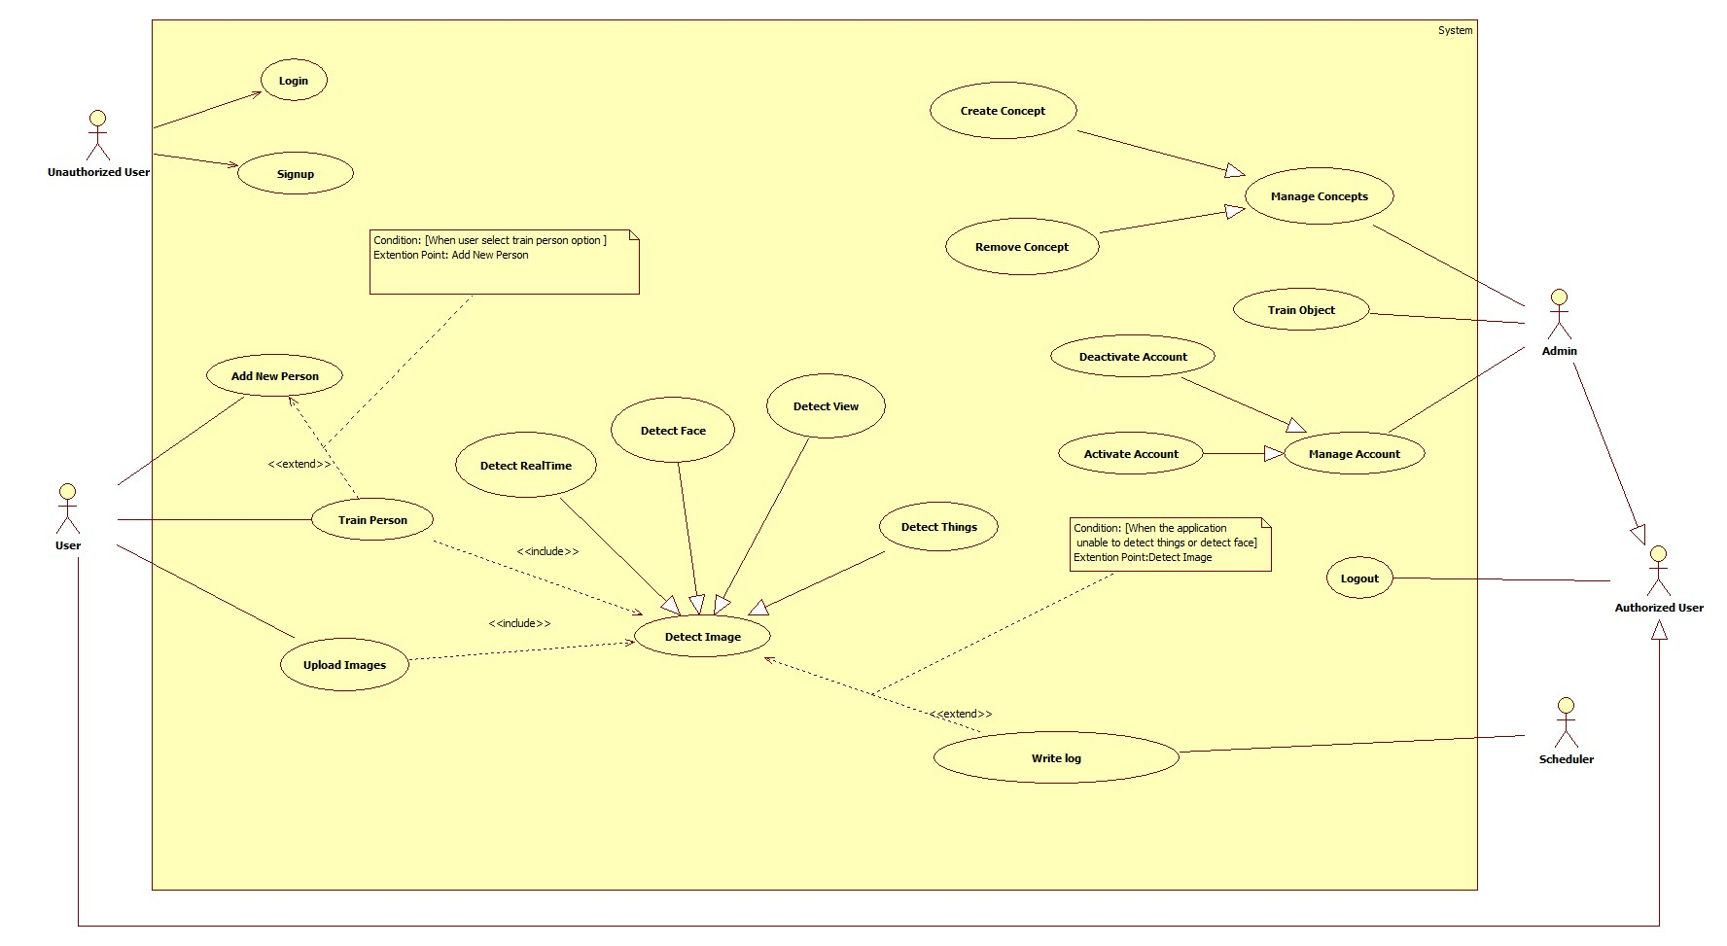

**Figure 2: System Overview Use Case**

### List of Use Case

#### <User> Overview Use Case



***Figure 3: User Overview Use Case***

##### <User> Add New Peron



**Figure 4: <User> Add New Person (UC_US01)**

|  |  |  |  |
| --- | --- | --- | --- |
| **USE CASE – UC_US01** | | | |
| **Use Case No.** | UC_US01 | **Use Case Version** | 1.0 |
| **Use Case Name** | Add New Person | | |
| **Author** | SonNVH | | |
| **Date** | 04/11/2017 | **Priority** | High |
| **Actor:**   * User   **Summary:**   * This use case allows user to add a new person to the system for later recognition.   **Goal:**   * A new person is added to the system with name and description. The system can be trained later to recognize this person when the user request.   **Triggers:**   * User sends command to add a new person .   **Preconditions:**   * Actor must login at user role.   **Post Conditions:**   * **Success:** New person has been added to the system. * **Fail:** Show error message.   **Main Success Scenario:**   |  |  |  | | --- | --- | --- | | Step | Actor Action | System Response | | 1 | User sends command to add new person | System open Add New Person view. | | 2 |  | System requires information from user:   * Name: free text input. Required. length is 3 - 128. * User Description: free text input. The size limit is 128 characters. * Image: hidden free text input. Valid image size is from 1KB to 4MB. | | 3 | User inputs information. |  | | 4 | User sends command to create new Person.  [Alternative 1, 2] | System validates information.  [Exception 1, 2, 3, 4, 5, 6] | | 5 |  | Adds new person into the system.  Shows successful message.  [Exception 8, 9, 10] |   **Alternative Scenario:**  *[Alternative 1]*   |  |  |  | | --- | --- | --- | | Step. | Actor Action | System Response | | 1 | User sends command to reset. | System resets all required information fields. |   *[Alternative 2]*   |  |  |  | | --- | --- | --- | | Step. | Actor Action | System Response | | 1 | User sends command to cancel. | System closes adding new Person view. |   **Exceptions:**   |  |  |  | | --- | --- | --- | | No. | Cause | System Response | | 1 | Name is empty. | System responses: “Name không được bỏ trống”. | | 2 | Length of Name is not between 3 - 128 characters. | System responses: “Độ dài của Name trong khoảng 3 -128 kí tự”. | | 3 | Image size exceeded the limit size (4Mb) | System automatically compresses the image but remains its resolution. | | 4 | Invalid subscription Key or user/plan is blocked. | System responses: “Tạo người mới thất bại”. | | 5 | Out of call volume quota | System responses: “Lượng truy cập cho phép đã hết. Truy cập sẽ khả dụng trở lại trong ## ngày”. | | 6 | Rate limit is exceeded | System responses: “Đã đạt lượng truy cập tối đa. Vui lòng chờ trong vào ## giây để tiếp tục”. |   **Relationships:**  N/A.  **Business Rules:**   * New created person information will be stored at both system Database and Microsoft Cognitive Service. * The Person ID must be consistent in both system Database and Microsoft Cognitive Service. * The person group contains the newly created person must be trained after successfully created a new Person. | | | |

***Table 14: USE CASE – UC_AS01 - <User> Add New Person***

##### <User> Upload Images

**Figure 5: <User> Upload Images (UC_US02)**

|  |  |  |  |
| --- | --- | --- | --- |
| **USE CASE – UC_US02** | | | |
| **Use Case No.** | UC_US02 | **Use Case Version** | 1.0 |
| **Use Case Name** | Upload Image | | |
| **Author** | SonNVH | | |
| **Date** | 04/11/2017 | **Priority** | High |
| **Actor:**   * User   **Summary:**   * This use case allows user to send a picture to the system. After received the picture, the system can use it for later functions (detections, create new person).   **Goal:**   * The taken / uploaded picture from user is stored in the system.   **Triggers:**   * When user capture a picture from device’s camera. * When user choose an image(s) to create a new person.   **Preconditions:**   * Actor must login at user role.   **Post Conditions:**   * **Success:** captured / uploaded picture from user is now stored in the system. * **Fail:** No image is stored in the system. Show error message.   **Main Success Scenario:**   |  |  |  | | --- | --- | --- | | Step | Actor Action | System Response | | 1 | User captures new picture. [Alternative 1] |  | | 2 |  | System stores captured image, compress the image file. | | 3 |  | System uploads image to server.[Exception 1, 2] |   **Alternative Scenario:**  *[Alternative 1]*   |  |  |  | | --- | --- | --- | | Step. | Actor Action | System Response | | 1 | User choose image(s) from device. | System open image picker. | | 2 | User choose image(s) | System shows preview of chosen image(s) | | 5 | User sends upload command | System stores chosen image(s), compress image file(s). | | 6 |  | System uploads image to server.[Exception 1, 2] |   **Exceptions:**   |  |  |  | | --- | --- | --- | | No. | Cause | System Response | | 1 | No image file is found by the system. | System responses with error message | | 2 | No Internet connection / request denied by upload host. | System responses with upload fail error message. |   **Relationships:** N/A.  **Business Rules:**   * Captured image will be compressed to reduce the size but still remain the resolution. The compressed image size is between 20Kb – 70Kb. * The system must provide option for user to crop out faces in the images. * Captured / Chosen images must have size between 1Kb – 4Mb, with resolution between 36x36 and 4096x4096 pixels. * Support image formats are: JPG, PNG, BMP, GIF (the first frame). * After the upload process, the system will receive a direct link of the image. | | | |

***Table 15: USE CASE – UC_US02 - <User> Upload Images***

##### <User> Train Person



**Figure 6: <User> Train Person (UC_US03)**

|  |  |  |  |
| --- | --- | --- | --- |
| **USE CASE – UC_US03** | | | |
| **Use Case No.** | UC_US03 | **Use Case Version** | 1.0 |
| **Use Case Name** | Train Person | | |
| **Author** | SonNVH | | |
| **Date** | 04/11/2017 | **Priority** | High |
| **Actor:**   * User   **Summary:**   * This use case allows user to teach the system how to identify a person that has been added to the system.   **Goal:**   * The system can identify the person that has been added to the system.   **Triggers:**   * After a new person is added to the system successfully. * After user finish updated a person information. * When user sends command to train person.   **Preconditions:**   * Actor must login at user role. * The person group contains the person is not in a training process.   **Post Conditions:**   * **Success:** The system can identify the trained persons . * **Fail:** System cannot identify newly added person. System shows error response.   **Main Success Scenario:**   |  |  |  | | --- | --- | --- | | Step. | Actor Action | System Response | | 1 | User sends request to train person. [Alternative 1, 2] | System redirects to Train Person View | | 2 |  | System requires input information from user:   * personGroupId: hidden free text input. Required. Length between 3 – 64 characters. | | 3 | User input required information | System validate input information from user  [Exception 1, 2, 3] | | 4 | User sends command to train person | System run training process.  Show success message when done.  Redirects to main activity[Exception 4, 5, 6] |   **Alternative Scenario:**  *[Alternative 1]*   |  |  |  | | --- | --- | --- | | Step. | Actor Action | System Response | | 1 | User updated a person’s information. | System gets personGroupId from user, begin training process | | 2 |  | Show success message when done.  Redirect to main activity[Exception 4, 5, 6] |   *[Alternative 2]*   |  |  |  | | --- | --- | --- | | Step | Actor Action | System Response | | 1 | User successfully created a new person | System gets personGroupId from user, begin training process | | 2 |  | Show success message when done.  Redirect to main activity[Exception 4] |   **Exceptions:**   |  |  |  | | --- | --- | --- | | No. | Cause | System Response | | 1 | PersonGroupId is not existed | System responses: “Person Group ID không tồn tại”. | | 2 | Person group is in a training process | System responses: “Person group hiện đang trong quá trình training” | | 3 | Out of call volume quota | System responses: “Lượng truy cập cho phép đã hết. Truy cập sẽ khả dụng trở lại trong ## ngày”. | | 4 | Rate limit is exceeded | System responses: “Đã đạt lượng truy cập tối đa. Vui lòng chờ trong vào ## giây để tiếp tục”. |   **Relationships:** N/A.  **Business Rules:**   * Person Group Id is gotten from logged in user. * Image will be compressed when upload to the system, less than 300kb. * User can choose to crop out the face in their picture. * If training process is fail, return training status to user. | | | |

***Table 16: USE CASE – UC_US03 - <User> Train Person***

##### <User> Detect Face

**Figure 7: <User> Detect Face (UC_US04)**

|  |  |  |  |
| --- | --- | --- | --- |
| **USE CASE – UC_US04** | | | |
| **Use Case No.** | UC_US04 | **Use Case Version** | 1.0 |
| **Use Case Name** | Detect Face | | |
| **Author** | SonNVH | | |
| **Date** | 04/11/2017 | **Priority** | High |
| **Actor:**   * User   **Summary:**   * This use case allows user to identify a person by taking a picture of him/her. The system will detect and notify back the person identity to user by voice.   **Goal:**   * User can knows who is the person in front of them.   **Triggers:**   * User sends command to detect a person.   **Preconditions:**   * Actor must login at user role. * Person Group training process is finished.   **Post Conditions:**   * **Success:** The person is identified. His / her information is noticed to the user through voice notification. * **Fail:** System cannot identify the person. Notify user through voice notification.   **Main Success Scenario:**   |  |  |  | | --- | --- | --- | | Step | Actor Action | System Response | | 1 | User sends request to detect a person | System opens camera. | | 2 | User takes a picture of the person. | System uploads picture to server. [Exception 1] | | 3 |  | System validate inputted information | | 4 |  | System calls Microsoft Cognitive Service to detect faces in the uploaded image.  [Alternative 1]  [Exception 4, 5, 6] | | 5 |  | System call Microsoft Cognitive Service to identify detected face(s) in the person group and return candidate(s)  [Exception 2, 3, 6]  [Alternative 2] | | 6 |  | System get detected person’s information and notify it to the user.  [Exception 6] |   **Alternative Scenario:**  *[Alternative 1]*   |  |  |  | | --- | --- | --- | | Step. | Actor Action | System Response | | 1 | No face is detected in the image | System response: cannot detect the person. Notify result to user through voice notification. |   *[Alternative 2]*   |  |  |  | | --- | --- | --- | | Step. | Actor Action | System Response | | 1 | No candidates is found in the person group that matched the detected faces. | System response: cannot detect the person. Notify result to user through voice notification. | | 2 |  | System ask if user want to add this person. | | 3 | User sends confirm command  [Alternative 3] | System ask user to input the person name. | | 4 | User input person name. | System write log file of new person.  Return to main screen |   *[Alternative 3]*   |  |  |  | | --- | --- | --- | | Step. | Actor Action | System Response | | 1 | User sends denied command | System returns to main screen waiting for new command. |   **Exceptions:**   |  |  |  | | --- | --- | --- | | No. | Cause | System Response | | 1 | Unable to upload image | System response with error message. | | 2 | Person Group Id not found | System response: “Person group không tồn tại” | | 3 | Person group is in a training process | System responses: “Person group hiện đang trong quá trình training” | | 4 | System detects more than 10 faces in the uploaded image. | System response: “Ứng dụng chỉ nhận biết được tối đa 10 khuôn mặt cùng một lúc” | | 5 | Out of call volume quota | System responses: “Lượng truy cập cho phép đã hết. Truy cập sẽ khả dụng trở lại trong ## ngày”. | | 6 | Rate limit is exceeded | System responses: “Đã đạt lượng truy cập tối đa. Vui lòng chờ trong vào ## giây để tiếp tục”. |   **Relationships:** N/A.  **Business Rules:**   * Person Group Id is gotten from logged in user. * Image will be compressed when uploaded to the system. * System can only detect 10 person at a time. * Identification works well for frontal faces and near-frontal faces. * If no person is identified, the system will describe the gender of the person back to the user through voice notification. * Identification result will be noticed to the user through voice notification. * Log file structure in database:  |  |  |  |  |  |  | | --- | --- | --- | --- | --- | --- | | **ID** | **USER_ID** | **IMAGE_URL** | **IMAGE_TYPE** | **DATETIME** | **ACTIVE** | |  |  |  |  |  |  |  * The detecting face process:  1. Face Detection:    * Microsoft Cognitive Service receives image url, turn it into black and white image.    * Using algorithms, scanning every pixel from left to right to detect the human face.    * When a face is detected, the service return a unique FaceId, along with facial details (age, gender) for each of the detected faces. This faceid will be expired in 24 hours. 2. Face Identification:    * With the return FaceId from detecting process, the system compares and identify with trained faces.    * If there is a match, the system will return a person Id of a candidate which have the highest accuracy percentage.    * If there is no match, the system will return the facial details returned from Detecting Process back to the user. 3. Get Person info:    * Using the returned Person Id from Identifying process, the system look for that person in the person group.    * If a matched person is found, personal information of that person will be returned to user.    * If there is no match of the person is found, the system will return the facial details back to the user. | | | |

***Table 17: USE CASE – UC_US04 - <User> Detect Face***

##### <User> Detect View

**Figure 8: <User> Detect View (UC_US05)**

|  |  |  |  |
| --- | --- | --- | --- |
| **USE CASE – UC_US05** | | | |
| **Use Case No.** | UC_US05 | **Use Case Version** | 1.0 |
| **Use Case Name** | Detect View | | |
| **Author** | SonNVH | | |
| **Date** | 04/11/2017 | **Priority** | High |
| **Actor:**   * User   **Summary:**   * This use case allows the application to describe the view / landscape in the taken image by the user though voice notification.   **Goal:**   * User knows what is in the view they took picture of.   **Triggers:**   * User sends command to detect view.   **Preconditions:**   * Actor must login at user role.   **Post Conditions:**   * **Success:**  System describes back to the user the view they took picture of and notify it through voice notification. * **Fail:** System cannot describe what is going on in the view. Notify result to user through voice notification.   **Main Success Scenario:**   |  |  |  | | --- | --- | --- | | Step | Actor Action | System Response | | 1 | User sends request to detect view | System opens camera. | | 2 | User takes a picture of the view. | System uploads image to server. [Exception 1] | | 3 |  | System validate inputted information. | | 4 |  | System calls Microsoft Cognitive Service to detect what is going on in the uploaded image.  [Alternative 1]  [Exception 2, 3] | | 5 |  | System notify detection result back to user through voice notification. |   **Alternative Scenario:**  *[Alternative 1]*   |  |  |  | | --- | --- | --- | | Step. | Actor Action | System Response | | 1 | Microsoft Cognitive Service cannot describe the image. | System response: Cannot describe the image. Notify result to user through voice notification. |   **Exceptions:**   |  |  |  | | --- | --- | --- | | No. | Cause | System Response | | 1 | Unable to upload image | System response with error message. | | 2 | Out of call volume quota | System responses: “Lượng truy cập cho phép đã hết. Truy cập sẽ khả dụng trở lại trong ## ngày”. | | 3 | Rate limit is exceeded | System responses: “Đã đạt lượng truy cập tối đa. Vui lòng chờ trong vào ## giây để tiếp tục”. |   **Relationships:** N/A.  **Business Rules:**   * Image will be compressed when uploaded to the system. * Identification result will be noticed to the user through voice notification. | | | |

***Table 17: USE CASE – UC_US05 - <User> Detect View***

##### <User> Detect Object

**Figure 9: <User> Detect Object (UC_US06)**

|  |  |  |  |
| --- | --- | --- | --- |
| **USE CASE – UC_US06** | | | |
| **Use Case No.** | UC_US07 | **Use Case Version** | 1.0 |
| **Use Case Name** | Detect Object | | |
| **Author** | SonNVH | | |
| **Date** | 04/11/2017 | **Priority** | High |
| **Actor:**   * User   **Summary:**   * This use case allows user to identify what object is in front of them by captured image.   **Goal:**   * System can describes what the object is to user through voice notification.   **Triggers:**   * User sends command to detect an object.   **Preconditions:**   * Actor must login at user role.   **Post Conditions:**   * **Success:**  System describes the object back to the user through voice notification. * **Fail:** System cannot describes the object. Notify result to user through voice notification.   **Main Success Scenario:**   |  |  |  | | --- | --- | --- | | Step | Actor Action | System Response | | 1 | User sends request to detect object | System opens camera. | | 2 | User takes a picture of the object. | System upload image to server.[Exception 1] | | 3 |  | System validate inputted information.  [Exception 1] | | 4 |  | System call service to identify object.  [Alternative 1] | | 5 |  | System notify detection result back to user through voice notification. |   **Alternative Scenario:**  *[Alternative 1]*   |  |  |  | | --- | --- | --- | | Step. | Actor Action | System Response | | 1 | System cannot detect object. | System response: Cannot describe the image. Notify result to user through voice notification. | | 2 |  | System generates log file in database. | | 3 |  | Redirect to main activity. |   **Exceptions:**   |  |  |  | | --- | --- | --- | | No. | Cause | System Response | | 1 | No image is upload to the system | System response with error message. | | 2 | No Internet connection | System response with error message. |   **Relationships:** N/A.  **Business Rules:**   * Image will be compressed when uploaded to the system. The compressed image file size is between 20Kb – 70Kb. * Identification result will be noticed to the user through voice notification. * If the application cannot identify the object, a Log file will be created in the system and system Admin will be noticed. * Log file structure in database:  |  |  |  |  |  | | --- | --- | --- | --- | --- | | **ID** | **CREATED_DATE** | **IMAGE_URL** | **USER_ID** | **ACTIVE** | |  |  |  |  |  |  * + **ID**: Log File ID: integer   + **User**_ID: Id of authorized user that requested the identification of object: String   + **Image**_URL: URL of the object image: String   + **Created**_Date: Date and Time when the log file is created: Datetime dd/MM/yyyy hh:mm:ss   + **Active**: activation state of the log file: Bit | | | |

***Table 18: USE CASE – UC_US06 - <User> Detect Object***

##### <User> Detect Real-time

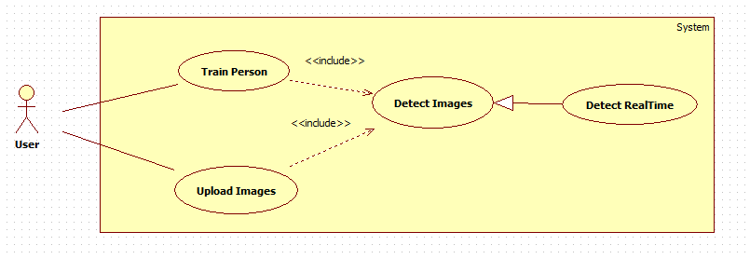

**Figure 10: <User> Detect Real-time (UC_US07)**

|  |  |  |  |
| --- | --- | --- | --- |
| **USE CASE – UC_US07** | | | |
| **Use Case No.** | UC_US07 | **Use Case Version** | 1.0 |
| **Use Case Name** | Detect Real-time | | |
| **Author** | SonNVH | | |
| **Date** | 04/11/2017 | **Priority** | High |
| **Actor:**   * User   **Summary:**   * This use case allows user to detect person continuously in real time.   **Goal:**   * The application can automatically detect person without the user command to capture picture.   **Triggers:**   * User sends command to begin streaming detecting process .   **Preconditions:**   * Actor must login at user role.   **Post Conditions:**   * **Success:** The application automatically identify any detected person. * **Fail:** Show response message.   **Main Success Scenario:**   |  |  |  | | --- | --- | --- | | Step | Actor Action | System Response | | 1 | User sends command to begin streaming detecting process.  [Alternative 1] | System open device camera. | | 2 |  | System notify begin the streaming detecting process by voice. | | 3 | The device detected a human face. | System automatically capture the human face and begin identifying process. | | 4 |  | System notify the person information to the user by voice.  [Alternative 2] |   **Alternative Scenario:**  *[Alternative 1]*   |  |  |  | | --- | --- | --- | | Step. | Actor Action | System Response | | 1 | User send command to quit streaming detecting process | System close camera, back to main screen. |   *[Alternative 2]*   |  |  |  | | --- | --- | --- | | Step. | Actor Action | System Response | | 1 | A person is detected but cannot be identified. | System continue the streaming process. |   **Exceptions:**   |  |  |  | | --- | --- | --- | | No. | Cause | System Response | | 1 | Invalid subscription Key or user/plan is blocked. | System returns response message. | | 2 | Out of call volume quota | System returns response message. | | 3 | Rate limit is exceeded | System returns response message. |   **Relationships:**  N/A.  **Business Rules:**   * The application must notifies user the beginning of the streaming process through voice. * The application will continuously detect for human faces in real time. * When a human faces is detected, the application captures a picture of the human face and begin the identifying process. * When a human face is detected, the application has 3 seconds to identify the person. * After 3 seconds, the application continues to detect human faces automatically in real time. * After 3 seconds, if the human face is identified successfully, the application will notify the person information to user by voice. * If the human face cannot be identified, the application will not notify any response message. | | | |

***Table 19: USE CASE – UC_US07 - <User> Detect Real-time***

#### <Unauthorized User> Overview Use Case



**Figure 11: <Unauthorized User> Overview Use Case**

##### <Unauthorized User> Signup



**Figure 12: <Unauthorized User> Signup (UC_UU01)**

|  |  |  |  |
| --- | --- | --- | --- |
| **USE CASE – UC_UU01** | | | |
| **Use Case No.** | UC_UU01 | **Use Case Version** | 2.0 |
| **Use Case Name** | Signup | | |
| **Author** | DuyNC | | |
| **Date** | 13/02/2017 | **Priority** | Normal |
| **Actor:**   * Unauthorized User   **Summary:**   * This use case allows unauthorized user register new account in the system for login in the next time.   **Goal:**   * Actor cans signup new account in the system.   **Triggers:**   * Actor sends the signup command.   **Preconditions:**   * **N/A**   **Post Conditions:**   * **Success:** New account has been created in the system. * **Fail:** Show error message.   **Main Success Scenario:**   |  |  |  | | --- | --- | --- | | Step | Actor Action | System Response | | 1 | Actor goes to signup view. | System requires identity information from Unauthorized user:   * Full Name: free text input, required, length 5–50 characters. * Username: free text input, required, length 5–30 characters. * Password: free text input, required, length 5–30 characters. * Gender: select one of the options (Male, Female), required. * Phone number: free text input, required, length 10-11 digits. * Address: free text input, length 10-100 characters. | | 2 | Actor inputs information. |  | | 3 | Actor sends command to signup new account. | System will sign up with validates inputted information.  [Alternative 1]  [Exception 1,2,3,4,5,6,7,8,9,10,11,12] |   **Alternative Scenario:**  *[Alternative 1]*   |  |  |  | | --- | --- | --- | | Step. | Actor Action | System Response | | 1 | Unauthorized user sends the cancel command. | System closes signup new account form. |   **Exceptions:**   |  |  |  | | --- | --- | --- | | No. | Cause | System Response | | 1 | Full name is empty. | System shows error message the “Tên không được để trống”. | | 2 | Length of full name out of range 5-50 characters. | System shows error message the “Độ dài của tên phải trong khoảng từ 5 đến 50 ký tự”. | | 3 | Username is empty. | System shows error message the “Tên đăng nhập không được để trống”. | | 4 | Length of username out of range 5-30 characters. | System shows error message the “Độ dài của tên đăng nhập phải trong khoảng từ 5 đến 30 ký tự”. | | 5 | Password is empty. | System shows error message the “Mật khẩu không được để trống”. | | 6 | Length of password out of range 5-30 characters. | System shows error message the “Độ dài của mật khẩu phải trong khoảng từ 5 đến 30 ký tự”. | | 7 | Gender is not selected. | System shows error message the “Giới tính phải được chọn”. | | 8 | Phone number is empty. | System shows error message the “Số điện thoại không được để trống”. | | 9 | Length of phone number out of range 10-11 digits. | System shows error message the “Độ dài của số điện thoại phải trong khoảng từ 10 đến 11 số”. | | 10 | Phone number contains alphabetical characters. | System shows error message the “Số điện thoại chỉ chứa số”. | | 11 | Username had already existed in the system. | System shows error message the “Tên đăng nhập đã tồn tại”. | | 12 |  | System shows error message the “Hệ thống hiện đang bận. Vui lòng thử lại sau.” when the internet is lost. |   **Relationships:** N/A.  **Business Rules:**   * Password is encrypted before being sent to server. * System does not allow duplicate “Email”. * After signup in the system, unauthorized user will be redirected to login view. * All newly signed up account will be assigned to “User” role. * Each user will have a unique Person Group created for them after signed up successfully, with the Person Group ID is the same as the User ID. | | | |

***Table 20: USE CASE – UC_UU01 - <Unauthorized User > Signup***

##### <Unauthorized User> Login



***Figure 13: <Unauthorized User> Login (UC_UU02)***

|  |  |  |  |
| --- | --- | --- | --- |
| **USE CASE – UC_UU02** | | | |
| **Use Case No.** | UC_UU02 | **Use Case Version** | 2.0 |
| **Use Case Name** | Login | | |
| **Author** | DuyNC | | |
| **Date** | 13/02/2017 | **Priority** | Normal |
| **Actor:**   * Unauthorized User   **Summary:**   * This use case allows unauthorized user to login in the system and use permission function.   **Goal:**   * Actor cans login in the system.   **Triggers:**   * Actor sends the login command.   **Preconditions:**   * Account must be existed in the system.   **Post Conditions:**   * **Success:** Actor login in the system. * **Fail:** Show error message.   **Main Success Scenario:**   |  |  |  | | --- | --- | --- | | Step | Actor Action | System Response | | 1 | Actor goes to login view. | System requires identity information from Actor:   * Username: free text input, required. * Password: free text input, required. | | 2 | Actor inputs information. |  | | 3 | Actor sends command to login in the system. | Actor will login with theirs specific role.  [Alternative 1]  [Exception 1] |   **Alternative Scenario:**  *[Alternative 1]*   |  |  |  | | --- | --- | --- | | Step. | Actor Action | System Response | | 1 | Unauthorized user enters wrong identity information. | Wrong identity information, system shows error message. |   **Exceptions:**   |  |  |  | | --- | --- | --- | | No. | Cause | System Response | | 1 |  | System shows error message the “Hệ thống hiện đang bận. Vui lòng thử lại sau.” when the internet is lost. |   **Relationships:** N/A.  **Business Rules:**   * Password is encrypted before being sent to server. * After login in the system, unauthorized user will be redirected to specific view based on their role in the system: admin or user. * If role is “Admin”, the system will display to admin page. * If role is “User”, the system will display to user view. * If the account is Deactivated, user cannot login and a response message will be shown to user. | | | |

***Table 21: USE CASE – UC_UU02 - <Unauthorized User >Login***

#### <Admin> Overview Use Case



***Figure 14: <Admin> Overview Use Case***

##### <Admin> Activate Account



***Figure 15: <Admin> Activate Account (UC_AD01)***

|  |  |  |  |
| --- | --- | --- | --- |
| **USE CASE – UC_AD01** | | | |
| **Use Case No.** | UC_AD01 | **Use Case Version** | 1.0 |
| **Use Case Name** | Activate Account | | |
| **Author** | QuanVH | | |
| **Date** | 04/11/2017 | **Priority** | High |
| **Actor:**   * Admin   **Summary:**   * This use case allows admin to activate account.   **Goal:**   * An account is activated and allowed to access the system.   **Triggers:**   * Admin send Activate account command   **Preconditions:**   * Actor must log in the system with “Admin” role. * The account is deactivated.   **Post Conditions:**   * **Success:** An account’s status is updated in the database. * **Fail:** System displays the error message.   **Main Success Scenario:**   |  |  |  | | --- | --- | --- | | Step | Actor Action | System Response | | 1 | Admin sends “Activate” command on a specific account | System activates the account and saves the account status to database. |   **Alternative Scenario: N/A**  **Exceptions: N/A**  **Relationships:** N/A.  **Business Rules:**   * An account’s status can be “Activated” or “Deactivated”.   + “Activated” means account is activated and can be used to access the system.   + “Deactivated” means account is disabled and can’t be used to access the system. * After being activated, the “Active” record of the user account in the system will be updated to “True”. | | | |

***Table 21: USE CASE – UC_AD01 - <Admin >Activate Account***

##### <Admin> Deactivate Account



***Figure 16: <Admin> Deactivate Account (UC_AD02)***

|  |  |  |  |
| --- | --- | --- | --- |
| **USE CASE – UC_AD02** | | | |
| **Use Case No.** | UC_AD02 | **Use Case Version** | 1.0 |
| **Use Case Name** | Deactivate Account | | |
| **Author** | QuanVH | | |
| **Date** | 04/11/2017 | **Priority** | High |
| **Actor:**   * Admin   **Summary:**   * This use case allows admin to deactivate account.   **Goal:**   * An account is deactivated and can’t access the system.   **Triggers:**   * Admin send Deactivate account command   **Preconditions:**   * Actor must log in the system with “Admin” role. * The selected account is activated.   **Post Conditions:**   * **Success:** An account’s status is updated in the database. * **Fail:** System displays the error message.   **Main Success Scenario:**   |  |  |  | | --- | --- | --- | | Step | Actor Action | System Response | | 1 | Admin sends “Deactivate” command on a specific account | System deactivate the account and saves the account status to database. |   **Alternative Scenario: N/A**  **Exceptions: N/A**  **Relationships:** N/A.  **Business Rules:**   * An account’s status can be “Activated” or “Deactivated”.   + “Activated” means account is activated and can be used to access the system.   + “Deactivated” means account is disabled and can’t be used to access the system. * After being activated, the “Active” record of the user account in the system will be updated to “False”. | | | |

***Table 22: USE CASE – UC_AD02 - <Admin >Deactivate Account***

##### <Admin> Remove Concept



***Figure 17: <Admin> Remove Concept (UC_AD03)***

|  |  |  |  |
| --- | --- | --- | --- |
| **USE CASE – UC_AD03** | | | |
| **Use Case No.** | UC_ AD03 | **Use Case Version** | 1.0 |
| **Use Case Name** | Remove Concept | | |
| **Author** | ThanhPT | | |
| **Date** | 20/03/2017 | **Priority** | Normal |
| **Actor:**   * Admin   **Summary:**   * This use case allows admin remove concept in the system.   **Goal:**   * Concept is removed out off system.   **Triggers:**   * Admin sends the remove command.   **Preconditions:**   * Account must be login with admin role. * Concept must exist in the system.   **Post Conditions:**   * **Success:** System will send success message when concept is removed successfully. * **Fail:** System will show error message.   **Main Success Scenario:**   |  |  |  | | --- | --- | --- | | Step | Actor Action | System Response | | 1 | Admin goes to concept view. | System show list of concept includes: image, name, description. | | 2 | Admin choose a concept. |  | | 3 | Admin sends command to remove concept. | System removes chosen concept. |   **Alternative Scenario:** N/A  **Exceptions:** N/A  **Relationships:** N/A.  **Business Rules:**   * The Active record of the chosen Concept will be updated to False after successfully Deactivated. * Concept ID must be unique. * The Concept’s Images must be also deactivated when removing the Concept. | | | |

***Table 23: USE CASE – UC_AD03 - <Admin >Remove Concept***

##### <Admin> Create Concept



***Figure 18: <Admin> Create Concept (UC_AD04)***

|  |  |  |  |
| --- | --- | --- | --- |
| **USE CASE – UC_AD04** | | | |
| **Use Case No.** | UC_ AD04 | **Use Case Version** | 1.0 |
| **Use Case Name** | Create Concept | | |
| **Author** | DuyNC | | |
| **Date** | 20/03/2017 | **Priority** | Normal |
| **Actor:**   * Admin   **Summary:**   * This use case allows admin create new concept to the system predict object and can recognize object.   **Goal:**   * A new concept is created into the system.   **Triggers:**   * Admin sends create new concept command.   **Preconditions:**   * Account must be login with admin role.   **Post Conditions:**   * **Success:** System will send success message when concept is created successfully. * **Fail:** System will show error message.   **Main Success Scenario:**   |  |  |  | | --- | --- | --- | | Step | Actor Action | System Response | | 1 | Admin goes to create new concept view. | System require information from actor:   * Concept Name: free text input, required. The size limit is 100 characters. * Description: free text input, required. The size limit is 100 characters. * Images: image type input, required. | | 3 | Admin inputs information. |  | | 3 | Admin sends command to create new concept. | System validates inputted information.  [Exception 1,2,3,4] | | 4 |  | System create new concept and redirects to view all concept view. |   **Alternative Scenario:** N/A  **Exceptions:**   |  |  |  | | --- | --- | --- | | No. | Cause | System Response | | 1 | Concept name is empty. | System shows error message: “Tên đồ vật không được để trống”. | | 2 | Images are empty. | System shows error message: “Vui lòng chọn hình ảnh”. | | 3 | Invalid image. | System shows error message: “Vui lòng chỉ chọn hình”. | | 4 | Description is empty | System shows error message: “Mô tả không được bỏ trống” |   **Relationships:** N/A.  **Business Rules:**   * System must validates user inputted information before create a Concept. * Concept ID must be unique. * Each concept must have at least one image of it (input). * If user does not input Concept Name, the Concept ID will be used as Concept Name by default. * System will redirect to all concept list view after successfully created Concept. * Support image formats are: JPG, PNG, JPEG. | | | |

***Table 24: USE CASE – UC_AD04 - <Admin > Create Concept***

##### <Admin> Train Object



***Figure 19: <Admin> Train Object (UC_AD05)***

|  |  |  |  |
| --- | --- | --- | --- |
| **USE CASE – UC_AD05** | | | |
| **Use Case No.** | UC_ AD05 | **Use Case Version** | 1.0 |
| **Use Case Name** | Train Object | | |
| **Author** | ThanhPT | | |
| **Date** | 20/03/2017 | **Priority** | Normal |
| **Actor:**   * Admin   **Summary:**   * This use case allows admin train object by adding image into concept from log file.   **Goal:**   * The system can recognize object has been added to the system.   **Triggers:**   * Admin sends trains object command.   **Preconditions:**   * Account must be login with admin role. * Log must be existed.   **Post Conditions:**   * **Success:** The system can recognize the trained object. * **Fail:** System cannot recognize newly added object. System shows error response.   **Main Success Scenario:**   |  |  |  | | --- | --- | --- | | Step | Actor Action | System Response | | 1 | Admin goes to logs view. | System shows all logs. | |  | Admin choose log to train. | System show table include: image, all name of concept had existed. | | 2 | Admin choose name of concept had existed to update.  [Alternative 1] |  | | 3 | Admin sends command to train object. | System run training process.  Show success message when done.  Redirects to logs view. |   **Alternative Scenario:**  *[Alternative 1]*   |  |  |  | | --- | --- | --- | | Step | Actor Action | System Response | | 1 | Admin sends command to create new concept. | System redirect to create new concept page. | | 2 | Admin goes to create new concept view. | System require information from actor:   * Object Name: free text input, required. The size is [2,100] characters. * Description: #free text input, required. The size is [2,100] | | 3 | Admin inputs information. |  | | 4 | Admin sends command to create new object. | System validates inputted information.  [Exception 1,3] | | 5 |  | System creates new object and redirect to view concept page. [Exception 2] |   **Exceptions:**   |  |  |  | | --- | --- | --- | | No. | Cause | System Response | | 1 | Object name is empty. | System shows error message: “Tên đồ vật không được để trống”. | | 2 | Rate limit is exceeded | System responses: “Tài khoản đã đạt đến giới hạn tạo concept”. | | 3 | Description is empty | System responses: “Mô tả đồ vật không được để trống” |   **Relationships:** N/A.  **Business Rules:**   * Support image formats are JPG, PNG, JPEG. * After object is trained successfully, Active state will be updated to “False”. * Log structure in database:  |  |  |  |  |  | | --- | --- | --- | --- | --- | | **ID** | **CREATED_DATE** | **IMAGE_URL** | **USER_ID** | **ACTIVE** | |  |  |  |  |  |  * + **ID**: Log ID: integer   + **User**_ID: Id of authorized user that requested the identification of object: String   + **Image**_URL: URL of the object image: String   + **Created**_Date: Date and Time when the log is created: Datetime Format: dd/MM/yyyy hh:mm:ss.   + **Active**: activation state of the log file: Bit * #Each Concept must have at least 1 image (1 input). * #If Concept ID is already existed, the inputted image will be used to train that Concept. | | | |

***Table 25: USE CASE – UC_AD05 - <Admin > Train Object***

#### <Authorized User> Log out



***Figure 20: <Authorized User> Logout (UC_AU01)***

|  |  |  |  |
| --- | --- | --- | --- |
| **USE CASE – UC_AU01** | | | |
| **Use Case No.** | **UC_AU01** | **Use Case Version** | 1.0 |
| **Use Case Name** | Log out | | |
| **Author** | QuanVH | | |
| **Date** | 04/11/2017 | **Priority** | Normal |
| **Actor:**   * Authorized User   **Summary:**   * This use case helps Authorized User to sign out of their account.   **Goal:**   * Authorized User can sign out of the system.   **Triggers:**   * Authorized User sends Logout command.   **Preconditions:**   * Actor logged in system with role “Authorized User”.   **Post Conditions:**   * **Success:** Authorized User is logged out. * **Fail:** System will return error response message.   **Main Success Scenario:**   |  |  |  | | --- | --- | --- | | Step | Actor Action | System Response | | 1 | Authorized User sends logout command. | System clears the current session of the user then redirects user to Login page. |   **Alternative Scenario: N/A**  **Exceptions: N/A**  **Relationships:** N/A.  **Business Rules:**   * After logging out of the system, user is no longer has permission to access any authorized function of the system. * After login, user will be redirected to Login Page. | | | |

***Table 25: USE CASE – UC_AU01 - <Authorized User >Logout***

## Software System Attribute

### Usability

#### Graphic User Interface

* All the texts, labels must be written in Vietnamese.
* The content of alert, log file can be written in English.

#### Usability

* Admin, the trainer should need less than 2 hours of training to be used with the system.

### Reliability

* The log file will be written when application detect face and things unsuccessfully.
* Server have back-up method to make sure that if it has problem while running then all necessary data must be protected and restore as soon as.

### Availability

* Server has back up method to protect and restore necessary data as soon as possible whenever there is a problem.

### Security

* Privacy: Each role of user has a specific permission to interact with system.

### Maintainability

* The system is divided into separated modules.

### Portability

* Admin, the trainer can use application on Google Chrome, version 42 or above.
* Employee can use mobile application on Android that support 6.0.1 Marshmallow or later.

### Performance

* Request from web application are responded in less 8 seconds at 4Mbps bandwidth speed and 2.2GHz processing Speed of CPU.

## Conceptual Diagram

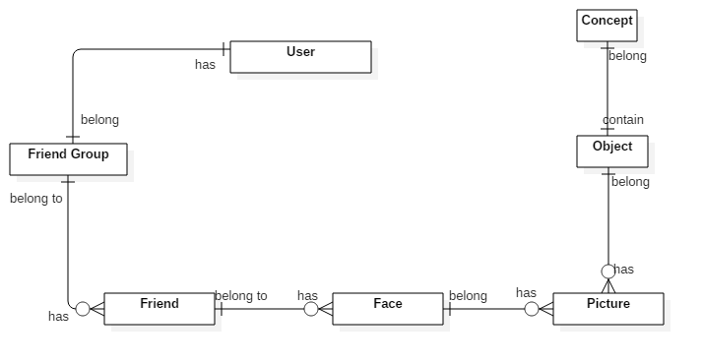

***Figure 21: Conceptual Diagram***

**Data Dictionary**

|  |  |
| --- | --- |
| **Entity Name** | **Description** |
| User | The person who using the system |
| Friend Group | Contain all properties about friend group |
| Friend | Contain all properties about friend of the blind |
| Face | Contain all properties about face of Friend |
| Picture | Store all picture of object |
| Object | Contain all properties of object |
| Concept | Contain all properties of concept |

***Table 26: Data Dictionary***

# Software Design Description

## Design Overview

* The architectural design describes the overall architecture of the system and the architecture of each main component and subsystem.
* The detailed design describes static and dynamic structure for each component and functions. It includes class diagrams, class explanations and sequence diagrams for each use cases.
* The database design describes the relationships between entities and details of each entity.
* Document overview:
* Section 1: gives an overall description of the system architecture design.
* Section 2: gives component diagrams that describe the connection and integration of the system.
* Section 3: gives the detail design description, which includes class diagram, class explanation, and sequence diagram to details the application functions.
* Section 4: gives the interface design description, which includes component interface, web application interface and mobile application design.
* Section 5: describe a fully attributed Entity Relationship Diagram.
* Section 6: describe the algorithms that apply to the system

## System Architectural Design

### Mobile Application Architecture Description

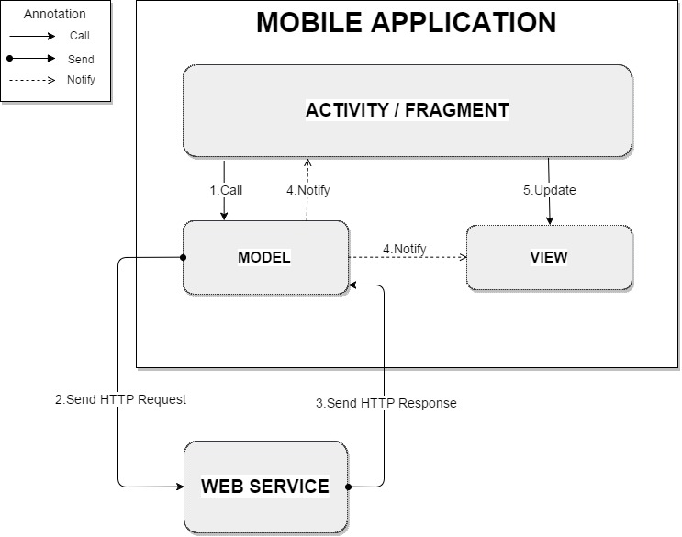

***Figure 22: Mobile Application Architecture Description***

The mobile application is developed in android platform and the application architecture conforms Android architecture.

+ Controller(Activity/Fragment): the logic layer, gets notified of the user’s behavior and updates the Model as needed.

+ View: the UI layer - a visualization of the data from the Model.

+ Model: the data layer, responsible for managing the business logic and handling network or database API.

### Web Service Architecture Description

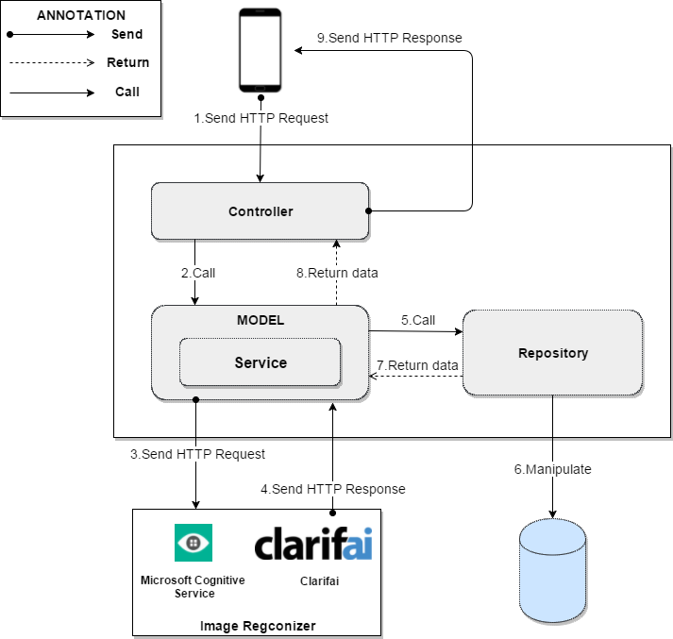

***Figure 23: Web Service Architecture Description***

### Web Application Architecture Description

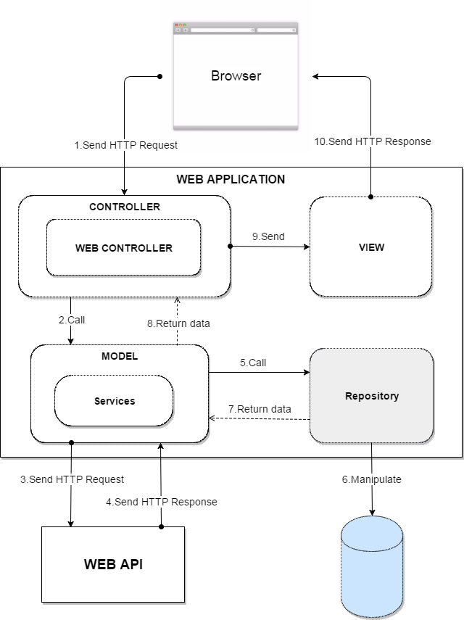

***Figure 24: Web Application Architecture Description***

## Component Diagram



***Figure 25: Component Diagram***

|  |  |
| --- | --- |
| **Name** | **Description** |
| AAIV System | Automatic Alternative Image Recognition to Voice System |
| Web Api | Component is used to provide API for application to interact with the system. |
| Business Logic | Common services are used to handle system’s business operations |
| Controller | Component to handle HTTP request |
| Management | Component to manage system data |
| Image Recognizer | External component for doing image recognizer |
| Image Storage | External component for storing images. |
| Detect | Component to handle detecting requests |
| Training | Component to train new Person and Object to be recognized by system |
| Data Access Object | Abstract interface to interact with database system |
| Database System | Component for system to store and access Data |
| Scheduler | Run background job and send message to other system |
| **Table 27: Component Dictionary** | |

## Detailed Description

### Class Diagram

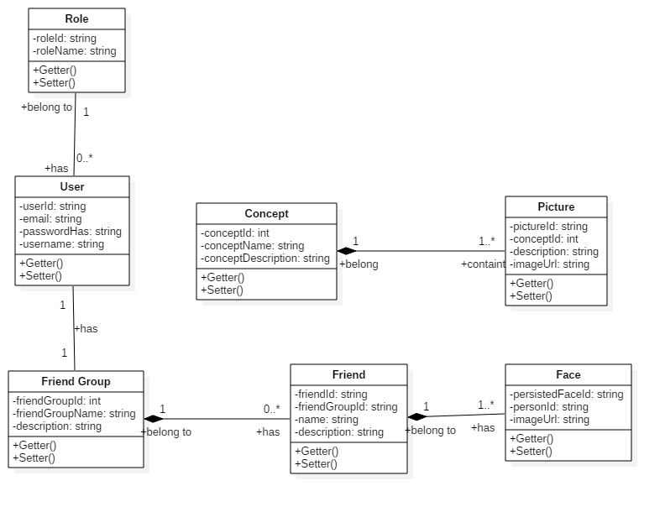

***Figure 26: Class Diagram***

|  |  |  |
| --- | --- | --- |
| **Class dictionary: Describe Class** | | |
| **Class Name** | **Mapping class with conceptual diagram** | **Description** |
| Role | N/A | Not exist in conceptual diagram. But contains in class diagram to store the permission of entities (Admin, User) after being combined into group “User” |
| User | User | Contains the information of users in the system |
| Friend Group | Friend Group | Contain the information of friend group in the system |
| Friend | Friend | Contains the friends of user in the system |
| Concept | Concept | Contains the information of object |
| Picture | Picture | Contains the image of object |
| Face | Face | Contains the information of face |

***Table 28: Class dictionary – Describe Class***

### Class Diagram Explanation

#### Role

**Attributes**

|  |  |  |  |
| --- | --- | --- | --- |
| **Attribute** | **Type** | **Visibility** | **Description** |
| roleId | String | Private | Unique id of role |
| roleName | String | Private | Name of role |

***Table 29: Role class Attributes explanation***

**Methods:**

|  |  |  |  |
| --- | --- | --- | --- |
| **Method** | **Type** | **Visibility** | **Description** |
| Getter | Attribute type | Public | Get attribute value |
| Setter | Void | Public | Set value of attribute |

***Table 30: Role Class methods explanation***

#### User

**Attributes:**

|  |  |  |  |
| --- | --- | --- | --- |
| **Attribute** | **Type** | **Visibility** | **Description** |
| userId | String | Private | Unique id of user |
| Email | String | Private | Email of user |
| passwordHash | String | Private | Password of user |
| username | String | Private | Username of user |

***Table 31: User Class attributes explanation***

**Methods:**

|  |  |  |  |
| --- | --- | --- | --- |
| **Method** | **Type** | **Visibility** | **Description** |
| Getter | Attribute type | Public | Get attribute value |
| Setter | Void | Public | Set value of attribute |

***Table 32: User class methods explanation***

#### Friend Group

**Attributes:**

|  |  |  |  |
| --- | --- | --- | --- |
| **Attribute** | **Type** | **Visibility** | **Description** |
| friendGroupId | Int | Private | Unique id of friend group |
| friendGroupName | String | Private | Name of friend group |
| Description | string | Private | Description of friend group |

***Table 33: Friend Group class attributes explanation***

**Methods:**

|  |  |  |  |
| --- | --- | --- | --- |
| **Method** | **Type** | **Visibility** | **Description** |
| Getter | Attribute type | Public | Get attribute value |
| Setter | Void | Public | Set value of attribute |

***Table 34: Friend Group class methods explanation***

#### Concept

**Attributes:**

|  |  |  |  |
| --- | --- | --- | --- |
| **Attribute** | **Type** | **Visibility** | **Description** |
| conceptId | Int | Private | Unique id of concept |
| conceptName | String | Private | Name of concept |
| conceptDescription | String | Private | Description of concept |

***Table 35: Concept class attributes explanation***

**Methods:**

|  |  |  |  |
| --- | --- | --- | --- |
| **Method** | **Type** | **Visibility** | **Description** |
| Getter | Attribute type | Public | Get attribute value |
| Setter | Void | Public | Set value of attribute |

***Table 36: Concept class methods explanation***

#### Picture

**Attributes:**

|  |  |  |  |
| --- | --- | --- | --- |
| **Attribute** | **Type** | **Visibility** | **Description** |
| pictureId | String | Private | Unique id of picture |
| conceptId | Int | Private | Id of concept contain picture |
| Description | String | Private | Description of picture |
| imageUrl | string | Private | URL of the image |

***Table 37: Picture class attributes explanation***

**Methods:**

|  |  |  |  |
| --- | --- | --- | --- |
| **Method** | **Type** | **Visibility** | **Description** |
| Getter | Attribute type | Public | Get attribute value |
| Setter | Void | Public | Set value of attribute |

***Table 38: Picture class methods explanation***

#### Friend

**Attributes:**

|  |  |  |  |
| --- | --- | --- | --- |
| **Attribute** | **Type** | **Visibility** | **Description** |
| friendId | String | Private | Unique id of friend |
| friendGroupId | String | Private | Id of friend group |
| Name | String | Private | Name of friend |
| description | string | Private | Description of friend |

***Table 39: Friend class attributes explanation***

**Methods:**

|  |  |  |  |
| --- | --- | --- | --- |
| **Method** | **Type** | **Visibility** | **Description** |
| Getter | Attribute type | Public | Get attribute value |
| Setter | Void | Public | Set value of attribute |

***Table 40: Friend class methods explanation***

#### Face

**Attributes:**

|  |  |  |  |
| --- | --- | --- | --- |
| **Attribute** | **Type** | **Visibility** | **Description** |
| persistedFaceId | String | Private | Unique id of face |
| personId | String | Private | If of person contain this face |
| imageUrl | String | Private | Image url contain this face |

***Table 41: Face class attributes explanation***

**Methods:**

|  |  |  |  |
| --- | --- | --- | --- |
| **Method** | **Type** | **Visibility** | **Description** |
| Getter | Attribute type | Public | Get attribute value |
| Setter | Void | Public | Set value of attribute |

***Table 42: Face class methods explanation***

### Interaction Diagram

#### Mobile Application

##### <Unauthorized User> Login

Summary: This diagrams show the process of unauthorized user login into the system using mobile application



***Figure 27: Activity Diagram - <Unauthorized User> Login***

|  |  |  |
| --- | --- | --- |
| 1. Start | 2. Go to Login view | 3. Request email and password |
| 4. Input email and password | 5. Calling web api service | 6. Check email and password in database |
| 6.1. Invalid email or password | 6.2. Valid email and password. Go to home page | 6.1.1. Show error message and go to login page. |

##### <Unauthorized User> Register

Summary: This diagram show the process of unauthorized user register new account to login in the system.



***Figure 28: Activity Diagram - <Unauthorized User> Register***

|  |  |  |
| --- | --- | --- |
| 1. Start | 2. Go to register view | 3. User input email and password |
| 4. Call web api to check. | 4.1. Email or password invalid. | 4.2 Email and password is validated. |
| 4.1.1. Show error message to tell user input again. | 4.2.1. Email exists in database. | 4.2.2. Email not exist in database. |
| 5. Create new account with data user input also create friend group with id is userid. | 6. Redirect to home page |  |

##### <Authorized User> Detect Face

Summary: This diagrams show the process of authorized user detect face to know who stand before with picture using mobile application.



***Figure 29: Activity Diagram - <Authorized User> Detect Face***

|  |  |  |
| --- | --- | --- |
| 1. Start | 2. Send detect face command. | 3. Open camera. |
| 4. User send command to check picture. | 5. Compress image and upload to server. | 6. Call service. |
| 7. Detect faces in image. | 7.1. Image do not contain any face. | 7.2. Image contain face. |
| 7.1.1. Show error message. | 7.2.1. Calling service. | 7.2.2. Find person in image |
| 7.2.2.1. Image do not contain any person. | 7.2.2.1.1. Write to log file. | 7.2.2.2. Image contain person. |
| 7.2.2.2.1. Return list name of person was detected. | 7.2.2.2.2. Show list name of person was detected. | 8. Text to speech. |

##### <Authorized User> Detect View

Summary: This diagrams show the process of authorized user detect view by capture picture using mobile application. 

***Figure 30: Activity Diagram - <Authorized User> Detect View***

|  |  |  |
| --- | --- | --- |
| 1. Start. | 2. User send detect view command. | 3. Open camera. |
| 4. User send command to take picture. | 5. Compress image and upload to server. | 6. Call service to detect view. |
| 7. Analyst image | 8. Return message describe image in English. | 9. Translate English to Vietnamese. |
| 10. Text to speech |  |  |

##### <Authorized User> Detect Object

Summary: This diagram show the process detect things in the front of the Authorized User by using Mobile Application.



***Figure 31: Activity Diagram - <Authorized User> Detect Object***

|  |  |  |
| --- | --- | --- |
| 1. Start. | 2. User send detect object command. | 3. Open camera. |
| 4. User send command to take picture. | 5. Compress image and update to server. | 6. Call service to detect object. |
| 7. Detect object in image. | 7.1. Do not know object in image. | 7.2. Know the object in the image. |
| 7.1.1. Show the error message. | 7.1.2. Show the error message. | 7.2.1. Get information detail of the object. |
| 7.2.2. Display result. | 8. Text to speech. |  |

##### <Authorized User> Detect Person Real-time

Summary: This diagram show the process of Authorized User detect person real-time using mobile application



***Figure 32: Activity Diagram - <Authorized User> Detect Person Real-time***

|  |  |  |
| --- | --- | --- |
| 1. Start. | 2. Send detect person real-time command. | 3. Open camera. |
| 4.1. Camera not available. | 4.2. Camera is available. | 4.2.1. Detect face in frame. |
| 4.2.1.1. Do not have face in frame. | 4.2.1.2. Frame contain face | 4.2.1.2.1. Take picture when frame contain face. |
| 4.2.1.2.2. Identify person in image |  |  |

#### Web Application

##### <Admin> Create Concept

Summary: This diagram show the process of admin add new object for detect using web application.



***Figure 33: Sequence Diagram - <Admin > Create Concept***

##### <Admin> Edit Concept

Summary: This diagram show the process of Admin edit concept using the web application.

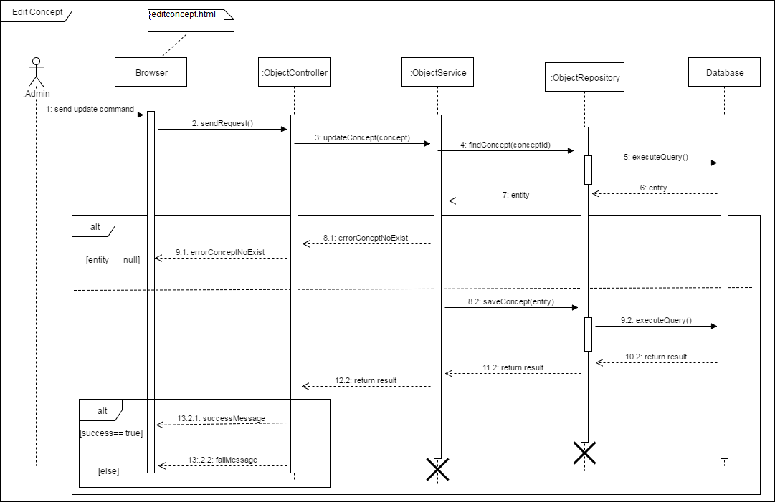

***Figure 34: Sequence Diagram - <Admin >Edit Concept***

##### <Admin> Get Log Object

Summary: This diagram show the process of Admin getting logs using the web application.



***Figure 35: Sequence Diagram - <Admin > Get Log Object***

##### <User> Get Log Person

Summary: This diagram show the process of User getting logs using web application.



***Figure 36: Sequence Diagram - <Admin > Get Log Person***

## Interface

### Component interface

#### Modula of Object API

|  |  |  |  |  |  |
| --- | --- | --- | --- | --- | --- |
| **Signature** | **Description** | **Input** | **Output** | **Output Format** | **Exception** |
| createConcept(String name, String description) | Create new Concept | * Name: name of the new concept. * Description: the display concept information | Newly created concept informaion displayed | Formated sring | Error Message displayed as formated string |
| addImage(Integer conceptId, MultipartFile fileImage) | Add image to Concept | * ConceptId: Id of concept * FileImage: list image | Json new list image | Formated sring | JsonProcessingException |
| removeImage(Integer conceptId, String pictureId) | Remove image from concept | * ConceptId: Id of concept * PictureId: Id of picture | Json information image removed | Formated sring | JsonProcessingException |
| detectObject(String imageUrl) | Get information of object in the picture | * ImageUrl: url of image | Json string | Formated sring | JsonProcessingException |
| ***Table 43: Object Api*** | | | | | |

#### Modula of Person API

|  |  |  |  |  |  |
| --- | --- | --- | --- | --- | --- |
| **Signature** | **Description** | **Input** | **Output** | **Output Format** | **Exception** |
| AddFaceToPerson (MultipartFile imageFile,String personId) | Add face into Person on MCS to training | * ImageFile: list image face * PersonId: id of person | Json String of faceid | Formated sring | JsonProcessingException |
| RemoveFaceFromPerson (String personId, String faceId) | Remove face from person on MCS | * PersonId: id of person * faceId: id of face | Json boolean of status | Formated sring | JsonProcessingException |
| ListFace( String personId) | List face of person | * PersonId: id of person | Json string of List FaceModel contains | Formated sring | sonProcessingException |
| CreatePersonGroup(String personGroupId, String groupName) | Create new person group | * PersonGroupId: id of person group * GroupName: name of person group | Json String of person group. | Formated sring | JsonProcessingException |
| GetPeopleInGroup (String personGroupId) | Get all person in specify group | * PersonGroupId: id of person group | Json list of person | Formated sring | JsonProcessingException |
| GetGroups() | Get all person group in system |  | Json list of person groups | Formated sring | JsonProcessingException |

***Table 44: Person Api***

#### Modula of View API

|  |  |  |  |  |  |
| --- | --- | --- | --- | --- | --- |
| **Signature** | **Description** | **Input** | **Output** | **Output Format** | **Exception** |
| GetDetailPicture (String imageUrl) | Describe the picture | * ImageUrl: url of image | Json String describe the picture | Formated sring | JsonProcessingException |
| ***Table 45: View Api*** | | | | | |

#### Modula of Data API

|  |  |  |  |  |  |
| --- | --- | --- | --- | --- | --- |
| **Signature** | **Description** | **Input** | **Output** | **Output Format** | **Exception** |
| CreateLogPerson(String useriId, String imageUrl) | Write log when can not detect person | * UserId: id of user * ImageUrl: url of person can not detect | Json String of log | Formated sring | JsonProcessingException |
| GetAllLogFromUser (String useriId) | Get all log from specify user | * UserId: id of user | Json String all log of user | Formated sring | JsonProcessingException |
| getAllLogObject() | Get all logs |  | Json list of logs | Formated sring | JsonProcessingException |
| CreateLogObject(String userId, String imageUrl) | Create Log Object when can not detect. | * UserId: id of user * ImageUrl: url of Image | Json string of log | Formated sring | JsonProcessingException |
| GetDescriptionConcept (int conceptId) | Get description of concept | * ConceptId: Id of concept | Json String description of concept | Formated sring | JsonProcessingException |
| GetNameConcept (int conceptId) | Get name of concept | * ConceptId: Id of concept | Json String name of concept | Formated sring | JsonProcessingException |
| ***Table 46: Data Api*** | | | | | |

### User Interface Design

#### Mobile Application Design

##### Unauthorized User

###### <Unauthorized User> Login

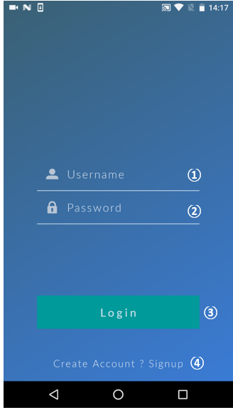

***Figure 37: Mobile Application UI - <Unauthorized User> Login***

**Fields:**

|  |  |  |  |  |  |  |  |
| --- | --- | --- | --- | --- | --- | --- | --- |
| **No** | **Field name** | **Description** | **Read only** | **Mandatory** | **Control type** | **Data type** | **Length** |
| 1 | Username | Fill in username | No | Yes | Textbox | String | N/A |
| 2 | Password | Fill in password | No | Yes | Password | String | N/A |
|  | | | | | |  |  |

**Buttons/Hyperlinks:**

|  |  |  |  |  |
| --- | --- | --- | --- | --- |
| **No** | **Function** | **Description** | **Validation** | **Outcome** |
| 3 | Login | Log-in to the system | Email and Password cannot be empty | Transfer to specific page with specific account |
| 4 | Create account? Sign up | Sign up a new account | N/A | Redirect user to Sign up page |

###### <Unauthorized User> Sign up

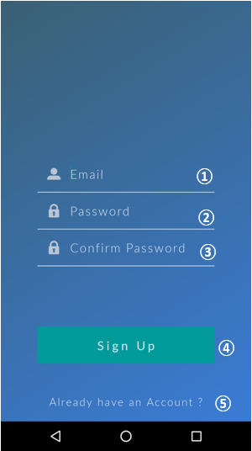

***Figure 38: Mobile Application UI - <Unauthorized User> Sign Up***

**Fields:**

|  |  |  |  |  |  |  |  |
| --- | --- | --- | --- | --- | --- | --- | --- |
| **No** | **Field name** | **Description** | **Read only** | **Mandatory** | **Control type** | **Data type** | **Length** |
| 1 | Username | Fill in username | No | Yes | Textbox | String | N/A |
| 2 | Password | Fill in password | No | Yes | Password | String | N/A |
| 3 | Confirm password | Fill in password again | No | Yes | Password | String | N/A |
|  | | | | | |  |  |

**Buttons/Hyperlinks:**

|  |  |  |  |  |
| --- | --- | --- | --- | --- |
| **No** | **Function** | **Description** | **Validation** | **Outcome** |
| 4 | Sign up | Create a new account in database | Email, Password and Confirm Password cannot be empty | Transfer to homepage for user |
| 5 | Already have an account? | User already has an account | N/A | Redirect user to Login page |

##### Authorized User

###### <Authorized User> Menu

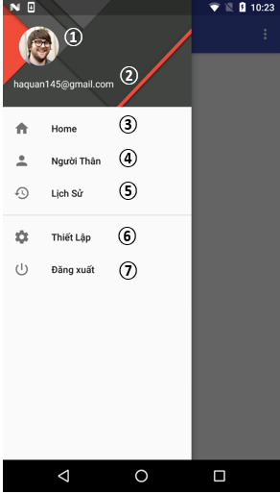

***Figure 39: Mobile Application UI - <Authorized User> Menu***

**Fields:**

|  |  |  |  |  |  |  |  |
| --- | --- | --- | --- | --- | --- | --- | --- |
| **No** | **Field name** | **Description** | **Read only** | **Mandatory** | **Control type** | **Data type** | **Length** |
| 1 | Avatar | User’s avatar | No | No |  | Image | N/A |
| 2 | Username | Username of current user | No | Yes | Label | String | N/A |
|  | | | | | |  |  |

**Buttons/Hyperlinks:**

|  |  |  |  |  |
| --- | --- | --- | --- | --- |
| **No** | **Function** | **Description** | **Validation** | **Outcome** |
| 3 | Home | Homepage of the application; | N/A | Transfer to Homepage |
| 4 | Người thân | Person list of current user | N/A | Transfer to Person list page |
| 5 | Lịch sử | List of unidentified person | N/A | Transfer to Log page |
| 6 | Thiết lập | The configuration page (Voice commands, …) | N/A | Transfer to Setup page |
| 8 | Đăng xuất | Logout user from the system | N/A | Transfer to Login page |

###### <Authorized User> View Person List



***Figure 40: Mobile Application UI - <Authorized User> View Person List***

**Fields:**

|  |  |  |  |  |  |  |  |
| --- | --- | --- | --- | --- | --- | --- | --- |
| **No** | **Field name** | **Description** | **Read only** | **Mandatory** | **Control type** | **Data type** | **Length** |
| 1 | Person’s Image | The avatar of the person | No | Yes |  | Image | N/A |
| 2 | Name | Name of the person | No | Yes | Label | String | N/A |
|  | | | | | |  |  |

**Buttons/Hyperlinks:**

|  |  |  |  |  |
| --- | --- | --- | --- | --- |
| **No** | **Function** | **Description** | **Validation** | **Outcome** |
| 3 | Menu | Menu trigger button | N/A | Show the menu bar |
| 4 |  |  | N/A |  |
| 5 | Add new person | Add a new person to the list | N/A | Transfer to new person page |

###### <Authorized User> Add New Person



***Figure 41: Mobile Application UI - <Authorized User> Add New Person***

**Fields:**

|  |  |  |  |  |  |  |  |
| --- | --- | --- | --- | --- | --- | --- | --- |
| **No** | **Field name** | **Description** | **Read only** | **Mandatory** | **Control type** | **Data type** | **Length** |
| 1 | Name | Fill in the person’s name | No | Yes | Textbox | String | N/A |
| 2 | Description | Fill in the person’s description | No | No | Textbox | String | N/A |
| 3 | Image preview | Show the preview of selected face images | No | Yes |  | Image | N/A |
| 4 | Notification | Show the status after clicking “Save” button | No | Yes | Label | String | N/A |
|  | | | | | |  |  |

**Buttons/Hyperlinks:**

|  |  |  |  |  |
| --- | --- | --- | --- | --- |
| **No** | **Function** | **Description** | **Validation** | **Outcome** |
| 5 | Add photos | Add face photos of person | N/A | Show the image browser for choosing |
| 6 | Save | Save person’s information | Person’s name cannot be blank | Create a new person with inputted information in the system |

###### <Authorized User> Select Person’s face image



***Figure 43: Mobile Application UI - <Authorized User> Select Person Face Image***

**Fields:**

|  |  |  |  |  |  |  |  |
| --- | --- | --- | --- | --- | --- | --- | --- |
| **No** | **Field name** | **Description** | **Read only** | **Mandatory** | **Control type** | **Data type** | **Length** |
| 1 | Image | Image for choosing | No | Yes |  | Image | N/A |
|  | | | | | |  |  |

**Buttons/Hyperlinks:**

|  |  |  |  |  |
| --- | --- | --- | --- | --- |
| **No** | **Function** | **Description** | **Validation** | **Outcome** |
| 2 | Back | Return to the previous step | N/A | Return to the New Person page |
| 3 | Done | Confirm image selection | N/A | Return to the New Person pager with selected images |

###### <Authorized User> Crop Image



***Figure 44: Mobile Application UI - <Authorized User> Crop Image***

**Fields:**

|  |  |  |  |  |  |  |  |
| --- | --- | --- | --- | --- | --- | --- | --- |
| **No** | **Field name** | **Description** | **Read only** | **Mandatory** | **Control type** | **Data type** | **Length** |
| 1 | Crop zone | Selected zone for cropping | No | Yes |  | Image | N/A |
|  | | | | | |  |  |

**Buttons/Hyperlinks:**

|  |  |  |  |  |
| --- | --- | --- | --- | --- |
| **No** | **Function** | **Description** | **Validation** | **Outcome** |
| 2 | Rotate | Rotate the image | N/A |  |
| 3 | Crop | Confirm the selected zone for cropping | N/A | Return to the New Person pager with cropped image |

###### <Authorized User> Update Person’s Information



***Figure 45: Mobile Application UI - <Authorized User> Update Person Information***

**Fields:**

|  |  |  |  |  |  |  |  |
| --- | --- | --- | --- | --- | --- | --- | --- |
| **No** | **Field name** | **Description** | **Read only** | **Mandatory** | **Control type** | **Data type** | **Length** |
| 1 | Name | Fill in the person’s name | No | Yes | Textbox | String | N/A |
| 2 | Description | Fill in the person’s description | No | No | Textbox | String | N/A |
| 3 | Image preview | Show the preview of selected face images | No | Yes |  | Image | N/A |
|  | | | | | |  |  |

**Buttons/Hyperlinks:**

|  |  |  |  |  |
| --- | --- | --- | --- | --- |
| **No** | **Function** | **Description** | **Validation** | **Outcome** |
| 4 | Add photos | Add face photos of person | N/A | Show the image browser for choosing |
| 5 | Update | Save person’s information | Person’s name cannot be blank | Update person with inputted information in the system |

###### <Authorized User> Detect Person



***Figure 46: Mobile Application UI - <Authorized User> Detect Person***

**Fields:**

|  |  |  |  |  |  |  |  |
| --- | --- | --- | --- | --- | --- | --- | --- |
| **No** | **Field name** | **Description** | **Read only** | **Mandatory** | **Control type** | **Data type** | **Length** |
| 1 | Image | Show the captured image | No | Yes |  | Image | N/A |
| 2 | Name | Name of the person in the image | No | Yes | Label | String | N/A |
|  | | | | | |  |  |

**Buttons/Hyperlinks:**

|  |  |  |  |  |
| --- | --- | --- | --- | --- |
| **No** | **Function** | **Description** | **Validation** | **Outcome** |
| 3 | Voice control | Get the voice command | N/A | Transfer to the specific page follows the inputted command |

###### <Authorized User> Detect Objects



***Figure 47: Mobile Application UI - <Authorized User> Detect Object***

**Fields:**

|  |  |  |  |  |  |  |  |
| --- | --- | --- | --- | --- | --- | --- | --- |
| **No** | **Field name** | **Description** | **Read only** | **Mandatory** | **Control type** | **Data type** | **Length** |
| 1 | Image | Show the captured image | No | Yes |  | Image | N/A |
| 2 | Name | Show the name of the object in image | No | Yes | Label | String | N/A |
|  | | | | | |  |  |

**Buttons/Hyperlinks:**

|  |  |  |  |  |
| --- | --- | --- | --- | --- |
| **No** | **Function** | **Description** | **Validation** | **Outcome** |
| 3 | Voice control | Get the voice command | N/A | Transfer to the specific page follows the inputted command |

###### <Authorized User> Detect View



***Figure 48: Mobile Application UI - <Authorized User> Detect View***

**Fields:**

|  |  |  |  |  |  |  |  |
| --- | --- | --- | --- | --- | --- | --- | --- |
| **No** | **Field name** | **Description** | **Read only** | **Mandatory** | **Control type** | **Data type** | **Length** |
| 1 | Image | Show the captured image | No | Yes |  | Image | N/A |
| 2 | Description | The information about the view in the image | No | Yes | Label | String | N/A |
|  | | | | | |  |  |

**Buttons/Hyperlinks:**

|  |  |  |  |  |
| --- | --- | --- | --- | --- |
| **No** | **Function** | **Description** | **Validation** | **Outcome** |
| 3 | Voice control | Get the voice command | N/A | Transfer to the specific page follows the inputted command |

###### <Authorized User> View log



***Figure 49: Mobile Application UI - <Authorized User> View Logs***

**Fields:**

|  |  |  |  |  |  |  |  |
| --- | --- | --- | --- | --- | --- | --- | --- |
| **No** | **Field name** | **Description** | **Read only** | **Mandatory** | **Control type** | **Data type** | **Length** |
| 1 | Image | Show the log image | No | Yes |  | Image | N/A |
| 2 | Name | Name of the person in the image | No | Yes | Label | String | N/A |
| 3 | Date | Created date of the log | No | Yes | Label | Date time |  |

###### <Authorized User> View voice command setting

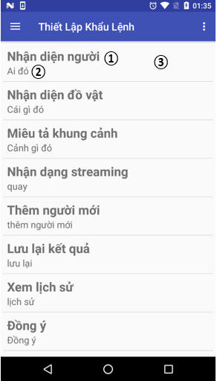

***Figure 50: Mobile Application UI - <Authorized User> Voice Commands Setting***

**Fields:**

|  |  |  |  |  |  |  |  |
| --- | --- | --- | --- | --- | --- | --- | --- |
| **No** | **Field name** | **Description** | **Read only** | **Mandatory** | **Control type** | **Data type** | **Length** |
| 1 | Command name | The name of the command | No | Yes | Label | String | N/A |
| 2 | Command | The command string to activate the specific function | No | Yes | Label | String | N/A |

**Buttons/Hyperlinks:**

|  |  |  |  |  |
| --- | --- | --- | --- | --- |
| **No** | **Function** | **Description** | **Validation** | **Outcome** |
| 3 | Modify command | Change the command string | N/A | Display the textbox to get the command input |

#### Web Application Design

##### Unauthorized User

###### <Unauthorized User> Register



***Figure 51: Web Application Interface - <Unauthorized> Register***

**Fields:**

|  |  |  |  |  |  |  |  |
| --- | --- | --- | --- | --- | --- | --- | --- |
| **No** | **Field Name** | **Description** | **Read Only** | **Mandatory** | **Control Type** | **Data Type** | **Length** |
| **1** | Email | Fill in email | No | Yes | Textbox | String | N/A |
| **2** | Mật khẩu | Fill in password | No | Yes | Password | String | N/A |
| **3** | Xác nhận | Fill in confirmation password | No | Yes | Password | String | N/A |

***Table 47: Web Application Interface – Register - Fields***

**Buttons/Hyperlinks:**

|  |  |  |  |  |
| --- | --- | --- | --- | --- |
| **No** | **Function** | **Description** | **Validation** | **Outcome** |
| **4** | Đăng ký | Sign up a new account |  | Redirect to home page for user |
| **5** | Đã có tài khoản? Đăng nhập | Go back to login page | N/A | Redirect to login page |

***Table 48: Web Application Interface – Register – Buttons/Hyperlinks:***

###### <Unauthorized User> Login



***Figure 52: Web Application Interface - <Unauthorized> Login***

**Fields:**

|  |  |  |  |  |  |  |  |
| --- | --- | --- | --- | --- | --- | --- | --- |
| **No** | **Field Name** | **Description** | **Read Only** | **Mandatory** | **Control Type** | **Data Type** | **Length** |
| **1** | Email | Fill in email | No | Yes | Textbox | String | N/A |
| **2** | Mật khẩu | Fill in password | No | Yes | Password | String | N/A |
| **3** | Remember me | Check for saving account | No | No | Checkbox |  | N/A |

***Table 49: Web Application Interface – Login - Fields***

**Buttons/Hyperlinks:**

|  |  |  |  |  |
| --- | --- | --- | --- | --- |
| **No** | **Function** | **Description** | **Validation** | **Outcome** |
| **4** | Đăng nhập | Login to system | N/A | Redirect to home page |
| **5** | Đăng ký tài khoản mới | Sign up a new account | N/A | Redirect to signup page |

***Table 50: Web Application Interface – Login – Buttons/Hyperlinks***

##### Authorized User

###### <Authorized User> Logout



***Figure 53: Web Application Interface - <Authorized> Logout***

**Fields:**

|  |  |  |  |  |  |  |  |
| --- | --- | --- | --- | --- | --- | --- | --- |
| **No** | **Field Name** | **Description** | **Read Only** | **Mandatory** | **Control Type** | **Data Type** | **Length** |
| **1** | User | User account | No | Yes | Label | String | N/A |

***Table 51: Web Application Interface – Logout - Fields***

**Buttons/Hyperlinks:**

|  |  |  |  |  |
| --- | --- | --- | --- | --- |
| **No** | **Function** | **Description** | **Validation** | **Outcome** |
| **2** | Đăng xuất | Send logout command | N/A | Destroy session and redirect to login page |

***Table 52: Web Application Interface – Logout - Buttons/Hyperlinks***

###### <Authorized User> View Persons



***Figure 54: Web Application Interface - <Authorized> View Persons***

**Buttons/Hyperlinks:**

|  |  |  |  |  |
| --- | --- | --- | --- | --- |
| **No** | **Function** | **Description** | **Validation** | **Outcome** |
| **1** | getPersons | Get all persons of user | N/A | Show list of all persons |
| **2** | showLogs | Get all logs (unidentified persons) of user | N/A | Show list of all logs |
| **3** | openContextMenu | Open context menu | N/A | Context menu is opened |
| **4** | addNewPerson | Add new person to system | N/A | Redirect to new person view |
| **5** | updatePerson | Modify information and photos of person | N/A | Redirect to person’s info view |
| **6** | deletePerson | Delete a person | N/A | Person is deleted out of the system |
| **7** | btnPrevious | Go back to previous person page | N/A | Show previous page |
| **8** | btnNext | Go to next person page | N/A | Show next page |

***Table 53: Web Application Interface –View Persons - Buttons/Hyperlinks***

**Fields:**

|  |  |  |  |  |  |  |  |
| --- | --- | --- | --- | --- | --- | --- | --- |
| **No** | **Field Name** | **Description** | **Read Only** | **Mandatory** | **Control Type** | **Data Type** | **Length** |
| **9** | Thứ tự | The position number | N/A | Yes | Label | String | N/A |
| **10** | Ảnh đại diện | The avatar of person | N/A | Yes |  | Image | N/A |
| **11** | Tên | The name of person | N/A | Yes | Label | String | N/A |
| **12** | Thông tin | The description of person | N/A | No | Label | String | N/A |
| **13** | Tìm kiếm |  |  |  |  |  |  |

***Table 54: Web Application Interface – View Persons - Fields***

###### <Authorized User> Add New Person



***Figure 55: Web Application Interface - <Authorized> Add New Person***

**Fields:**

|  |  |  |  |  |  |  |  |
| --- | --- | --- | --- | --- | --- | --- | --- |
| **No** | **Field Name** | **Description** | **Read Only** | **Mandatory** | **Control Type** | **Data Type** | **Length** |
| **1** | Tên | Fill in person’s name | No | Yes | Textbox | String | N/A |
| **2** | Thông tin | Fill in person’s information | No | No | Textbox | String | N/A |

***Table 55: Web Application Interface – Add New Person - Fields***

**Buttons/Hyperlinks:**

|  |  |  |  |  |
| --- | --- | --- | --- | --- |
| **No** | **Function** | **Description** | **Validation** | **Outcome** |
| **3** | addImage | Add new images to current person | N/A | Selected images preview is displayed |
| **4** | addPerson | A new person with selected image will be added to system | N/A | Redirect to Index page |

***Table 56: Web Application Interface – Add New Person - Buttons/Hyperlinks***

###### <Authorized User> Update Person



***Figure 56: Web Application Interface - <Authorized> Update Person***

**Fields:**

|  |  |  |  |  |  |  |  |
| --- | --- | --- | --- | --- | --- | --- | --- |
| **No** | **Field Name** | **Description** | **Read Only** | **Mandatory** | **Control Type** | **Data Type** | **Length** |
| **1** | Tên | Fill in person’s name | No | Yes | Textbox | String | N/A |
| **2** | Thông tin | Fill in person’s information | No | No | Textbox | String | N/A |

***Table 57: Web Application Interface – Update Person - Fields***

**Buttons/Hyperlinks:**

|  |  |  |  |  |
| --- | --- | --- | --- | --- |
| **No** | **Function** | **Description** | **Validation** | **Outcome** |
| **3** | updateFace | Show selected image information that can be replaced or deleted | N/A | A dialog contain selected image is displayed |
| **4** | addNewFace | Add new face image to current person | N/A | A file choosing dialog is displayed; selected face images will be added |
| **5** | updatePersonInfo | Inputted person’s information will be updated to current person | “Tên” cannot be blank | Update current person’s info and redirect to Index page |
| **6** | Quay lại | Go back to the previous page | N/A | Redirect to Index page |

***Table 58: Web Application Interface – Update Person - Buttons/Hyperlinks***

###### <Authorized User> Update Person’s Face



***Figure 57: Web Application Interface - <Authorized> Update Person’s Face***

**Fields:**

|  |  |  |  |  |  |  |  |
| --- | --- | --- | --- | --- | --- | --- | --- |
| **No** | **Field Name** | **Description** | **Read Only** | **Mandatory** | **Control Type** | **Data Type** | **Length** |
| **1** | Hình ảnh | Person’s face image | Yes | Yes |  | Image | N/A |

***Table 59: Web Application Interface – Update Person’s Face - Fields***

**Buttons/Hyperlinks:**

|  |  |  |  |  |
| --- | --- | --- | --- | --- |
| **No** | **Function** | **Description** | **Validation** | **Outcome** |
| **2** | deleteFace | Delete selected face image | N/A | Selected image is deleted and redirect to update person view |
| **3** | updateFace | Replace the current image by the selected face image | N/A | A new face image is updated and redirect to update person view |

***Table 60: Web Application Interface – Update Person’s Face - Buttons/Hyperlinks***

###### <Authorized User> Show Logs Person



***Figure 58: Web Application Interface - <Authorized> Show Logs Person***

**Fields:**

|  |  |  |  |  |  |  |  |
| --- | --- | --- | --- | --- | --- | --- | --- |
| **No** | **Field Name** | **Description** | **Read Only** | **Mandatory** | **Control Type** | **Data Type** | **Length** |
| **1** | Hình ảnh | Log image | No | Yes |  | Image | N/A |
| **2** | Tên | Name of the person in log | No | Yes | Label | String | N/A |
| **3** | Ngày tạo | The created date of log | No | Yes | Label | DateTime | N/A |

***Table 61: Web Application Interface – Show Logs From Person - Fields***

**Buttons/Hyperlinks:**

|  |  |  |  |  |
| --- | --- | --- | --- | --- |
| **No** | **Function** | **Description** | **Validation** | **Outcome** |
| **4** | addFaceFromLog | Add face from log to person | N/A | The dialog with selected log image is displayed for adding |
| **5** | deleteLog | Delete the current log | N/A | The log is deleted and redirect to the Log view |

***Table 62: Web Application Interface – Show Logs From Person - Buttons/Hyperlinks***

###### <Authorized User> Create/Update From Log Person



***Figure 59: Web Application Interface - <Authorized> Create/Update From Log Person***

**Fields:**

|  |  |  |  |  |  |  |  |
| --- | --- | --- | --- | --- | --- | --- | --- |
| **No** | **Field Name** | **Description** | **Read Only** | **Mandatory** | **Control Type** | **Data Type** | **Length** |
| **1** | Hình ảnh | Log image | No | Yes |  | Image | N/A |
| **2** | Tên | Choose an existed person from list | No | Yes | Dropdown | String | N/A |

***Table 63: Web Application Interface – Create/Update From Log Person - Fields***

**Buttons/Hyperlinks:**

|  |  |  |  |  |
| --- | --- | --- | --- | --- |
| **No** | **Function** | **Description** | **Validation** | **Outcome** |
| **3** | updateFromLog | Update the current face image to selected person from the list | N/A | Log face image is updated to selected person; current log is deleted and redirect to the Show Logs view |
| **4** | createNewFromLog | The current face image is added to new person with saved information | N/A | Redirect to Add New Person view with saved information |

***Table 64: Web Application Interface – Create/Update From Log Person - Buttons/Hyperlinks***

##### Admin

###### <Admin> Manage User



***Figure 60: Web Application Interface - < Admin > Manager User***

**Fields:**

|  |  |  |  |  |  |  |  |
| --- | --- | --- | --- | --- | --- | --- | --- |
| **No** | **Field name** | **Description** | **Read only** | **Mandatory** | **Control type** | **Data type** | **Length** |
| 1 | Danh sách tài khoản | Show list user | Yes | Yes | Label | String | N/A |
| 2 | ID | ID of user | Yes | Yes | Table | String | N/A |
| 3 | Tài Khoản | Username of user | Yes | Yes | Table | String | N/A |
| 4 | Email | Email of user to log in into system | Yes | Yes | Table | String | N/A |
| 5 | Số điện thoại | Phone number of user | Yes | Yes | Table | String | N/A |
| 6 | Status | Status of user to know user is active or deactive | Yes | Yes | Checkbox | bit | N/A |
| ***Table 65: Web Application Interface – Manage User - Fields*** | | | | | |  |  |

**Buttons/Hyperlinks:**

|  |  |  |  |  |
| --- | --- | --- | --- | --- |
| **No** | **Function** | **Description** | **Validation** | **Outcome** |
| 7 | Account | Information of account | N/A | Show information of account. |
| 8 | Search | Search data in table | N/A | Show data that are search |
| 9 | Show entries | Show the number of entries in table | N/A | Show the number of entries that are selected |
| 10 | getUser | Get to list all user view | N/A | Redirect to list of all user view |
| 11 | getAlslconcept | Get to list all object view | N/A | Redirect to list of all object view |
| 12 | getLog | Get to list all user view | N/A | Redirect to User view |
| 13 | Previous | Go to previous page | N/A | Go to previous page contain list data |
| 14 | Next | Go to next page | N/A | Go to next page contain list data |

***Table 66: Web Application Interface – Manage User - Buttons/Hyperlinks***

###### <Admin> View Concepts



***Figure 61: Web Application Interface - < Admin > View Concepts***

**Fields:**

|  |  |  |  |  |  |  |  |
| --- | --- | --- | --- | --- | --- | --- | --- |
| **No** | **Field name** | **Description** | **Read only** | **Mandatory** | **Control type** | **Data type** | **Length** |
| 1 | Danh sách đồ vật | Show list object | Yes | Yes | Label | String | N/A |
| 2 | No. | No. of object in table | Yes | Yes | Table | int | N/A |
| 3 | Image | Avatar of object | Yes | Yes | Table | Image | N/A |
| 4 | Tên | Name of object | Yes | Yes | Table | String | N/A |
| 5 | Chú thích | Description of object | Yes | Yes | Table | String | N/A |
| ***Table 67: Web Application Interface – View Concepts - Fields*** | | | | | |  |  |

**Buttons/Hyperlinks:**

|  |  |  |  |  |
| --- | --- | --- | --- | --- |
| **No** | **Function** | **Description** | **Validation** | **Outcome** |
| 6 | Search | Search data in table | N/A | Show data that are search |
| 7 | Show entries | Show the number of entries in table | N/A | Show the number of entries that are selected |
| 8 | createNewConcept | Create new object into system. | N/A | Redirect admin to create new object page. |
| 9 | testConcept | Test object have exist in the system. | N/A | Redirect admin to test object page. |
| 10 | editConcept | Update information of object in the system. | N/A | Redirect admin to update object page. |
| 11 | deleteConcept | Remove object in the system. | N/A | Remove object that is selected out of system. |

***Table 68: Web Application Interface – View Concepts – Buttons/Hyperlinks***

###### <Admin> Create Concept



***Figure 62: Web Application Interface - <Admin> Create Concept***

**Fields:**

|  |  |  |  |  |  |  |  |
| --- | --- | --- | --- | --- | --- | --- | --- |
| **No** | **Field name** | **Description** | **Read only** | **Mandatory** | **Control type** | **Data type** | **Length** |
| 1 | Tạo mới đồ vật | Create new object view | Yes | Yes | Label | String | N/A |
| 2 | Tên đồ vật | Fill in name object | No | Yes | Textbox | String | N/A |
| 3 | Mô tả đồ vật | Fill in description object | No | No | Textarea | String | N/A |
| 4 | Hình ảnh | Fill in file image | No | Yes | Img | Image | N/A |

***Table 69: Web Application Interface – Create Concepts - Fields***

**Buttons/Hyperlinks:**

|  |  |  |  |  |
| --- | --- | --- | --- | --- |
| **No** | **Function** | **Description** | **Validation** | **Outcome** |
| 5 | AddImage | Upload image | N/A | Show images that are selected |
| 6 | createConcept | Create new object | Tên đồ vật and Hình ảnh cannot be empty | Object is created into system. |
| 7 | viewAllConcept | Go back another page | N/A | Redirect view all object page. |

***Table 70: Web Application Interface – Create Concepts – Buttons/Hyperlinks***

###### <Admin> Update Concept



***Figure 63: Web Application Interface - <Admin> Update Concept***

**Fields:**

|  |  |  |  |  |  |  |  |
| --- | --- | --- | --- | --- | --- | --- | --- |
| **No** | **Field name** | **Description** | **Read only** | **Mandatory** | **Control type** | **Data type** | **Length** |
| 1 | Cập Nhật Đồ Vật | Update object view | Yes | Yes | Label | String | N/A |
| 2 | Tên đồ vật | Fill in name object | No | Yes | Textbox | String | N/A |
| 3 | Mô tả đồ vật | Fill in description object | No | No | Textarea | String | N/A |
| 4 | Thêm Hình | Fill in file image | No | Yes | Img | Image | N/A |

***Table 71: Web Application Interface – Update Concepts - Fields***

**Buttons/Hyperlinks:**

|  |  |  |  |  |
| --- | --- | --- | --- | --- |
| **No** | **Function** | **Description** | **Validation** | **Outcome** |
| 5 | AddImage | Upload image | N/A | Show images that are selected |
| 6 | selectImage | Selected image in system | N/A | The image will be selected. |
| 7 | DeleteImageBySelect | Remove images that are selected | Image must be selected | Images that are selected will remove out of system. |
| 8 | updateConcept | Update object exist in the system | Tên đồ vật cannot be empty | Object is update into system. |
| 9 | viewAllConcept | Go back another page | N/A | Redirect view all object page. |

***Table 72: Web Application Interface – Update Concepts – Buttons/Hyperlinks***

###### <Admin> View Logs



***Figure 64: Web Application Interface - <Admin> View Logs***

**Fields:**

|  |  |  |  |  |  |  |  |
| --- | --- | --- | --- | --- | --- | --- | --- |
| **No** | **Field name** | **Description** | **Read only** | **Mandatory** | **Control type** | **Data type** | **Length** |
| 1 | Danh Sách Vật Thể Chưa Nhận Diện Được | Show all log view | Yes | Yes | Label | String | N/A |
| 2 | No. | No. of log in table | Yes | Yes | Table | int | N/A |
| 3 | Image | Avatar of log | Yes | Yes | Table | Image | N/A |
| 4 | Ngày tạo | Create Date of log | Yes | Yes | Table | String | N/A |

***Table 73: Web Application Interface – View Logs - Fields***

**Buttons/Hyperlinks:**

|  |  |  |  |  |
| --- | --- | --- | --- | --- |
| **No** | **Function** | **Description** | **Validation** | **Outcome** |
| 5 | Search | Search data in table | N/A | Show data that are search |
| 6 | Show entries | Show the number of entries in table | N/A | Show the number of entries that are selected |
| 7 | Cập nhật log | Update information of object from log. | N/A | Show updates log view. |
| 8 | DeleteLog | Remove log in the system. | N/A | Remove log that is selected out of system. |

***Table 74: Web Application Interface – View Logs – Buttons/Hyperlinks***

###### <Admin> Update Concept From Log Object



***Figure 65: Web Application Interface - <Admin> Create/Update Concept From Log Object***

**Fields:**

|  |  |  |  |  |  |  |  |
| --- | --- | --- | --- | --- | --- | --- | --- |
| **No** | **Field name** | **Description** | **Read only** | **Mandatory** | **Control type** | **Data type** | **Length** |
| 1 | Thêm hình ảnh | Update image to concept view | Yes | Yes | Label | String | N/A |
| 2 | Image | Avatar of log | Yes | Yes | Table | Image | N/A |
| 3 | Tên đồ vật | Fill in name object | No | Yes | Dropdown | String | N/A |

***Table 75: Web Application Interface – Update Concept From Log Object - Fields***

**Buttons/Hyperlinks:**

|  |  |  |  |  |
| --- | --- | --- | --- | --- |
| **No** | **Function** | **Description** | **Validation** | **Outcome** |
| 4 | UpdateImagetoConcept | Update information of object from log. | Tên đồ vật cannot be empty | Object that is selected from log will be updated into system |
| 5 | CreateConcept | Create new object from log. | N/A | Redirect to create new object from log page. |

***Table 76: Web Application Interface – Update Concept From Log Object – Buttons/Hyperlinks***

###### <Admin> Create New Concept From Log Object

*****Figure 66: Web Application Interface - <Admin> Create New Concept From Log Object***

**Fields:**

|  |  |  |  |  |  |  |  |
| --- | --- | --- | --- | --- | --- | --- | --- |
| **No** | **Field name** | **Description** | **Read only** | **Mandatory** | **Control type** | **Data type** | **Length** |
| 1 | Tạo mới đồ vật | Create concept with image from log view | Yes | Yes | Label | String | N/A |
| 2 | Tên đồ vật | Fill in name object | No | Yes | Textbox | String | N/A |
| 3 | Mô tả đồ vật | Fill in description object | No | No | Textarea | String | N/A |
| 4 | Image | Avatar of log | Yes | Yes | Table | Image | N/A |

***Table 77: Web Application Interface – Create Concept From Log Object - Fields***

**Buttons/Hyperlinks:**

|  |  |  |  |  |
| --- | --- | --- | --- | --- |
| **No** | **Function** | **Description** | **Validation** | **Outcome** |
| 5 | AddConcept | Create new object | Tên đồ vật cannot be empty | Object is created into system. |
| 6 | viewAllLog | Go back another page | N/A | Redirect view all log page. |

***Table 78: Web Application Interface – Create Concept From Log Object – Buttons/Hyperlinks***

## Database Design

### Entity relationship diagram (ERD)



***Figure 67: <Admin > Entity relationship diagram (ERD)***

### Data Dictionary

|  |  |
| --- | --- |
| **Entity Data Dictionary: describe contents of all entities** | |
| **Entity Name** | **Description** |
| Account | Contains all user in the system |
| Role | Contains all role in the system |
| Friend Group | Contains all friend group in the system |
| Friend | Contains all friend of users in the system |
| Face | Contains all face of users in the system |
| Concept | Contains all concept in the system |
| Picture | Contain all picture of object in the system |

## Algorithms

### Person Group For Each User

#### Definition

* This document will explain why each user will have only one unique Person Group but not many Person Group.

#### Define Problem

* Microsoft Cognitive Service provides the **Person Group** terms. This is one of the most important parameter in the Identifying process. Each Person Group can has up to 1000 person.
* If device many person into smaller group, the identifying process can be faster.
* But because the user is blind, so if all the user’s person is divided into smaller groups, the Identifying process will have to look in all of the Person Group until the person is found.

#### Solution

* We spent time testing the detecting process’s speed, relative to the amount of Person in a Person Group, with different type of Internet Connection. The result is presented as bellow:

|  |  |  |
| --- | --- | --- |
| **Amount of Person** | **Speed – Using 3G Internet connection 10 Mbps** | **Speed – Using Fiber Optic Internet connection 36 Mbps** |
| 2 | 1,6 seconds | 0,73 second |
| 50 | 1,7 seconds | 0,79 second |
| 300 | 2 seconds | 1,1-1,6 second |

* The result shows little differences between Person Group with 2 people and Person Group with 300 people. From that, we decided that each user will only have one unique Person Group.

#### References

* <https://www.microsoft.com/cognitive-services/en-us/face-api/documentation/overview>
* <https://westus.dev.cognitive.microsoft.com/docs/services/563879b61984550e40cbbe8d/operations/563879b61984550f30395239>

### Voice Recognition Algorithms

#### Definition

* This algorithms is used to recognize user voice command when interact with the application.

#### Define Problem

* The main user of the application is blind person, so the application need to provide a way that users can use to communicate with the application.

#### Solution

* The Voice Recognition process can be broken down into followed steps:
  + Step1: User input voice data
  + Step2: Analog-to-Digital converter transfer analog wave into digital data that computer can understand. The process contains followed smaller steps:
    - Digitizes the input sound by taking precise measurement of the wave at the frequent intervals.
    - Filter out unwanted sounds.
    - Adjust the input voice to a constant volume level.
    - Adjust the input voice’s speed to match the samples stored in system memories.
  + Step3: Using language models and statistical analysis to reduce mistakes, analyze language pattern and speed up the process.
  + Step4: Artificial neural networks is used to recognize the words in the inputted voice after exhaustive training.
* Android Operating System provide a Voice Recognition Module that can analyze user input voice and transfer them into text.
* Using the return text, the application can determines which function the user want to trigger.
* Since the Voice Recognition Module of Android Operating System has similar procedure and pattern, we decided to use this module to help user communicate with application.

#### Complexity

* Since the complexity of the algorithms is not described or mentioned in the provider documents, we spent times testing and measuring the speed of the Voice Recognition process.
* The result is presented as bellow:

|  |  |  |
| --- | --- | --- |
| **Network**  **Type**  **Input**  **Voice** | **3G Network** (Ping 24ms, Download: 15.31 Mbps, Upload: 1.36 Mbps) | Wi-Fi Network (Ping: 3ms, Download: 30.55Mbps, Upload: 22.17 Mbps) |
| “Nhận diện hình ảnh” | 0.512 | 0.312 |
| “Thêm người mới” | 0.482 | 0.315 |
| “Cái gì đây” | 0.465 | 0.3 |

#### Flow Chart



#### References

* <http://www.explainthatstuff.com/voicerecognition.html>
* <https://www.youtube.com/watch?v=5Gn0soUYmLM>
* <https://developer.android.com/reference/android/speech/SpeechRecognizer.html>

### Image Recognition Algorithms

#### Definition

* This algorithms allow the system to analyze images to identify object and recognize human faces and their features.

#### Define Problems

* The application provides two main features:
  + Facial Recognition
  + Object Recognition
* In order to fulfil its features, the system must use an algorithms to analyze the provided image from user, to filter out human facial details or object details.

#### Solution

* Image Recognition process can be broken down into followed steps:
  + Step 1: turn inputted image into back and white image.
  + Step 2: divide inputted image into multiple overlapping parts
  + Step 3: Using small neural networks to process each of the divided parts of the image and return output as digital numbers.
  + Step 4: Down sampling process using Max-pooling algorithms to filter most important parts of the output in step 3.
  + Step 5: Making final guess using Fully-Connected Neural Network and return prediction.
* After examine the basic concept image recognition, we decided to use **Microsoft Cognitive Service** and **Clarifai** to be our Image Recognizer Service, because of followed reasons:
  + Both required inputted data as image to return predictions.
  + Both required training process to be able to make predictions.
  + Microsoft Cognitive Service provides a friendly and fully developed Face Recognition API, which can be used to store, train and identify human faces with high accuracy and good performance (refer to **4.7.4 Detect Person Algorithms**).
  + Clarifai provides a training service for training and recognize objects, with high accuracy depend on the amount of training data.

#### Complexity

* The complexity of the algorithms might varies depend on the size of inputted data or amount of Convolution layers.
* Refers to **4.7.4 Detect Person Algorithms** and **4.7.8 Detect Object Algorithms** for more information.

#### References

* <https://medium.com/@ageitgey/machine-learning-is-fun-part-3-deep-learning-and-convolutional-neural-networks-f40359318721>
* <https://www.cs.nyu.edu/~fergus/papers/zeilerECCV2014.pdf>

### Detect Person Algorithms

#### Definition

* This algorithms is used to identify person that matched the captured picture from user.

#### Define Problem

* The user need to use the application to identify unknown person. The user can command the application to capture a picture of the person, after the identification process, the person’s information will be returned.
* If the person is failed to be identified, the application will return the gender of the person, and ask if user want to add this person into contact.

#### Solution

The Identifying process content these followed steps:

* Step 1: User open Detect Person mode by voice command.
* Step 2: User capture picture of the person.
* Step 3: System stores captured picture and send image url to Image Recognizer to detect human face(s) as Face IDs and their Gender (Male or Female). If no human faces is detected in the image, the system will return response message to user by voice.
* Step 4: System receives Face IDs and send them to Image Recognizer with the Person Group ID of the user to identify the person.
* Step 5: If Image Recognizer is unable to identify the person (no candidates returned or confident rate is <= 65%), the application will describe the person Gender back to the user by voice.
* Step 6: Otherwise the application will describe the person information back to the user by voice.

#### Complexity

* For the complexity of this algorithms is depend on the Image Recognition Service, which is not described in their documents. Therefore we spent times testing the performance of the Identifying Process:

|  |  |
| --- | --- |
| **Network Type** | **Speed**  **(Voice Recognition + Image Recognition)** |
| Wi-Fi Network (Ping: 3ms, Download: 30.55Mbps, Upload: 22.17 Mbps) | 1,699 ms |
| **3G Network** (Ping 24ms, Download: 15.31 Mbps, Upload: 1.36 Mbps) | 2,372 ms |

#### Flow Chart



### Training Person Algorithms

#### Definition

* The training algorithms allow the system to learn and identify a person face by their images provided by the user.

Training process has two meaning:

* Train the system to identify a completely new Person
* Train an existed Person to increase the system’s accuracy.

#### Define Problem

* User use the application to identify Person by their image, so we need a algorithms to train the system to recognize the Person and improve the detecting accuracy.

#### Image Recognizer Concepts

* Person Group: Each person will belong to a Person Group. A Person Group can has up to 1000 person. Each User will have 1 Person Group.
* Person Face: The face of the Person. Each Person can have up to 248 faces.
* Person ID: Each person when created will have a unique Person ID. After the Identifying process, Image Recognizer will return the candidates as their Person ID.
* Face ID: When the image recognizer detects a human face in the image, it will return the Face ID of the detected human face, along with face attributes(age, gender…). Each Face ID will exist within 24 hours.
* Persisted Face ID: When the adding a new face to a person, the Image Recognizer will return a Persisted Face ID of that person face, which will not be expired.

#### Solution

The training person process includes these steps:

* Step 1: User creates a new Person with basic information: Name, Description.
* Step 2: User input images of the person to Image Recognizer. Frontal and near-frontal face will give best result. Each image shall contains one face only. User can resize or crop the person face where they see fit.
* Step 3: Image Recognizer detect the human face in the uploaded images, add the face from image into the person, then return a Persisted Face Id of the person face.
* Step 4: Image Recognizer trains the Person Group that contains the Person.
* Step 5: After successfully trained, #the system can now identify the person.

#### Complexity

For the complexity of this algorithms is depend on the Image Recognition Service, which is not described in their documents. Therefore we spent times testing the performance of the Training Process:

|  |  |  |
| --- | --- | --- |
| **Images Amount** | **Wi-Fi Network** (Ping: 3ms, Download: 30.55Mbps, Upload: 22.17 Mbps) | **3G Network** (Ping 24ms, Download: 15.31 Mbps, Upload: 1.36 Mbps) |
| 2 | 8,951 ms | 6,893 ms |
| 3 | 5,643 ms | 7,072 ms |
| 4 | 7,134 ms | 8,382 ms |
| 5 | 11,325 ms | 9,438 ms |

#### Accuracy

The accuracy of the algorithms is tested and the result is presented as bellow:

|  |  |
| --- | --- |
| **Image Amount** | **Confident Percentage** |
| 1 | 0.76543 |
| 2 | 0.776 |
| 3 | 0.80058 |
| 4 | 0.80287 |
| 5 | 0.80815 |

#### Flow Chart



### Find Duplicated Person By Faces Algorithms

#### Definition

* This function helps the user to find out persons which have the same faces, whether they have the same name or not.

#### Define Problem

* When a blind user creates a new person, the application asks the user what is the person name, the user will speak the name of the person they want to add. But sometimes, that person has already existed in the list, so that we will have the same persons with different names.
* There has to be an option to allow user to merge those persons into one person.

#### Solution

To solve the problem, follow these step:

* Given a person list of the user, each person will have a list of Faces.
* Sort this list ascending by the number of faces of each person.
* Compare each face of each unmatched person to the rest of the persons in the list, if the confidence rate (the number represents the matching percentage of the face and the compared person) is not less than 0.7, we accept the face and the compared person are matched.
* If a person has at least 3 faces or 50% the number of faces are matched with another person, we will mark these persons are the same.
* If no matched person found, we continue to the next person.
* Continue the process until the list has less than 2 people.
* After the process, we will have a list of person list with the same faces.
* Pseudo code:

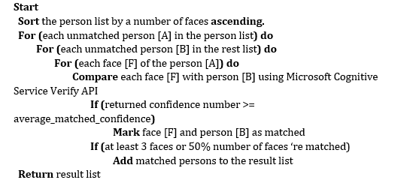

Ex:

* Given person list: [P1, P2, P3, P4, P5, P6]
* Compare faces of P1 to P2, P3, P4, P5, P6
* P1 matched with P2, P6, put them into a new list [P1, P2, P6]
* Continue with the unchecked person
* P3 doesn’t match P4 or P5
* P4 matched with P5, put them into a new list [P4, P5]
* Results: [ [P1, P2, P6], [P4, P5] ]

#### Complexity

* Given N is the number of persons in the list.
* Given M is the average number of faces per person.
* The sort algorithm takes O(*n2*) in the worst case.
* The complexity of comparing each person’s face to the others is M * O(*n2*)
* The complexity of this algorithm is: M * O(*n2*)

#### Accuracy

* From testing, the average confidence rate from Image Recognizer Service is more than 72%.
* Test result: <https://docs.google.com/spreadsheets/d/1YnqJRSUiCeizhDTHoaJgMHrDWH3k_4D5ou80jy2vLOA/edit?usp=sharing>

#### Flowchart



### Find Duplicated Person By Name Algorithms

#### Definition

* This function helps the user to find out persons which have the same name in the Person contact list.

#### Define Problem

* When the blind user adds a new person, they cannot determine whether there is already an existed person with the same name or not. The application will automatically create new the new person, result in there will be people in the person group that have the same name.

#### Solution

To solve this problem, we follow these steps:

* Find all Person in the contact list of the user, then group persons which have the same name.
* Ex:

+ We have the person list: [Nguyen Van A, Nguyen Van B, Nguyen Van C, Nguyen Van B, Nguyen Van D, Nguyen Van C].

+ After grouping, we have [Nguyen Van B, Nguyen Van B], [Nguyen Van C, Nguyen Van C].

* In each group, we use the “Find duplicated person by faces” which has been described in [1.1] to group persons which have the same name and may represent the same person in real life.
* After the process, we will have a list which contains groups of persons with the same name.

#### Complexity

* Given N is the number of persons in the list
* Given M is the average number of faces per person.
* The “Group persons by same name” process takes O(n)
* The “Find duplicated persons by faces” take M*O(*n2*) (reference 4.7.4.4)
* The complexity of this algorithm is: M * O(*n2*)

#### Flowchart



### Detect Object Algorithms

#### Definition

* This algorithms is used to identify object that matched the captured picture from user.

#### Define Problem

* The user need to use the application to identify unknown object. The user can command the application to capture a picture of the object, after the identification process, the object information will be returned by voice.

#### Solution

The Identifying process content these followed steps:

* Step 1: User open Detect Object mode by voice command.
* Step 2: User capture picture of the object.
* Step 3: System stores captured picture and send image url to Image Recognizer to detect object.
* Step 4: If Image Recognizer is unable to identify the object (object do not have in the system or confident rate is <= 60%), a Log file will be created in the system, and the application will return a response message back to the user by voice .
* Step 5: Otherwise the application will describe the object information back to the user by voice.

#### Complexity

* For the complexity of this algorithms is depend on the Image Recognition Service, which is not described in their documents. Therefore we spent times testing the performance of the Identifying Process:

|  |  |
| --- | --- |
| **Network Type** | **Speed**  **(Voice Recognition + Image Recognition)** |
| Wi-Fi Network (Ping: 3ms, Download: 30.55Mbps, Upload: 22.17 Mbps) | 5,731 ms |
| **3G Network** (Ping 24ms, Download: 15.31 Mbps, Upload: 1.36 Mbps) | 6,182 ms |

#### Accuracy

The accuracy of the algorithms is tested and the result is presented as bellow:

|  |  |  |  |  |  |
| --- | --- | --- | --- | --- | --- |
| **Image Amount In Concept** | **Confident Rate** | | | | |
| **> 90%** | **90% - 80%** | **80% - 70%** | **70% - 60%** | **60% - 50%** |
| 1 | 7 | 25 | 23 | 14 | 20 |
| 2 | 9 | 28 | 19 | 17 | 22 |
| 3 | 8 | 16 | 33 | 20 | 10 |
| 4 | 5 | 17 | 35 | 22 | 7 |

#### Flow chart



### Training Object Algorithms

#### Definition

* The training algorithms allow the system to learn and identify a object images provided by the user.

Training process has two meaning:

* Train the system to identify a completely new Object
* Train an existed Object to increase the system’s accuracy

#### Define Problem

* User use the application to identify Object by their image, so we need a algorithms to train the system to recognize the Object and improve the detecting accuracy

#### Image Recognizer Concepts

* **Concept**: is a definition that be attached to an image. It could be understood as tags of an image. A concept belongs to a model.
* **Input**: is an image used to feed a model. It could be an url or a raw file.
* **Model**: is a set of concepts (or tags), it could be customized to predict a given image. An output of a model is percent of each concept in that model.

#### Solution

The training object process includes these steps:

* Step 1: User creates a new object with basic information: Name, Description.
* Step 2: Admin can inputs one image or multiple images and concept that best describes the new object to Input.
* Step3: Admin create object with Concept contain Input and name concept. After the system finish success with data (image, concept). The system will start training process in Model.
* Step 4: After successful training the system then notify admin training success.

#### Complexity

For the complexity of this algorithms is depend on the Image Recognition Service, which is not described in their documents. Therefore we spent times testing the performance of the Training Process

|  |  |
| --- | --- |
| **Network Type** | **Speed** |
| Wi-Fi Network (Ping: 3ms, Download: 30.55Mbps, Upload: 22.17 Mbps) | 12,572 ms |
| **3G Network** (Ping 24ms, Download: 15.31 Mbps, Upload: 1.36 Mbps) | 13,742 ms |

#### Flow chart



# System Implementation & Test

## Introduction

### Overview

This section describes the approach and methodologies used by group to plan, organize and manage the testing of AAIV system. It provides in the detail all necessary information about the implementation and testing procedure of the system included test plans, test cases, test result, test environments, pass/fail criteria and risks estimations as well as a checklist to cover all possible cases.

### Test Approach

* Goal: Test all features in the whole AAIV system based on the core flow.
* Method: black-box testing
* Technique: check list

## Database Relationship Diagram

### Physical Diagram



**Figure 68: Physical Diagram**

### Data Dictionary

|  |  |  |
| --- | --- | --- |
| **Class Dictionary: Describe content of all table** | | |
| **Class name** | **Description** | **Mapping with ERD diagram** |
| Picture | Contain the information of picture object. | Concept |
| Concept | Contain the information of Concept. | Picture, Face |
| Person | Contain the information of Person. | PersonGroup |
| PersonGroup | Contain the information of PersonGroup. | AspNetUsers |
| Face | Contain the information of Face. | Person |
| AspNetUserClaims | Contain the information of Claims. | AspNetUsers |
| AspNetUserLogins | Contain the information of UserLogins. | AspNetUsers |
| AspNetUsers | Contain the information of all User in system. | AspNetUserClaims, AspNetUserLogins, AspNetUserRoles, LogObject, Log |
| AspNetUserRoles | Contain the information of user and which role of that user. | AspNetUsers |
| AspNetRoles | Contain the information of all Role in system. | AspNetUserRoles |
| LogObject | Contain the information of all Object can not detect. | AspNetUsers |
| Log | Contain the information of all Person can not detect. | AspNetUsers |

|  |  |  |  |  |
| --- | --- | --- | --- | --- |
| **Table Name** | **Attributes** | **Description** | **Domain** | **Allow Null** |
| Picture | PictureId{PK) | Unique identifier for Picture | Varchar(32) | No |
| ConceptId{FK} | FK reference to ‘Concept' table | Int | No |
| Description | Description of picture | Nvarchar(50) | Yes |
| ImageURL | Link of image | Nvarchar(MAX) | No |
| Active | The status of Department:  False: DE-ACTIVE  True: ACTIVE | Bit | No |
| Concept | ConceptId{PK} | Unique identifier for Concept | Int | No |
| ConceptName | Name of the concept | Nvarchar(100) | No |
| ConceptDescription | Description of concept | Nvarchar(100) | No |
| CreateDate | Created date | Datetime | Yes |
| Active | The status of Concept:  False: DE-ACTIVE  True: ACTIVE | Bit | No |
| Person | PersonId{PK} | Unique identifier for Person | Nvarchar(36) | No |
| PersonGroupId{FK} | FK reference to ‘PersonGroup' table | Nvarchar(128) | No |
| Name | Name of the person | Nvarchar(128) | No |
| Description | Description of the person | Nvarchar(250) | Yes |
| Active | The status of Person:  False: DE-ACTIVE  True: ACTIVE | Bit | No |
| PersonGroup | PersonGroupId{PK} | Unique identifier for PersonGroup | Nvarchar(128) | No |
| PersonGroupName | Name of the person group | Nvarchar(128) | No |
| Description | Description of the person group | Nvarchar(250) | Yes |
| Active | The status of PersonGroup:  False: DE-ACTIVE  True: ACTIVE | Bit | No |
| Face | PersistedFaceId{PK} | Unique identifier for Face | Nvarchar(36) | No |
| PersonID{FK} | FK reference to ‘Person' table | Nvarchar(36) | No |
| ImageURL | Url of image contain this face | Nvarchar(MAX) | No |
| Active | The status of Face:  False: DE-ACTIVE  True: ACTIVE | Bit | No |
| AspNetUsers | Id{PK} | Unique identifier for User | Nvarchar(128) | No |
| Email | Email of Use | Nvarchar(256) | Yes |
| EmailConfirmed | The status email confirmed or not:  False: Not confirm  Yes: Confirmed | Bit | No |
| PasswordHash | Password with Hash | nvarchar(MAX) | Yes |
| SecurityStamp | Security Stamp | nvarchar(MAX) | Yes |
| PhoneNumber | Phone number of User | nvarchar(MAX) | Yes |
| PhoneNumberConfirmed | The status phone confirmed or not:  False: Not confirm  True: Confirmed | bit | No |
| TwoFactorEnabled | Two-factor authentication | bit | No |
| LockoutEndDateUtc | Enddate of lockout user | datetime | Yes |
| LockoutEnabled | User can be locked out, not that the user is locked out | bit | No |
| AccessFailedCount | Access failed count | int | No |
| UserName | Username of user | nvarchar(256) | No |
| Active | The status of AspNetUsers:  False: DE-ACTIVE  True: ACTIVE | bit | No |
| Log | Id{PK} | Unique identifier for Log Person | Int | No |
| CreatedDate | Created date | Datatime | No |
| UserID{FK} | FK reference to ‘AspNetUsers ' table | Nvarchar(128) | No |
| ImageURL | Image URL of person was not detected | Nvarchar(MAX) | No |
| Name | Name of that person | Nvarchar(128) | Yes |
| Active | The status of Log:  False: DE-ACTIVE  True: ACTIVE | Bit | No |
| LogObject | ID{PK} | Unique identifier for LogObject | Int | No |
| CreatedDate | Created date | datetime | No |
| UserID{FK} | FK reference to ‘AspNetUsers ' table | nvarchar(128) | No |
| ImageURL | Image url of object detect fail | nvarchar(MAX) | No |
| Active | The status of LogObject:  False: DE-ACTIVE  True: ACTIVE | bit | No |
| AspNetUserRoles | UserId{PK} | PK reference to ‘AspNetUsers’ table | nvarchar(128) | No |
| RoleId{PK} | PK reference to ‘AspNetRoles’ table | nvarchar(128) | No |
| AspNetRoles | Id{PK} | Unique identifier for AspNetRoles | Nvarchar(128) | No |
| Name | Name of Role | Nvarchar(256) | No |

## Performance Measures

## Test Plan

The purpose of this section is to verify and ensure that SCP meets its design specification and other requirements from user. The following part will describe which features to be tested and which will not.

## System Testing Test Case

### Communication Diagram



**Figure 69: Communication Diagram**

### Test Cases

#### Mobile Application Test Cases

##### <User> Detect Person

|  |  |  |  |  |  |
| --- | --- | --- | --- | --- | --- |
| **ID** | **Test Case Description** | **Test case procedure** | **Expected output** | **Result** | **Test Date** |
| UDP01 | Detect person was trained | 1. Login successfully with role “User” in mobile application.  2. Say detect command.  3. Take picture. | Mobile application show the name of the person was trained. | Pass: 30  Fail: 2 | 01/04/2017 to 13/04/2017 |
| UDP02 | Detect person was not trained. | 1. Login successfully with role “User” in mobile application.  2. Send detect command.  3. Take picture. | Mobile application show the gender of the person. | Pass:27  Fail: 1 | 01/04/2017 to 13/04/2017 |
| UDP03 | Detect person while the face inclined 45 degrees to the camera. | 1. Login successfully with role “User” in mobile application.  2. Send detect command.  3. Take picture. | Mobile application show the name of the person. | Pass:20  Fail:10 | 01/04/2017 to 13/04/2017 |
| UDP04 | Detect person while the face inclined 30 degrees to the camera. | 1. Login successfully with role “User” in mobile application.  2. Send detect command.  3. Take picture. | Mobile application show the name of the person. | Pass:3  Fail:26 | 01/04/2017 to 13/04/2017 |
| UDP05 | Detect person while the face inclined 20 degrees to the camera. | 1. Login successfully with role “User” in mobile application.  2. Send detect command.  3. Take picture. | Mobile application show the name of the person. | Pass:0  Fail:28 | 01/04/2017 to 13/04/2017 |
| UDP06 | Detect person while have no one in picture. | 1. Login successfully with role “User” in mobile application.  2. Send detect command.  3. Take picture. | Mobile application show do not have any person message. | Pass:30  Fail:0 | 01/04/2017 to 13/04/2017 |
| UDP07 | Detect person while the person wear glasses. | 1. Login successfully with role “User” in mobile application.  2. Send detect command.  3. Take picture. | Mobile application show the name of the person. | Pass:20  Fail:3 | 01/04/2017 to 13/04/2017 |
| UDP08 | Detect person from behind. | 1. Login successfully with role “User” in mobile application.  2. Send detect command.  3. Take picture. | Mobile application show the name of the person. | Pass:0  Fail:18 | 01/04/2017 to 13/04/2017 |
| UDP09 | Detect person while picture contain ½ face. | 1. Login successfully with role “User” in mobile application.  2. Send detect command.  3. Take picture. | Mobile application show the name of the person. | Pass:0  Fail:17 | 01/04/2017 to 13/04/2017 |
| UDP10 | Detect person while picture contain 1/3­ face. | 1. Login successfully with role “User” in mobile application.  2. Send detect command.  3. Take picture. | Mobile application show the name of the person. | Pass:0  Fail:18 | 01/04/2017 to 13/04/2017 |
| UDP11 | Detect person from a distance of 1 meter. | 1. Login successfully with role “User” in mobile application.  2. Send detect command.  3. Take picture. | Mobile application show the name of the person. | Pass:28  Fail:1 | 01/04/2017 to 13/04/2017 |
| UDP12 | Detect person from a distance of 1.5 meter. | 1. Login successfully with role “User” in mobile application.  2. Send detect command.  3. Take picture. | Mobile application show the name of the person. | Pass:27  Fail:2 | 01/04/2017 to 13/04/2017 |
| UDP13 | Detect person from a distance of 2 meter. | 1. Login successfully with role “User” in mobile application.  2. Send detect command.  3. Take picture. | Mobile application show the name of the person. | Pass:20  Fail:5 | 01/04/2017 to 13/04/2017 |
| UDP14 | Detect person from a distance of 2.5 meter. | 1. Login successfully with role “User” in mobile application.  2. Send detect command.  3. Take picture. | Mobile application show the name of the person. | Pass:6  Fail:17 | 01/04/2017 to 13/04/2017 |
| UDP15 | Detect person from a distance of 3 meter. | 1. Login successfully with role “User” in mobile application.  2. Send detect command.  3. Take picture. | Mobile application show the name of the person. | Pass:0  Fail:18 | 01/04/2017 to 13/04/2017 |
| UDP16 | Take picture contain 2 person(1 trained and 1 not trained) | 1. Login successfully with role “User” in mobile application.  2. Send detect command.  3. Take picture. | Mobile application show the name of the person was trained. | Pass:24  Fail:0 | 01/04/2017 to 13/04/2017 |
| UDP17 | Take picture contain 2 person was trained. | 1. Login successfully with role “User” in mobile application.  2. Send detect command.  3. Take picture. | Mobile application show the name of 2 person. | Pass:24  Fail:2 | 01/04/2017 to 13/04/2017 |
| UDP18 | Take picture contain 3 person was trained. | 1. Login successfully with role “User” in mobile application.  2. Send detect command.  3. Take picture. | Mobile application show the name of 3 person. | Pass:14  Fail:2 | 01/04/2017 to 13/04/2017 |
| UDP19 | Take picture contain 4 person was trained. | 1. Login successfully with role “User” in mobile application.  2. Send detect command.  3. Take picture. | Mobile application show the name of 4 person. | Pass:5  Fail:0 | 01/04/2017 to 13/04/2017 |

***Table 79: Mobile Application Test Cases - <User> Detect Person***

##### <User> Detect Object

|  |  |  |  |  |  |
| --- | --- | --- | --- | --- | --- |
| **ID** | **Test Case Description** | **Test case procedure** | **Expected output** | **Result** | **Test Date** |
| UDO01 | Detect object was trained. | 1. Login successfully with role “User”.  2. Send detect object command. | Mobile application show the name of the object. | Pass:27  Fail: 3 | 01/04/2017 to 13/04/2017 |
| UDO02 | Detect object was not trained. | 1. Login successfully with role “User”.  2. Send detect object command. | Mobile application show the name of the object. | Pass:3  Fail: 17 | 01/04/2017 to 13/04/2017 |
| UDO03 | Detect object from a distance of 1 meter. | 1. Login successfully with role “User”.  2. Send detect object command. | Mobile application show the name of the object. | Pass:6  Fail: 2 | 01/04/2017 to 13/04/2017 |
| UDO04 | Detect object from a distance of 1.5 meter. | 1. Login successfully with role “User”.  2. Send detect object command. | Mobile application show the name of the object. | Pass:3  Fail: 3 | 01/04/2017 to 13/04/2017 |
| UDO05 | Detect object from a distance of 2 meter. | 1. Login successfully with role “User”.  2. Send detect object command. | Mobile application show the name of the object. | Pass:5  Fail: 8 | 01/04/2017 to 13/04/2017 |
| UDO06 | Detect object from a distance of 2.5 meter. | 1. Login successfully with role “User”.  2. Send detect object command. | Mobile application show the name of the object. | Pass:0  Fail: 5 | 01/04/2017 to 13/04/2017 |
| UDO07 | Detect object from a distance of 3 meter. | 1. Login successfully with role “User”.  2. Send detect object command. | Mobile application show the name of the object. | Pass:0  Fail: 5 | 01/04/2017 to 13/04/2017 |
| UDO08 | Take picture contain 2 object(1 trained and 1 not trained). | 1. Login successfully with role “User”.  2. Send detect object command. | Mobile application show the name of the object was trained. | Pass:1  Fail: 6 | 01/04/2017 to 13/04/2017 |
| UDO09 | Take picture contain 2 object was trained. | 1. Login successfully with role “User”.  2. Send detect object command. | Mobile application show the name of 2 object. | Pass:0  Fail: 6 | 01/04/2017 to 13/04/2017 |
| UDO10 | Take picture contain 3 object (1 trained and 2 not trained). | 1. Login successfully with role “User”.  2. Send detect object command. | Mobile application show the name of the object was trained. | Pass:0  Fail: 5 | 01/04/2017 to 13/04/2017 |

***Table 80: Mobile Application Test Cases - <User> Detect Object***

##### <User> Detect Person Streaming

|  |  |  |  |  |  |
| --- | --- | --- | --- | --- | --- |
| **ID** | **Test Case Description** | **Test case procedure** | **Expected output** | **Result** | **Test Date** |
| UDPS01 | Streaming contain no face in 30 seconds. | 1. Login successfully with role “User”.  2. Send streaming command. | Mobile application not take picture or detect. | Pass:10  Fail: 0 | 01/04/2017 to 13/04/2017 |

#### *Table 81: Mobile Application Test Cases - <User> Detect Person Streaming*

#### Web Application Test Cases

##### <Admin>View List Account

|  |  |  |  |  |  |
| --- | --- | --- | --- | --- | --- |
| **ID** | **Test Case Description** | **Test case procedure** | **Expected output** | **Result** | **Test Date** |
| AVLA01 | View list accounts | 1. Login successfully with role “Admin”.  2. Click “Quản lý tài khoản” button | Web application shows list accounts in “Quản lý tài khoản” view. | Pass:8  Fail:0 | 01/04/2017 to 13/04/2017 |

***Table 82: Web Application Test Case - <Admin> View List Accounts***

##### <Admin> Activate/Deactivate Account

|  |  |  |  |  |  |
| --- | --- | --- | --- | --- | --- |
| **ID** | **Test Case Description** | **Test case procedure** | **Expected output** | **Result** | **Test Date** |
| AADA01 | Activate specific account success | 1. Login successfully with role “Admin”.  2. In “Quản lý tài khoản” view, select a account in list and click “Activate” button.  3. Click “Cập nhật” button. | Web application shows “Cập nhật thành công” message. | Pass:7  Fail:0 | 01/04/2017 to 13/04/2017 |
| AADA02 | Activate specific account but cancels | 1. Login successfully with role “Admin”.  2. In “Quản lý tài khoản” view, select a deactivated account in list and click “Deactivate” button.  3. Refresh page without click “Cập nhật” button. | Web application does nothing, account still locked. | Pass:5  Fail:0 | 01/04/2017 to 13/04/2017 |
| AADA03 | Deactivate specific account success | 1. Login successfully with role “Admin”.  2. In “Quản lý tài khoản” view, select a activated account in list and click “Deactivate” button.  3. Click “Cập nhật” button when it show up. | Web application shows pop up with message: “Khóa tài khoản thành công”. | Pass:6  Fail:0 | 01/04/2017 to 13/04/2017 |

***Table 83: Web Application Test Case - <Admin> Activate/Deactivate Account***

# Software User’s Manual

## Installation Guide

### Setting up environment at server side

The specifications are based on the dependencies requirements and performance test result from previous section of this document.

#### Hardware Requirements

|  |  |
| --- | --- |
| **Hardware** | **Specification** |
| Internet Connection | 4 Mbps |
| Computer Processor | Intel® Core i3 1.4GHz or more |
| Computer Memory | 2GB of RAM or more |
| Hard Drive | 30GB or more |
| **Table 84: Installation Guide - Hardware Requirements** | |

#### Software Requirements

|  |  |
| --- | --- |
| **Software** | **Application name/version** |
| Operating System | Windows 7 Professional or latter |
| .Net | 4.5 |
| DBMS | Microsoft SQL Server 2014 |
| **Table 85: Installation Guide - Software Requirement** | |

#### Mobile Requirements

|  |  |
| --- | --- |
| **Hardware** | **Specification** |
| CPU | At least 1.8 GHz |
| Memory | At least 512 MB.  Recommended: 1GB |
| Storage | At least 40Mb.  Recommended: 1 GB |
| Camera | At least 3.0 MP  Recommended: 5.0 MP |
| Model | All Android devices with android version 5.0 or higher. |
| **Table 86: Installation Guide - Mobile Requirement** | |

### Web Services Application Deployment Process

#### Check Environment

* Check .Net Version

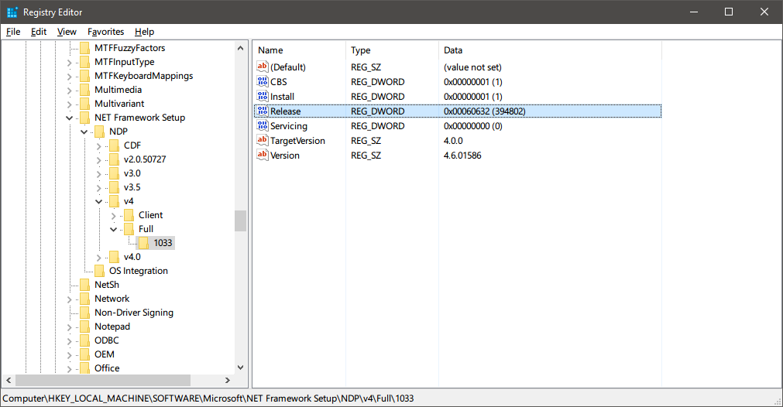

***Figure 70: Checking .Net Version***

|  |  |
| --- | --- |
| **Version** | **Value of the Release Data Word** |
| .NET Framework 4.5 | 378389 |
| .NET Framework 4.5.1 installed with Windows 8.1 | 378675 |
| .NET Framework 4.5.1 installed on Windows 8, Windows 7 SP1, or Windows Vista SP2 | 378758 |
| .NET Framework 4.5.2 | 379893 |
| .NET Framework 4.6 installed with Windows 10 | 393295 |
| .NET Framework 4.6 installed on all other Windows OS versions | 393297 |
| .NET Framework 4.6.1 installed on Windows 10 | 394254 |
| .NET Framework 4.6.1 installed on all other Windows OS versions | 394271 |
| .NET Framework 4.6.2 installed on Windows 10 Anniversary Update | 394802 |
| .NET Framework 4.6.2 installed on all other Windows OS versions | 394806 |
| .NET Framework 4.7 installed on Windows 10 Creators Update | 460798 |

***Table 87: .Net Version Release Code***

* Open Microsoft SQL Server and check Microsoft SQL Server version

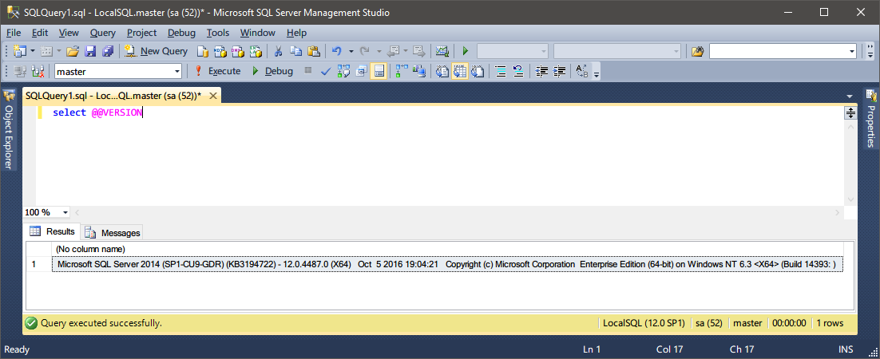

***Figure 71: Checking Microsoft SQL Server Version***

#### Prepare Image Recognize API

##### Prepare Microsoft Cognitive Service API

* Go to <https://www.microsoft.com/cognitive-services> and create an account.

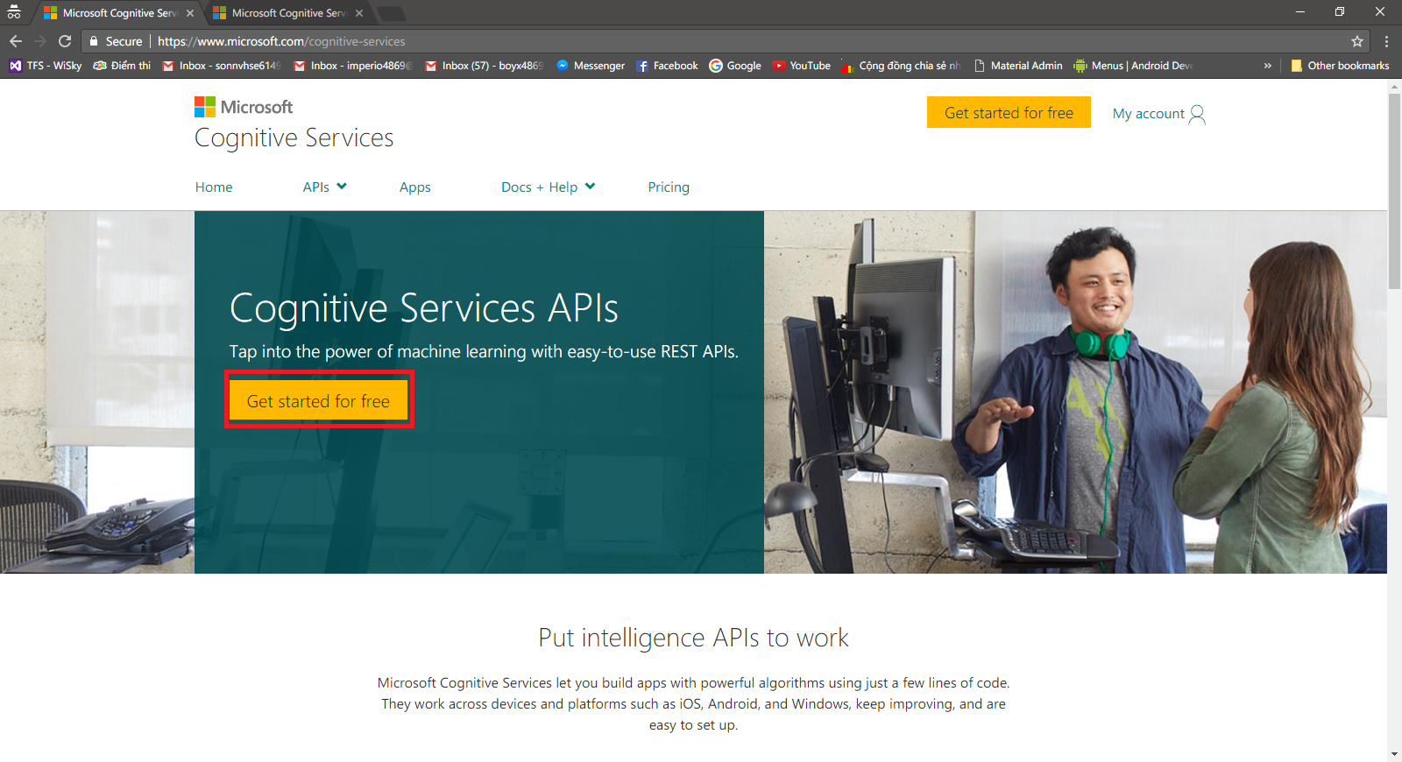

***Figure 72: Microsoft Cognitive Service Home Page***

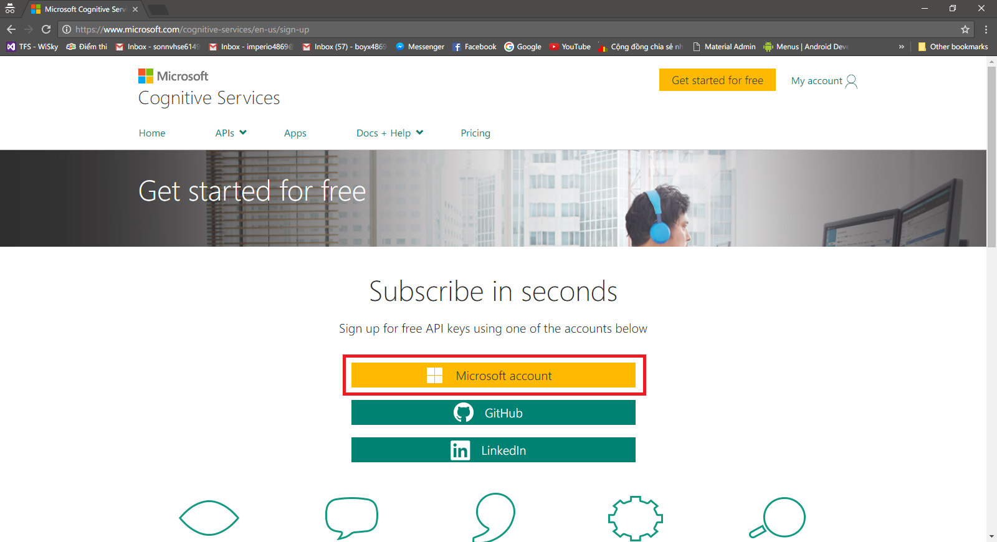

Click “Tạo tài khoản” to create new Microsoft Account

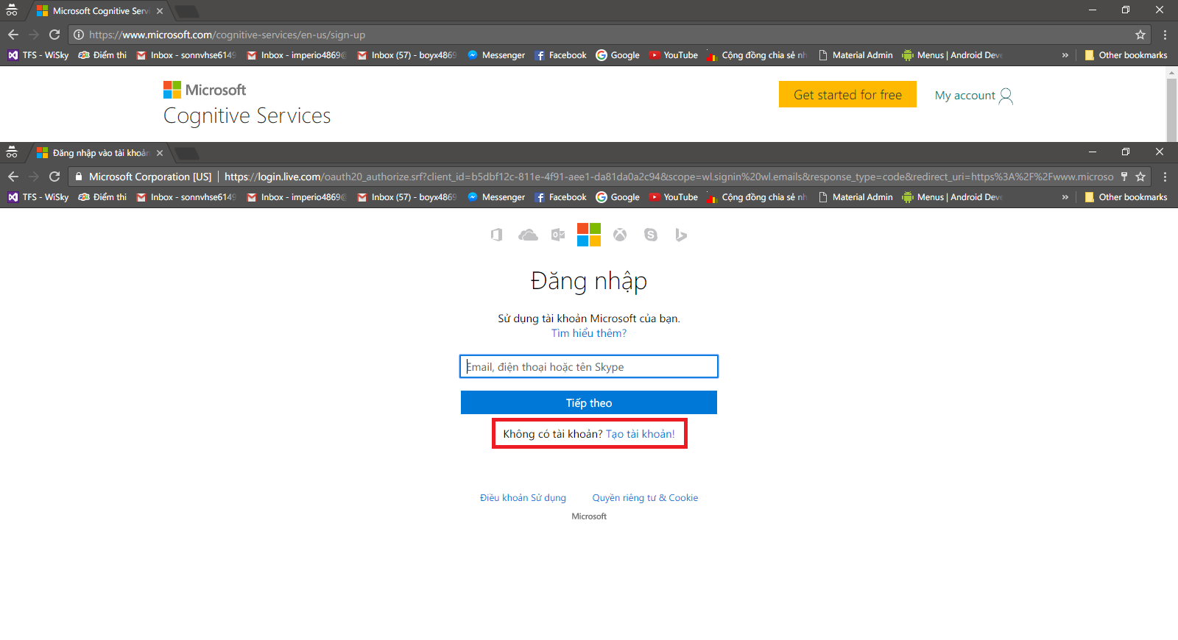

* Fill all necessary information and click “Tạo Tài khoản”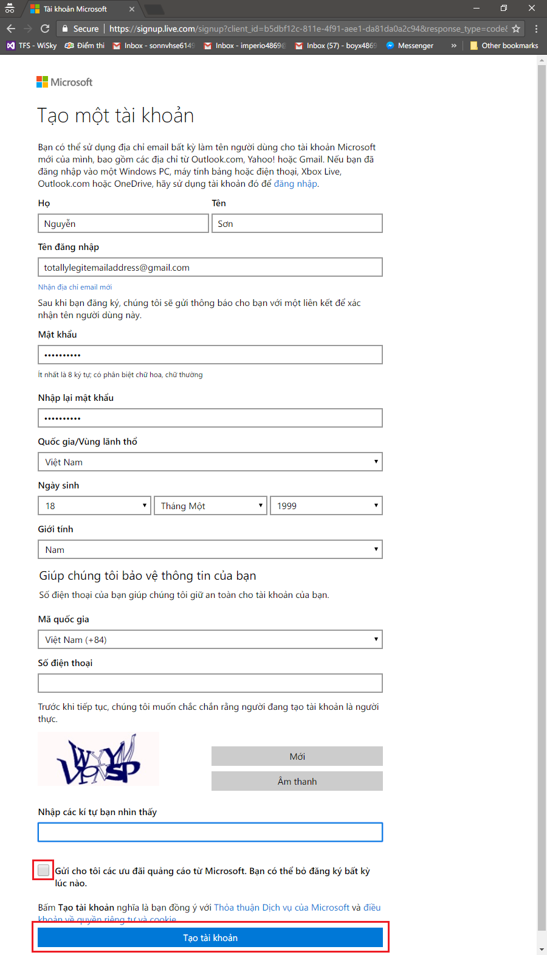

***Figure 73: Register Page***

* After successfully created an Microsoft Account, go to <https://www.microsoft.com/cognitive-services/en-us/face-api> to get an Face Review API key.

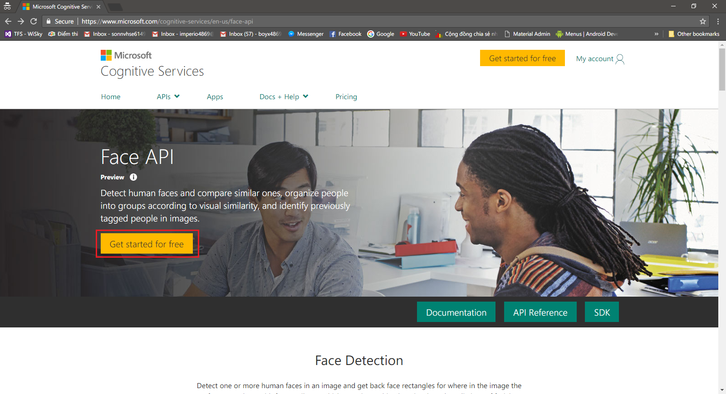

***Figure 74: Microsoft Face Review Home Page***

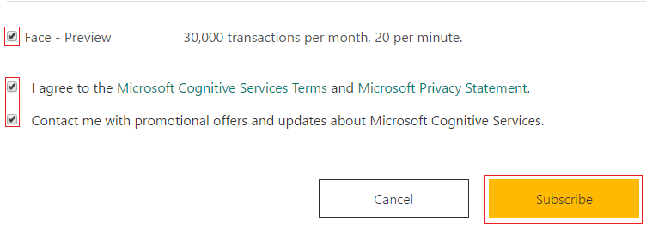

***Figure 75: Subscribe for Face Review API***

* Click Show to get API key

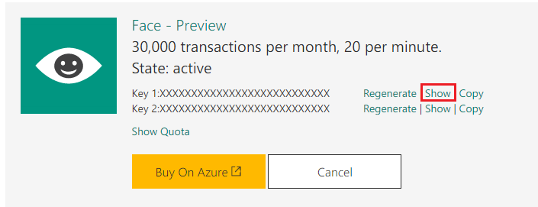

***Figure 76: Face Review API Key***

* Go to <https://www.microsoft.com/cognitive-services/en-us/computer-vision-api> to get Computer-Vision API key

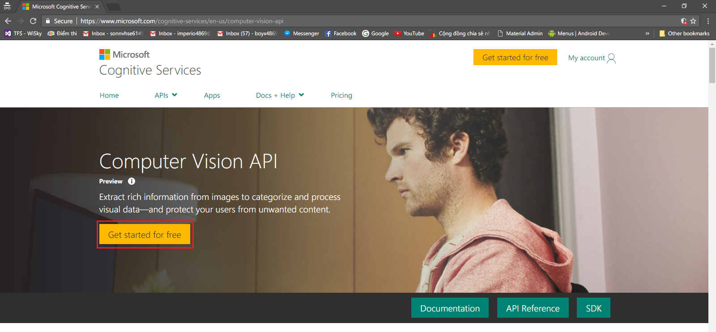

***Figure 77: Microsoft Computer Vision Home Page***

* Click Show to review the API key

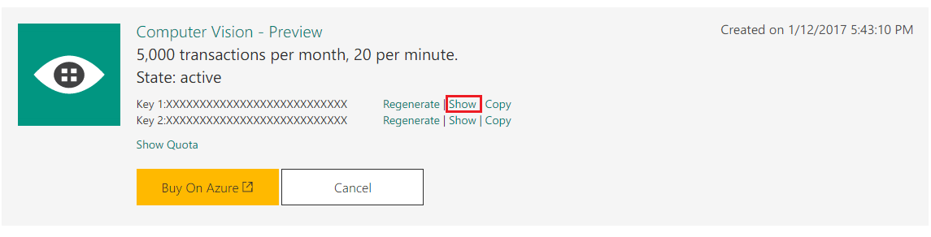

***Figure 78: Computer Vision API Key***

* Open web service project and edit file Assets.cs

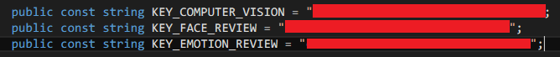***Figure 77: Update Application configurations for Microsoft Cognitive Service***

##### Prepare Clarifai API

* Go to Home page Clarifai <https://developer.clarifai.com/>



***Figure 78: Clarifai Home Page***

* Click [Sing Up] button to register account and fill information and check box

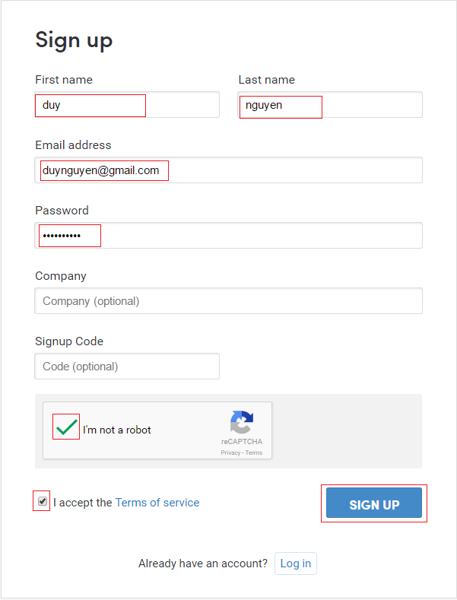

***Figure 79: Clarifai Account Sign Up Page***

* Click account to go to Manage Your Applications page



* Click [Create a New Applications] to create new app clarifai

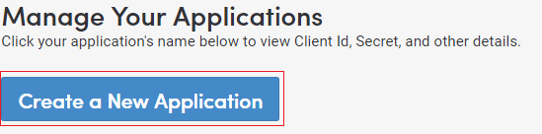

***Figure 80: Clarifai Manage your Applications Page***

* Fill name application, then click [Create Application] button

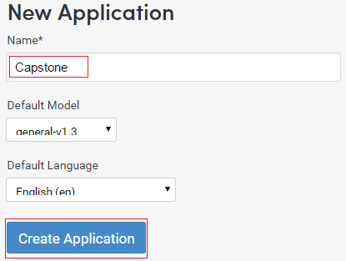

***Figure 81: Create New Application Form***

* Get Client Id and Client Secret

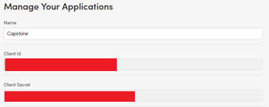

***Figure 82: Client ID and Secrets***

* Go to preview Clarifai page <https://preview.clarifai.com/#/> and login

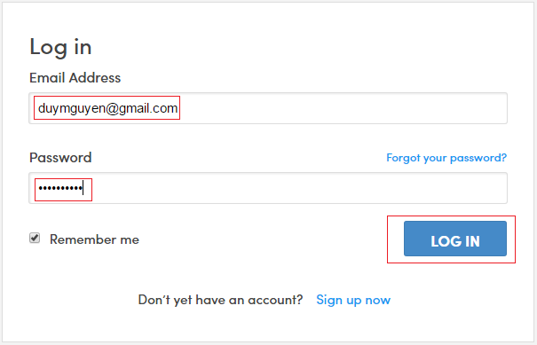

***Figure 83: Clarifai preview page***

* Click the previously created application

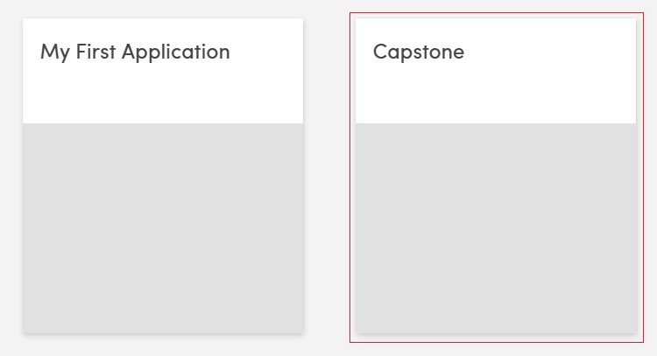

***Figure 84: Created Application***

* Click [CREATE MODEL] button

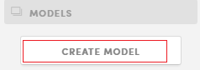

***Figure 84: Create Model button***

* Fill name of model after that click [Done] button to create new Model

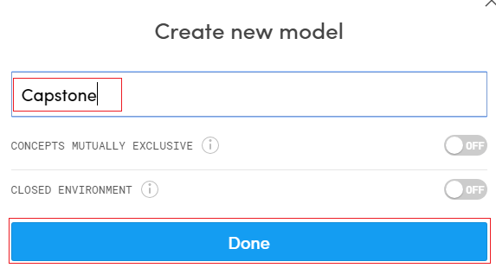

***Figure 85: Create new Model Form***

* Open and edit file clarifaiAPI.py



***Figure 86: Update application configuration for Clarifai API***

#### Prepare Image Storage

* Go to Cloudinary home page: <http://cloudinary.com/> and click [SIGN UP FOR FREE] button



***Figure 87: Cloudinary Home Page***

* Fill in information and click button [Create Account] to create new account

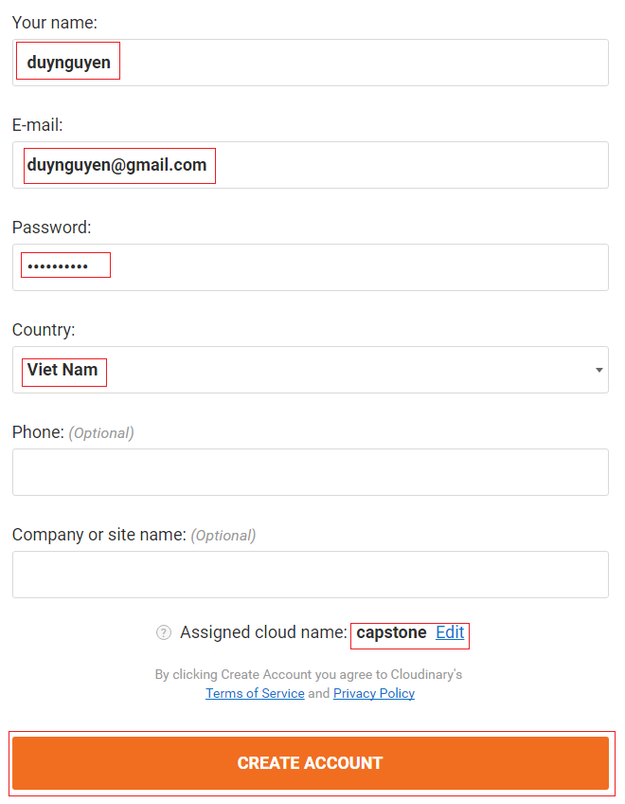

***Figure 88: Cloudinary Sign Up form***

* Click [Reveal] to show API Secret key

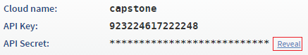

***Figure 89: Cloudinary API Key and Secrets***

* Open and edit file Assets.cs file

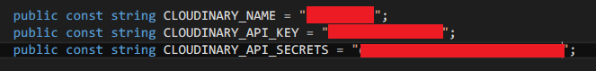

***Figure 90: Update application configuration for Image Storage***

#### Deploying web application

### Mobile Application Deployment Process

* Download the APK file from followed link:

<https://drive.google.com/file/d/0B2eM0JypmzdDcGZxQzJyZHVneWM/view?usp=sharing>

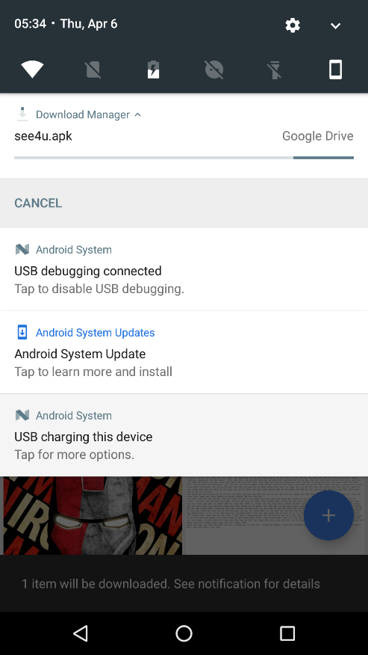

***Figure 93: Download APK file***

* After download the apk file, open it to install.

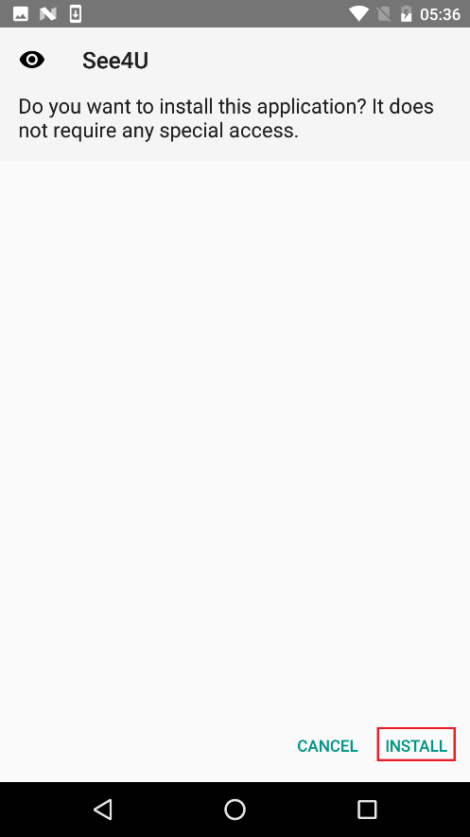 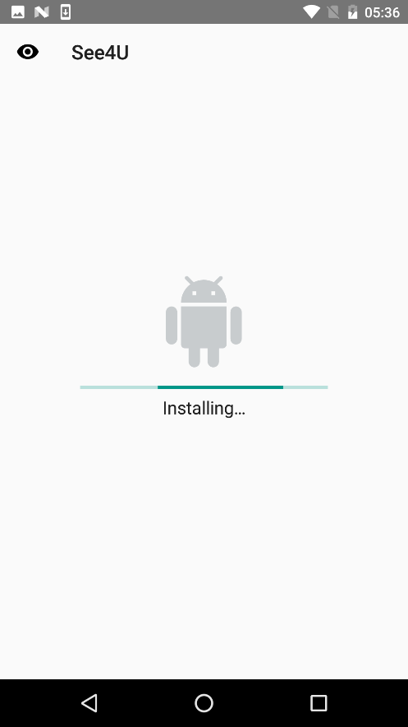

***Figure 94: Install APK file***

* After install successfully, click Open to start the application

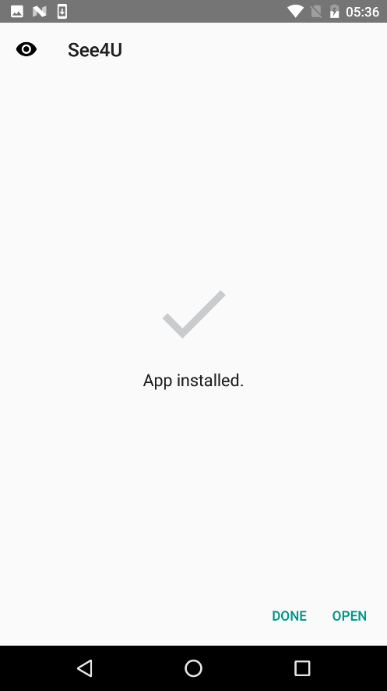 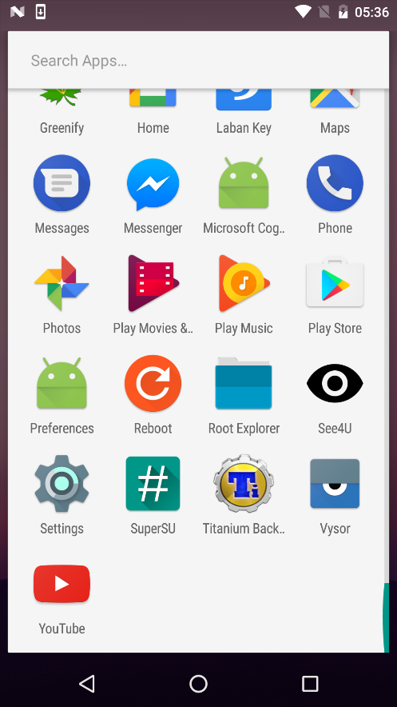

***Figure 95: Finish mobile application installation***

* Provide access permission for the application:

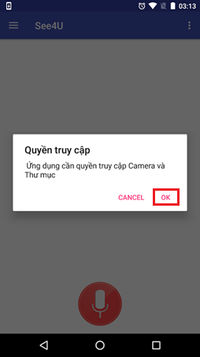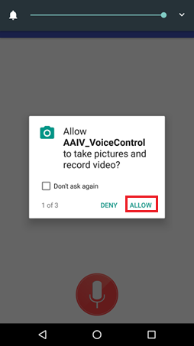

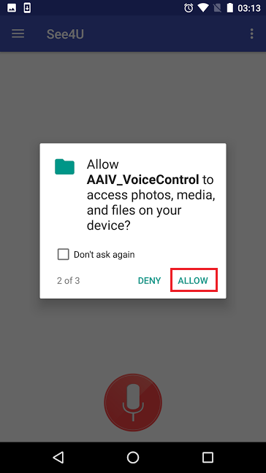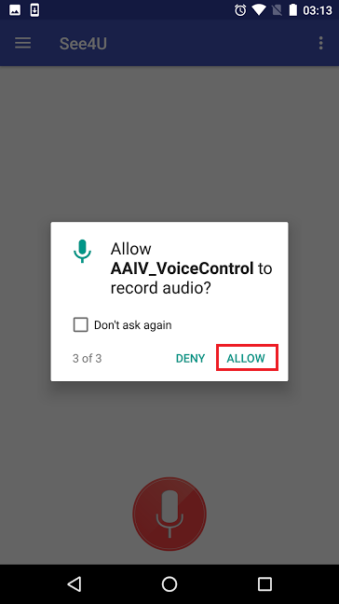

## User Guide

### Mobile Application Guide

#### Unauthorized User

##### <Unauthorized User> Login

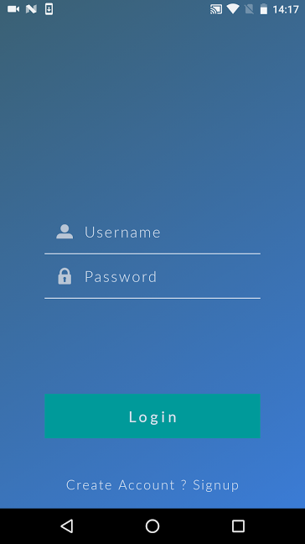

3

2

1

***Figure 96: Mobile Application Login Screen***

|  |  |
| --- | --- |
| **Step** | **Description** |
| 1 | Fill in Email and Password |
| 2 | Touch on “Login” to login |
| 3 | Touch on “Create Account ? Signup” to create new account |

##### <Unauthorized User> Register

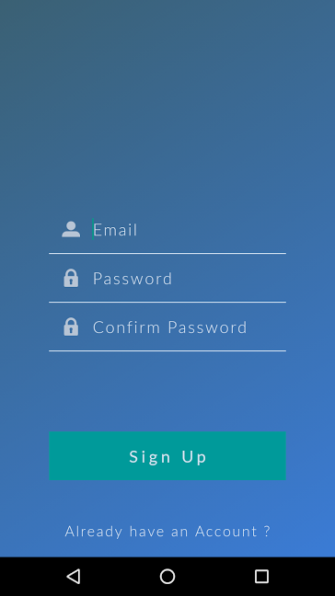

3

2

1

***Figure 97: Mobile Application Register screen***

|  |  |
| --- | --- |
| **Step** | **Description** |
| 1 | Fill in Email and Password and Confirm Password |
| 2 | Touch on “Sign Up” to create new account |
| 3 | Touch on “Already have an Account ?” to redirect to Login Screen |

#### Authorized User

##### <Authorized User> Detect Person

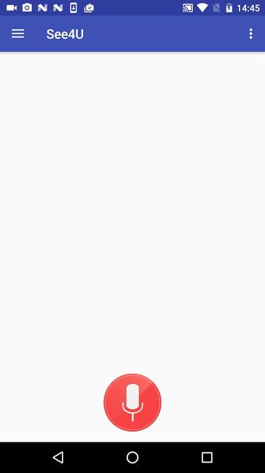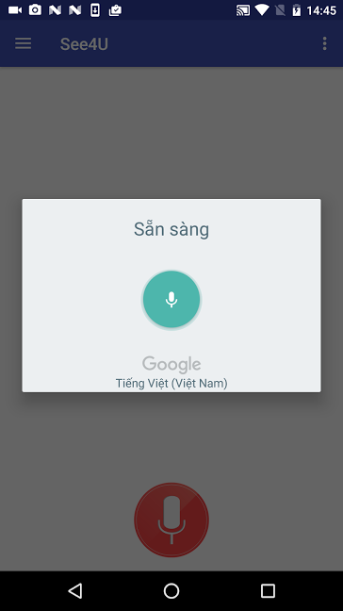

1.1

2

1

***Figure 98: Mobile Application Main screen***

|  |  |
| --- | --- |
| **Step** | **Description** |
| 1 | Touch the Voice Command button to begin speaking command |
| 1.1 | Shake device 2 times to begin speaking command |
| 2 | Speak Detect Person Command (edit command in “Thiết Lập” menu) |

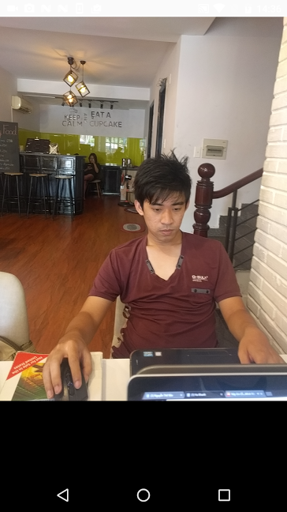

3

***Figure 99: Mobile Application Camera screen***

|  |  |
| --- | --- |
| **Step** | **Description** |
| 3 | Touch screen to capture image. |

* Identify Result of an Unknown Person

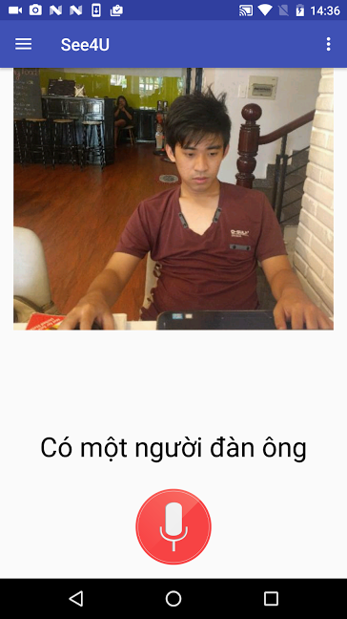

***Figure 100: Mobile Application identify result of unknown person***

* Identify Result of a known Person

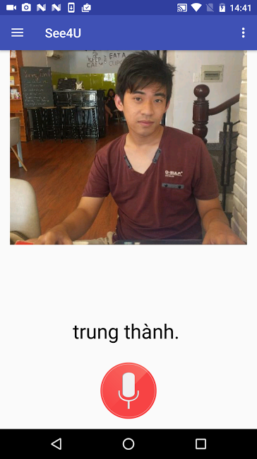

***Figure 101: Mobile Application identify result a known person***

##### <Authorized User> Detect Object



1.1

2

1

***Figure 102: Mobile Application Main Screen***

|  |  |
| --- | --- |
| **Step** | **Description** |
| 1 | Touch the Voice Command button to begin speaking command |
| 1.1 | Shake device 2 times to begin speaking command |
| 2 | Speak Detect Object Command (edit command in “Thiết Lập” menu) |

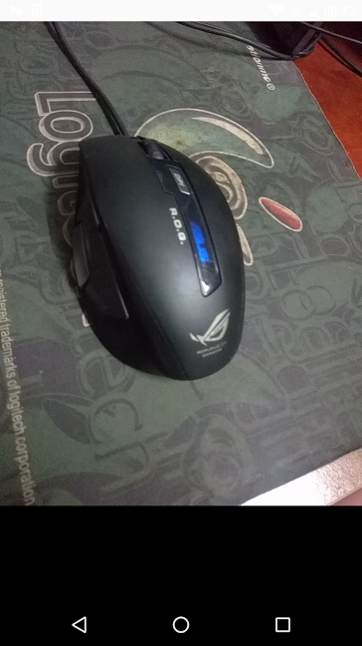

3

***Figure 103: Mobile Application camera screen***

|  |  |
| --- | --- |
| **Step** | **Description** |
| 3 | Touch device screen to capture image |

* Identify Result of an Unknown Object

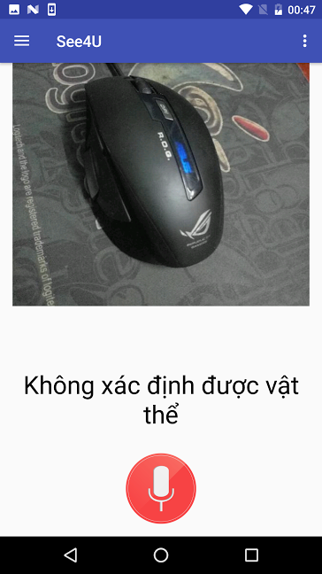

***Figure 104: Mobile Application identify result of an unknown object***

* Identify Result of a Known Object

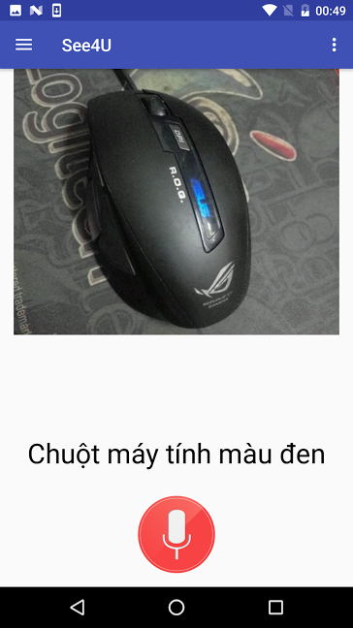

***Figure 105: Mobile Application identify result of a known object***

##### <Authorized User> Detect View



1.1

2

1

***Figure 106: Mobile Application Main Screen***

|  |  |
| --- | --- |
| **Step** | **Description** |
| 1 | Touch the Voice Command button to begin speaking command |
| 1.1 | Shake device 2 times to begin speaking command |
| 2 | Speak Detect View Command (edit command in “Thiết Lập” menu) |

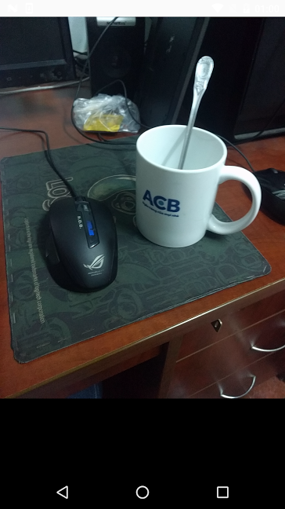

3

***Figure 107: Mobile Application camera screen***

|  |  |
| --- | --- |
| **Step** | **Description** |
| 3 | Touch device screen to capture image |

* Detect View Result

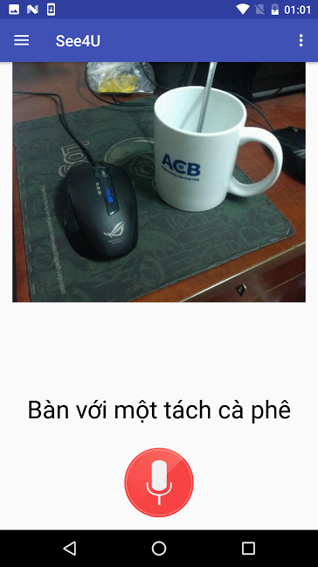

***Figure 107: Mobile Application detect view result***

##### <Authorized User> Create New Person

* Go to “Người Thân” Menu

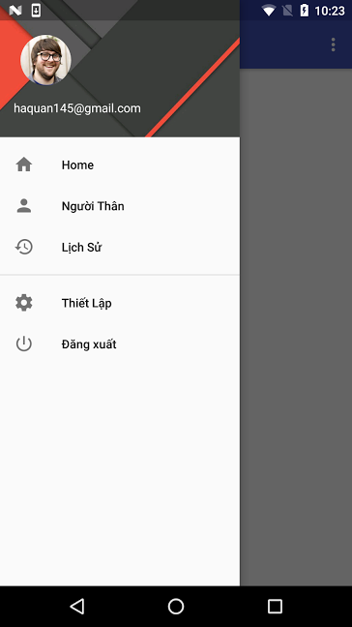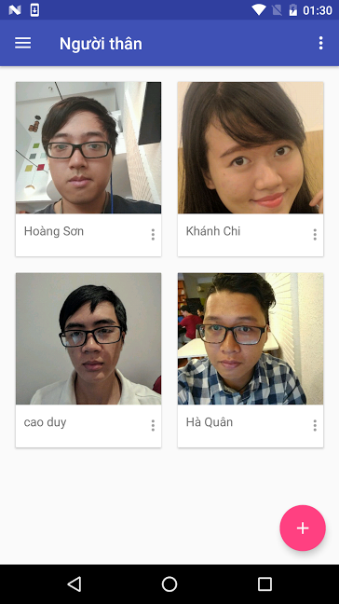

2.2

1

2.1

2

***Figure 108: Mobile Application Person List Screen***

|  |  |
| --- | --- |
| **Step** | **Description** |
| 1 | Touch “Người Thân” Menu to view Person List |
| 2 | Touch “+” button to create a new Person |
| 2.1 | Touch a Person card to view and update Person information |
| 2.2 | Touch icon to show menu |

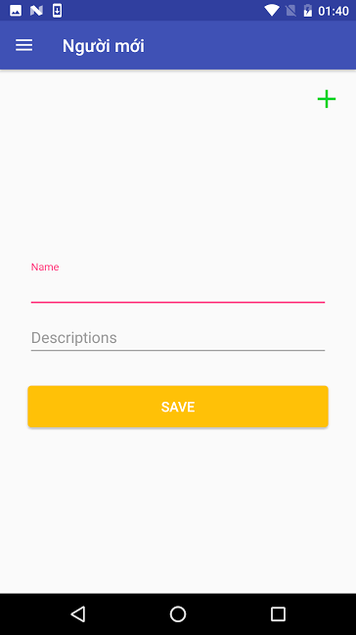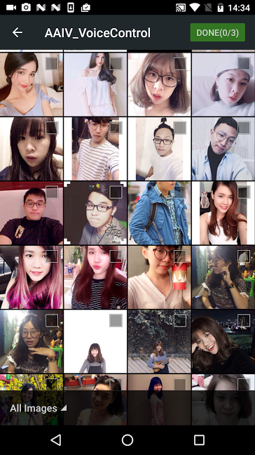

3

***Figure 109: Mobile Application Create New Person screen***

|  |  |
| --- | --- |
| **Step** | **Description** |
| 3 | Touch “+” sign to add new Image of person |

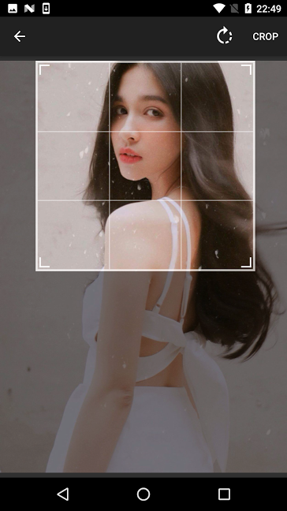

5.1

4.1

5

4

***Figure 110: Mobile Application Crop Image Screen***

|  |  |
| --- | --- |
| **Step** | **Description** |
| 4 | Adjust the crop box to fit the desire Person face. If there are more than one person in the picture, crop out only the person which you want to create. |
| 4.1 | Rotate the photo |
| 5 | Crop the image and proceed to next step |
| 5.1 | Back to previous step |

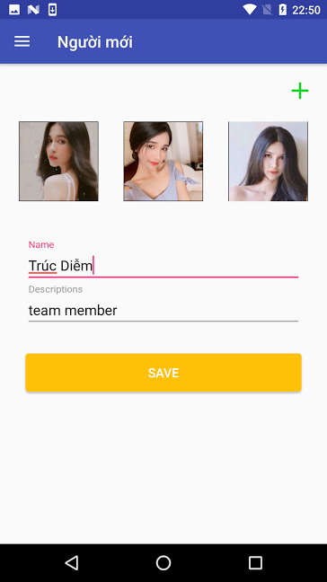

6.2

6.1

7

6

***Figure 111: Mobile Application Create New Person Screen***

|  |  |
| --- | --- |
| **Step** | **Description** |
| 6 | Fill Person Name and Description |
| 6.1 | Touch image to select another image |
| 6.2 | Long touch the image to crop the image |
| 7 | Touch “Save” button to Create new Person |

* Create new Person result

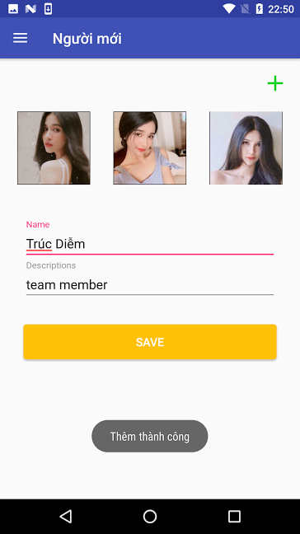 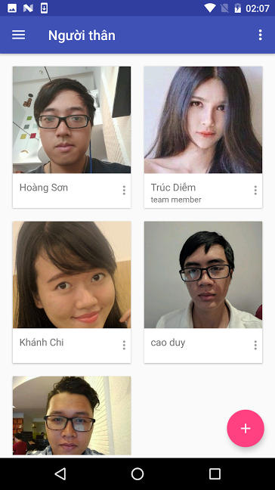

***Figure 112: Mobile Application Create New Person Successfully***

### Web Application Guide

#### Unauthorized User

##### <Unauthorized User> Login

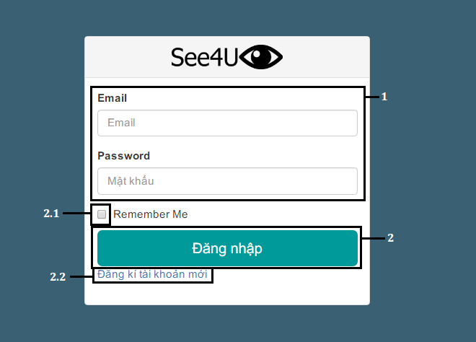

***Figure 113: Web Application Login page***

|  |  |
| --- | --- |
| **Step** | **Description** |
| 1 | Fill Email and Password |
| 2 | Click “Đăng nhập” button to Login to the website |
| 2.1 | Check “Remember Me” checkbox to automatically login next time |
| 2.2 | Click “Đăng kí tài khoản mới” to redirect to Register Page |

##### <Unauthorized User> Register

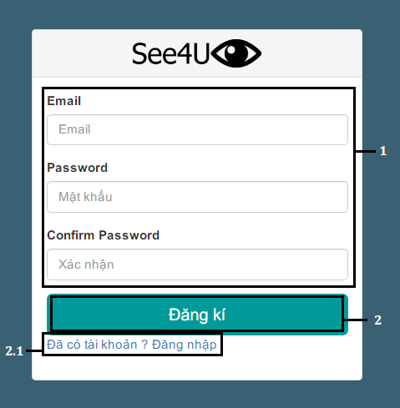

***Figure 114: Web Application Register page***

|  |  |
| --- | --- |
| **Step** | **Description** |
| 1 | Fill Email and Password and Confirm Password |
| 2 | Click “Đăng kí” button to create new account. |
| 2.1 | Check “Đã có tài khoản ? Đăng nhập” to redirect to Login Page |

#### Authorized User

##### <Authorized User> Admin

###### <Authorized User><Admin> Create New Object

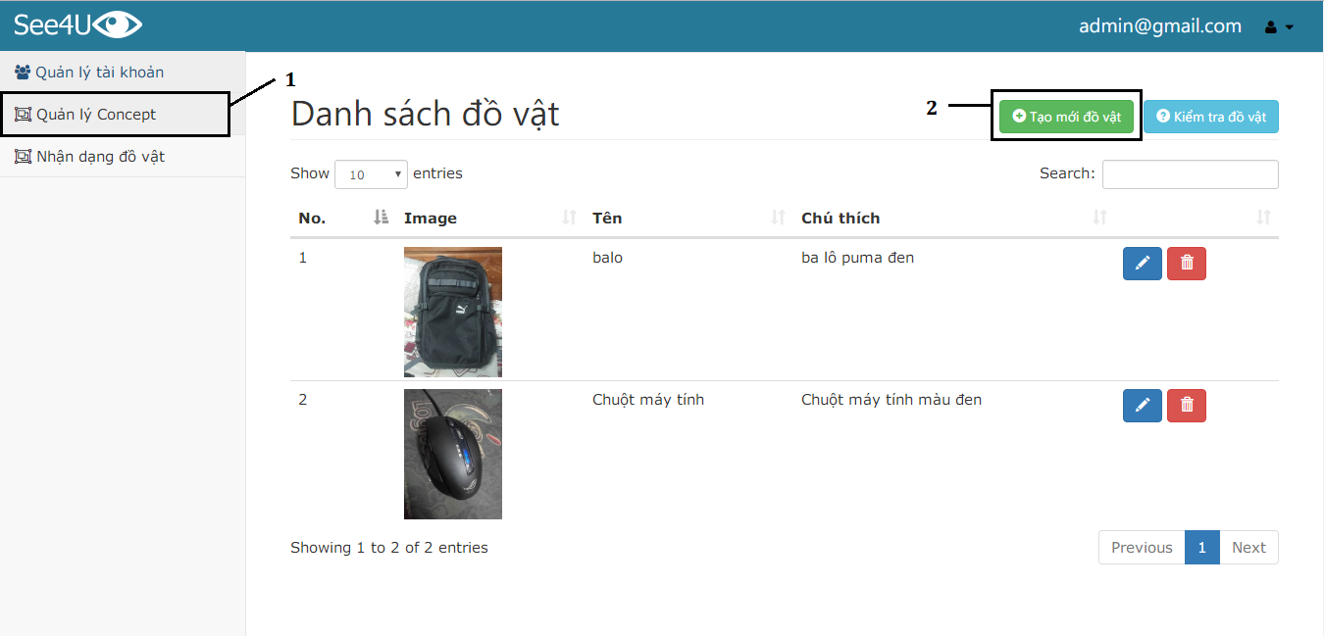

***Figure 115: Web Application Create New Object Page***

|  |  |
| --- | --- |
| **Step** | **Description** |
| 1 | Click “Quản lý Concept” menu |
| 2 | Click “Tạo mới đồ vật” button |

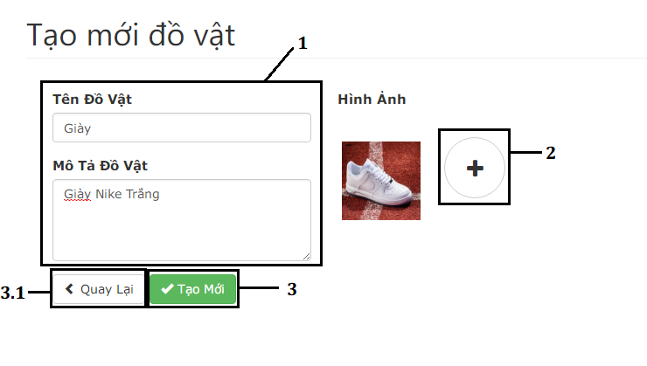

***Figure 116: Web Application Create New Concept form***

|  |  |
| --- | --- |
| **Step** | **Description** |
| 1 | Fill in Concept information:   * Tên Đồ Vật: Object Name * Mô tả đồ vật: Object Description |
| 2 | Click “+” button to add new picture of object |
| 3 | Click “Tạo mới” button to proceed to next step |
| 3.1 | Click “Quay lại” to back to previous page |

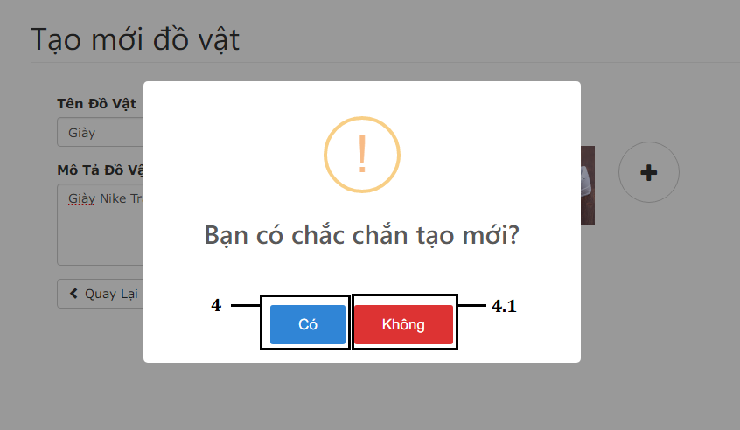

***Figure 117: Web Application Create New Concept confirmation***

|  |  |
| --- | --- |
| **Step** | **Description** |
| 4 | Click ‘’Có’’  button to create new Object |
| 4.1 | Click “Không” button to back to previous step |

* Create Object Result

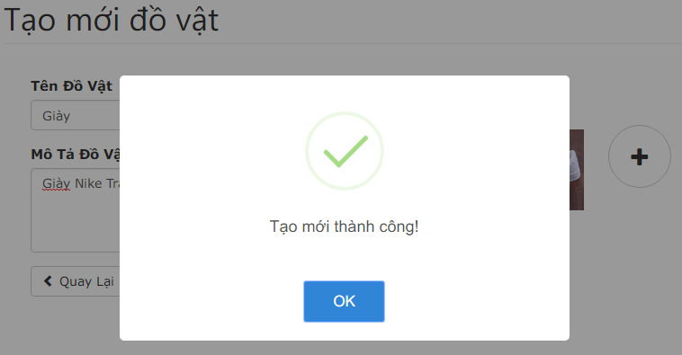

###### <Authorized User ><Admin> Manage Accounts

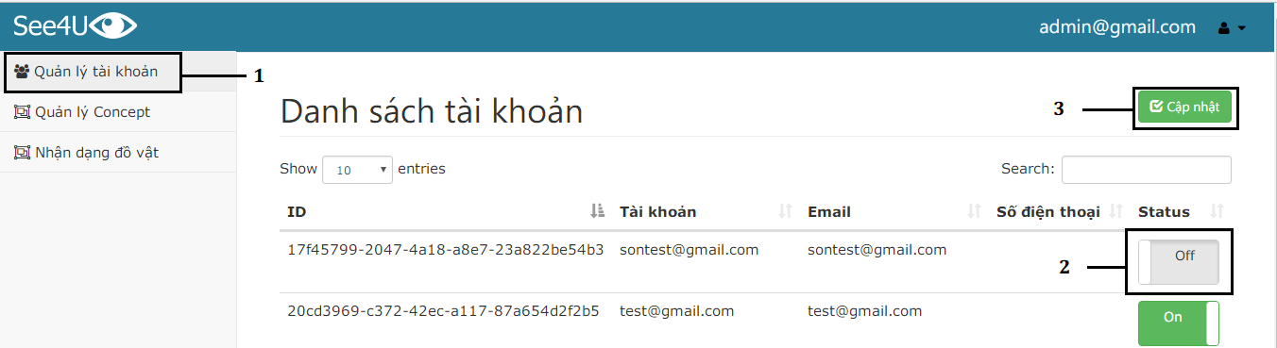

***Figure 118: Web Application Manage Accounts***

|  |  |
| --- | --- |
| **Step** | **Description** |
| 1 | Click “Quản lý tài khoản” menu |
| 2 | Click checkbox button to Activate / Deactivate an Account |
| 3 | Click “Cập Nhật” button to update accounts state. |

* Deactivated account:

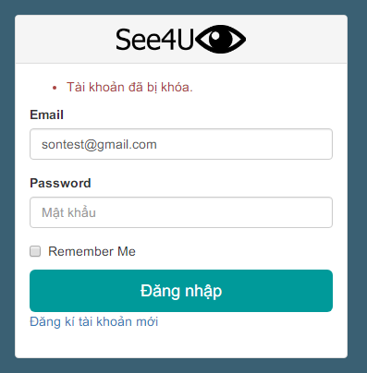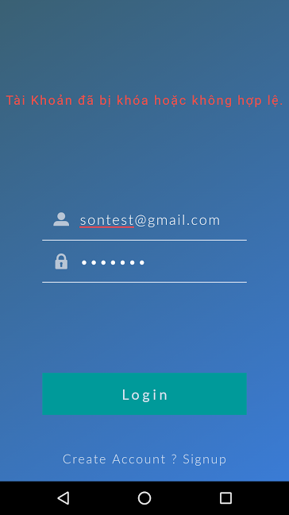

##### <Authorized User> User

###### <Authorized User><User> Add New Person

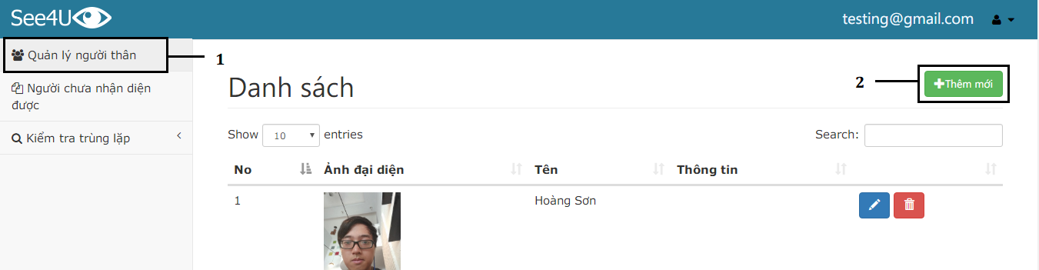

***Figure 119: Web Application Create New Person Page***

|  |  |
| --- | --- |
| **Step** | **Description** |
| 1 | Click “Quản lý người thân” menu |
| 2 | Click “Thêm Mới” button |

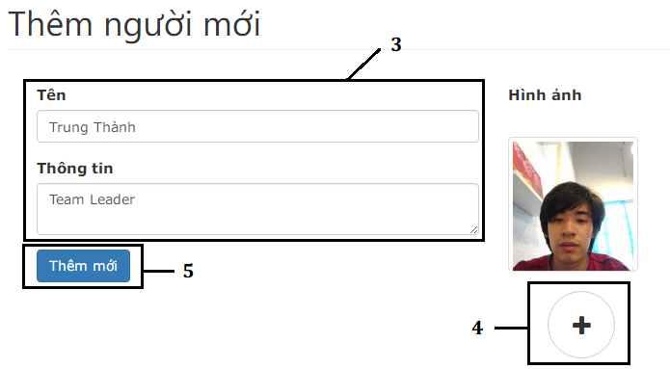

***Figure 120: Web Application Create New Person form***

|  |  |
| --- | --- |
| **Step** | **Description** |
| 3 | Fill in Person information:   * Tên: Input person name * Thông tin: input person description |
| 4 | Click “+” button to add new Person faces |
| 5 | Click “Thêm mới” button to proceed to create new person |

* Create new person result:

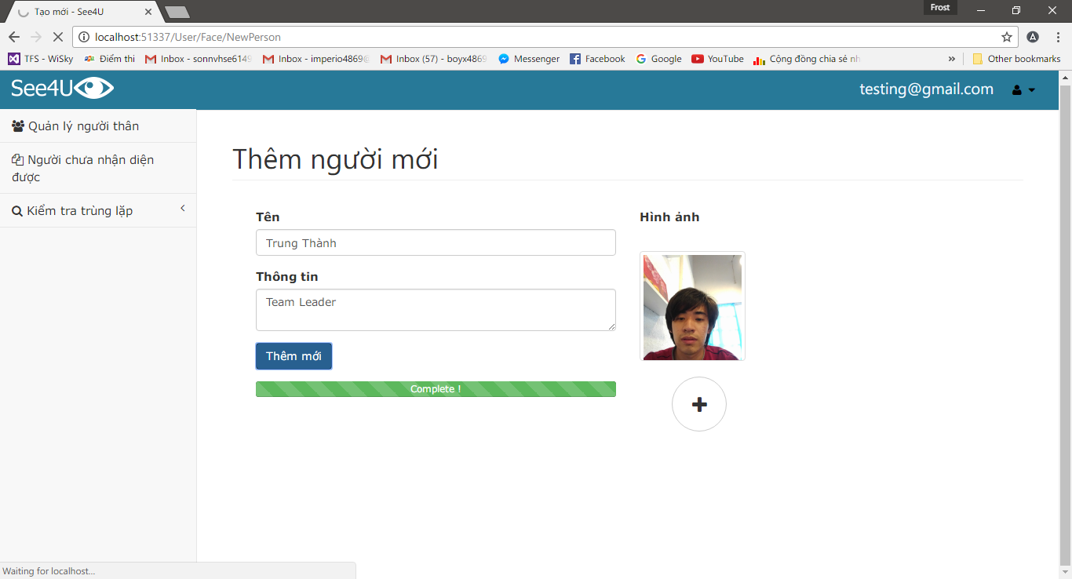

***Figure 121: Web Application Create New Person Successfully***

###### <Authorized User><User> Add New Person from Logs

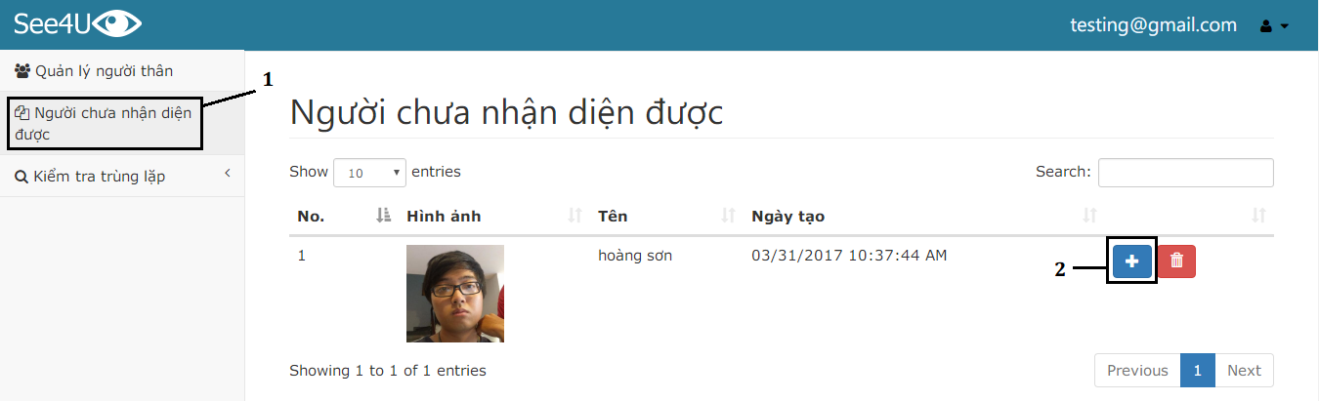

***Figure 122: Web Application Create New Person form Log page***

|  |  |
| --- | --- |
| **Step** | **Description** |
| 1 | Click “Người chưa nhận diện được” menu |
| 2 | Click “+” button to proceed to next step |

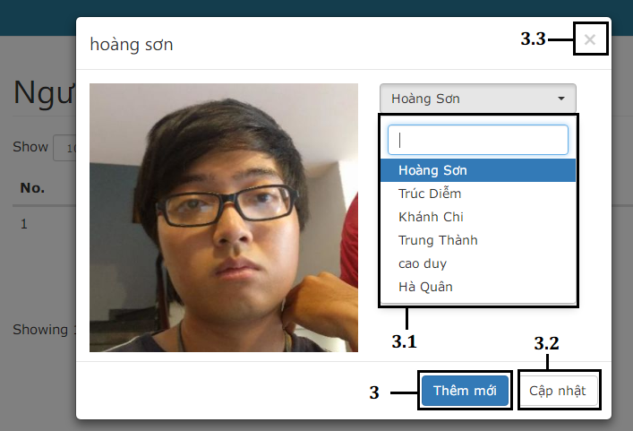

***Figure 123: Web Application Create new Person from log pop-up***

|  |  |
| --- | --- |
| **Step** | **Description** |
| 3 | Click “Thêm mới” button to proceed to next step |
| 3.1 | Choose existed Person to update |
| 3.2 | Click “Cập nhật” to add new image to chosen existed person in step 3.1 |
| 3.3 | Click “X” button to close pop-up panel, back to previous step |

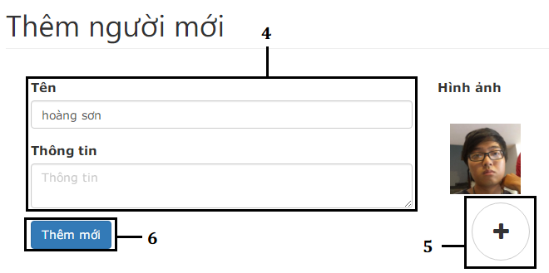

***Figure 124: Web Application Create new Person from log form***

|  |  |
| --- | --- |
| **Step** | **Description** |
| 4 | Fill in new person information:   * Tên: input person name. Default: person name from Log * Thông tin: input person description |
| 5 | Click “+” button to choose person image. Default: person picture from Log |
| 6 | Click “Thêm mới” to create new person from Log |

* Create new Person from Log result:

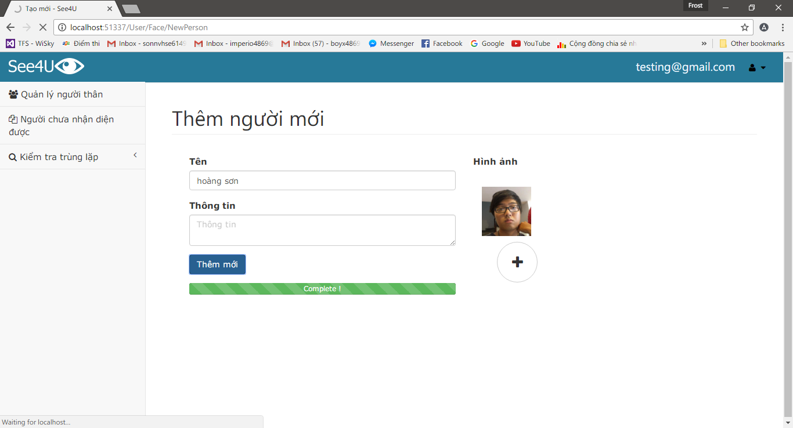

***Figure 125: Web Application Create new Person from log successfully***

###### <Authorized User><User> Update Person

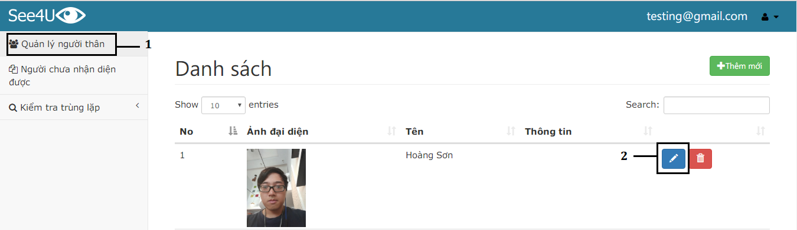

***Figure 126: Web Application Update a Person Information and Face***

|  |  |
| --- | --- |
| **Step** | **Description** |
| 1 | Click “Quản lý người thân” menu |
| 2 | Click “Edit” button to proceed to next step |

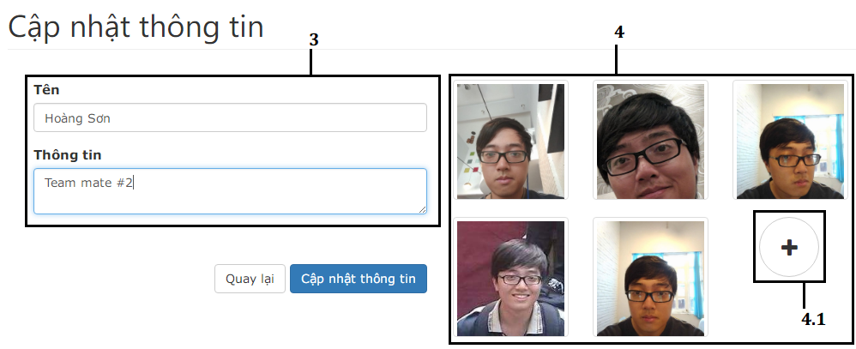

***Figure 127: Web Application Update Person Information form***

|  |  |
| --- | --- |
| **Step** | **Description** |
| 3 | Update person information |
| 4 | Click a image to update person face |
| 4.1 | Click “+” button to add new image of person face |

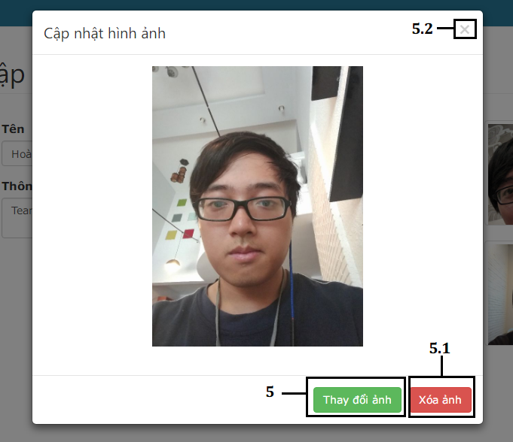

***Figure 128: Web Application Update Person Face Pop-up***

|  |  |
| --- | --- |
| **Step** | **Description** |
| 5 | Click “Thay đổi ảnh” button to choose another image for this image. |
| 5.1 | Click “Xóa ảnh” button to delete the chosen image. |
| 5.2 | Click “x” button to close Update person face pop-up. |

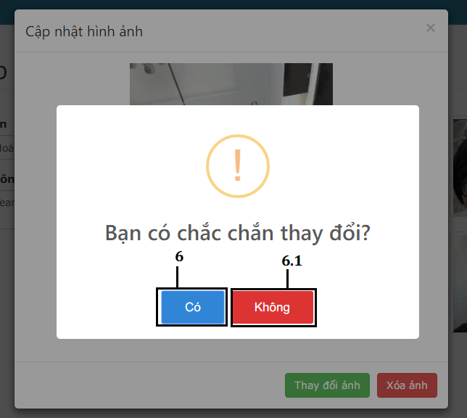

***Figure 129: Web Application Update Person Face confirmation***

|  |  |
| --- | --- |
| **Step** | **Description** |
| 6 | Click “Có” button to change to update the chosen image. |
| 6.1 | Click “Không” button to back to previous step |

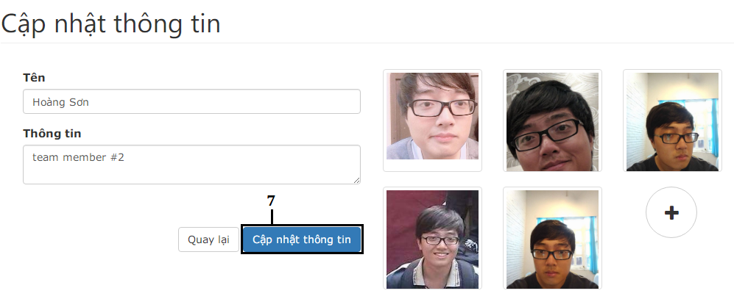

***Figure 130: Web Application Update Person***

|  |  |
| --- | --- |
| **Step** | **Description** |
| 7 | Click “Cập nhật thông tin” button to update person information. |

* Update person information result:

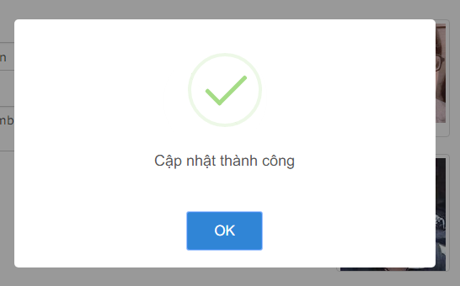

###### <Authorized User><User> Check Dupplicated People by Name

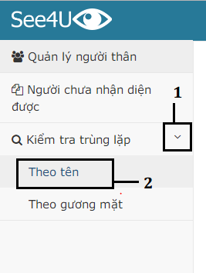

|  |  |
| --- | --- |
| **Step** | **Description** |
| 1 | Click “Kiểm tra trùng lặp” to show dropdown menu |
| 2 | Click “Theo tên” menu to proceed to next step |

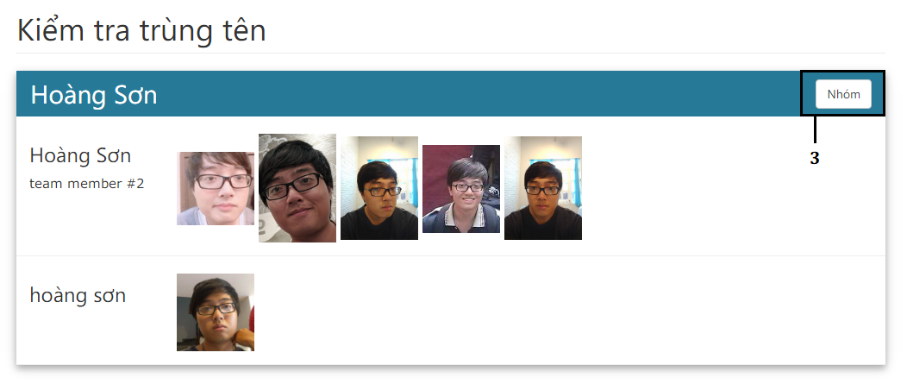

***Figure 131: Web Application Check Duplication Person by Name***

|  |  |
| --- | --- |
| **Step** | **Description** |
| 3 | Click “Nhóm” button to merge all duplicated person |

* Merge duplicated person result:

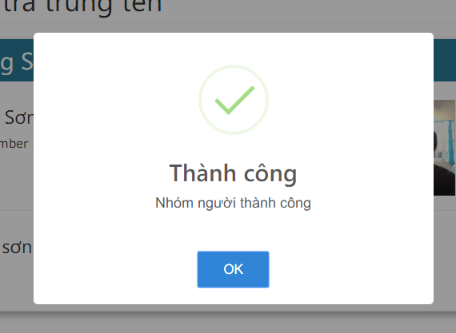

###### <Authorized User><User> Check Duplicated People by Faces

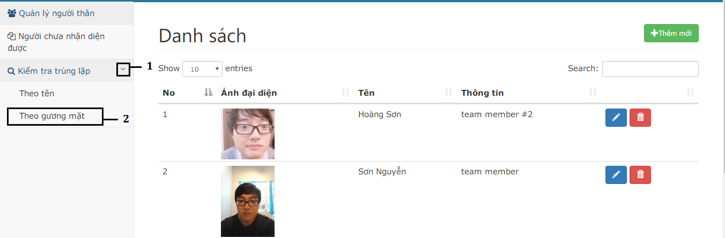

***Figure 132: Web Application Check Duplication Person by Faces***

|  |  |
| --- | --- |
| **Step** | **Description** |
| 1 | Click “Kiểm tra trùng lặp” menu |
| 2 | Click “Theo gương mặt” menu to proceed to next step |

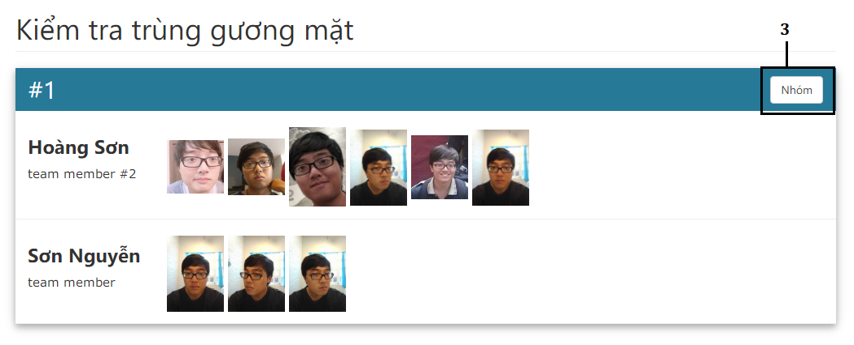

***Figure 133: Web Application Check Duplication Person by Faces***

|  |  |
| --- | --- |
| **Step** | **Description** |
| 3 | Click “Nhóm” to proceed to next step |

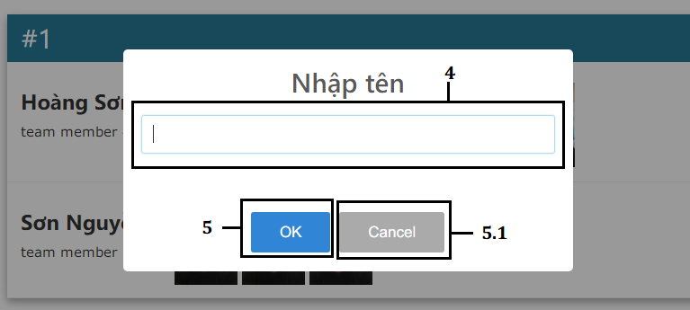

***Figure 134: Web Application Check Duplication Person by Faces – Choose New Person Name***

|  |  |
| --- | --- |
| **Step** | **Description** |
| 4 | Fill new person name when merge |
| 5 | Click “Ok” button to merge duplicated people with new name |
| 5.1 | Click “Cancel” button to back to previous step |

* Merge duplicated people by faces result:

